Solar Powered Educational tour in an EV bus – GRIFF, Technical Assistance Request
Video: https://youtu.be/NojT4JS69xQ

Unique challenge and needs:
1) Convert a vehicle to being 100% solar powered.
2) Coordination of events, seminars and lectures across various markets.
3) Marketing and promotion of solar, electric vehicles and affiliate referral system for greatest impact on duck curve problem.
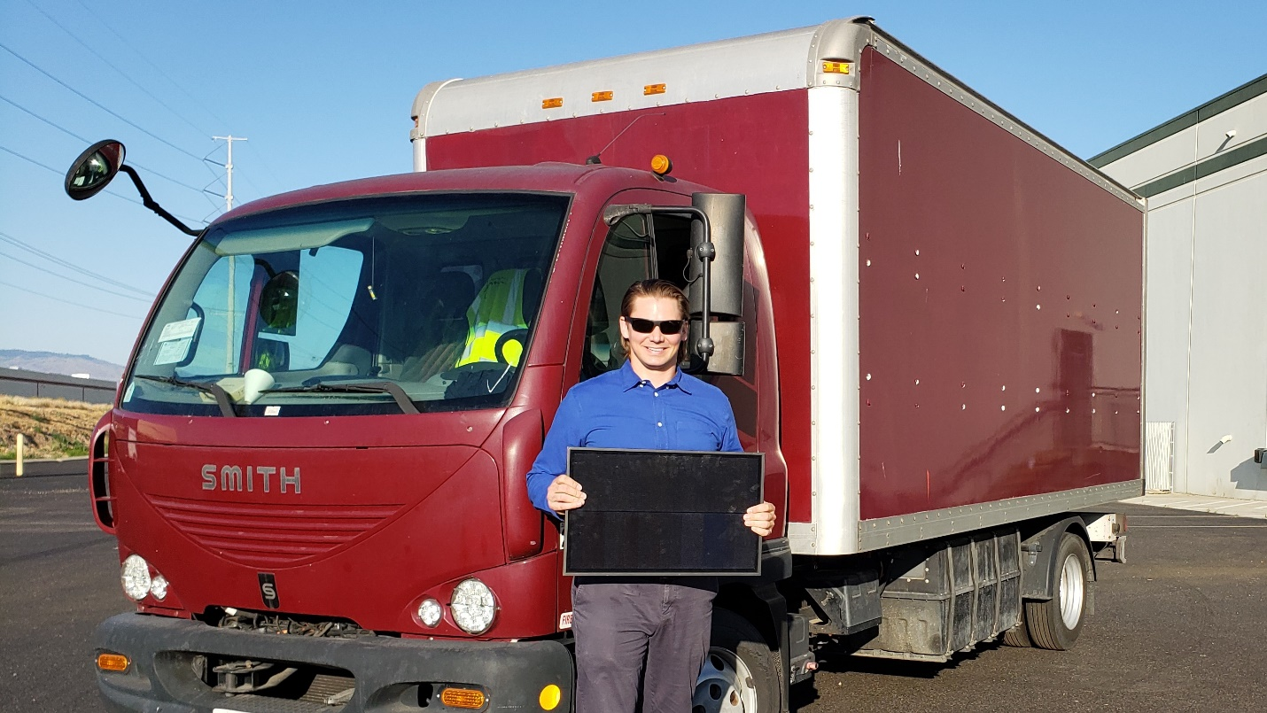

Proposed Assisting entity:
1) NREL.gov – National Renewable Energy Laboratory has the Vehicle Testing and Integration Facility, used in tandem with the Energy Systems Integration Facility, which serve as a unique fit for testing the capabilities of outfitting the electric box truck as a possible deployable energy source.
2 & 3) Cleantech San Diego – Business Services such as presentation/PR Opportunities and business service referrals will serve to connect the Griff project with potential marketing and digital systems specialists. Cleantech also has the resources to make professional connections to feature Griff in events all across the country and facilitate logistics of the proposed tour.

