Your Solar Experts (YSE) Technical Assistance Request
Video: https://youtu.be/qwi-8Op-ehc

Unique challenge and needs:
1) Advancement of solar sales training program.
2) Automation of evaluation and metrics for post-installation review processes.
3) Development of data procurement and follow up from solar customers.
4) Marketing and promotion of graduates and provider ratings system for greatest impact on decreasing solar soft costs.
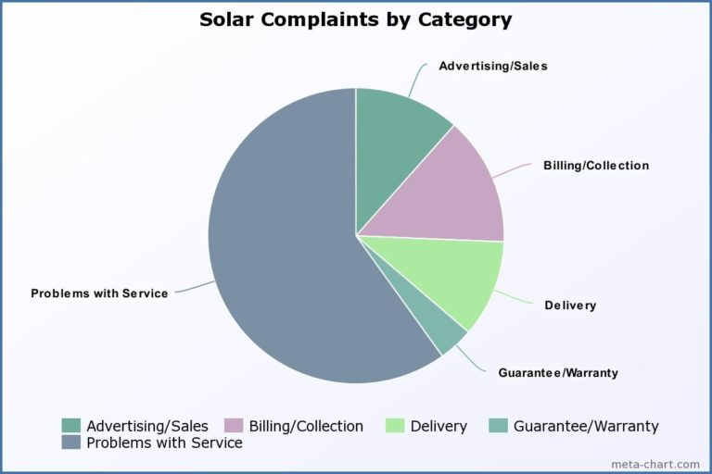 https://campaignforaccountability.org/work/what-consumer-complaints-reveal-about-the-solar-industry/

Proposed Assisting entity:
1) NREL.gov – The existing education programs, market research and analysis which exists at NREL should provide ample data and content to help develop the new training platform for scaled deployment.
2 & 3) Cleantech San Diego – Business Services such as software/data Analytics support and mentoring will provide ample resources to build online questionnaires and data gathering processes.
3 & 4) Powerhouse – Connection to the proper marketng specialists and organizations already advocating for increased sales training and distributing similar content will be invaluable for the success of YSE.

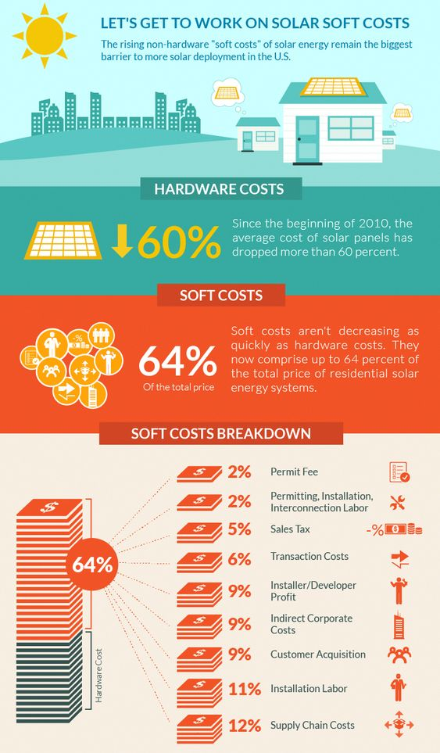 https://www.energy.gov/eere/articles/infographic-lets-get-work-solar-soft-costs

