technical assistance request (2 pages, including images, will be made public)

To create the apparatus outlined in my idea there would need to be a manufacturing facilities that could construct the air tight enclosure while having three conduits: one to remove air from inside the structure, the second to provide a pathway to channel water into the assembly and the boiler, and the third to let steam out of the boiler and the assembly. One of the goals of the apparatus is to thermally isolate the assembly’s system from the outside environment.

The top portion is a glass dome made of crystal clear glass that can withstand normal outside atmospheric pressure while having an interior pressure of less than 3 x 10³ Pa. The dome can have embedded burners to help concentrate sunlight rays to the boiler.

The bottom portion is a concave structure is fused to glass dome and has a concave mirror as its interior surface. The mirror is affixed and supported by a rigid material that can, just like the glass dome, withstand normal outside atmospheric pressure while having an interior pressure of less than 3 x 10³ Pa.

The boiler has a unique shape to it. It is a thin, hollow plate of either steel or iron with cavities filled with concrete or sand. Please refer to Figure 4, 5, and 6. The inlet and outlet conduits are made of a ceramic to impede heat leaving the boiler. The primary aim of this device is to expel thermal energy only as steam.

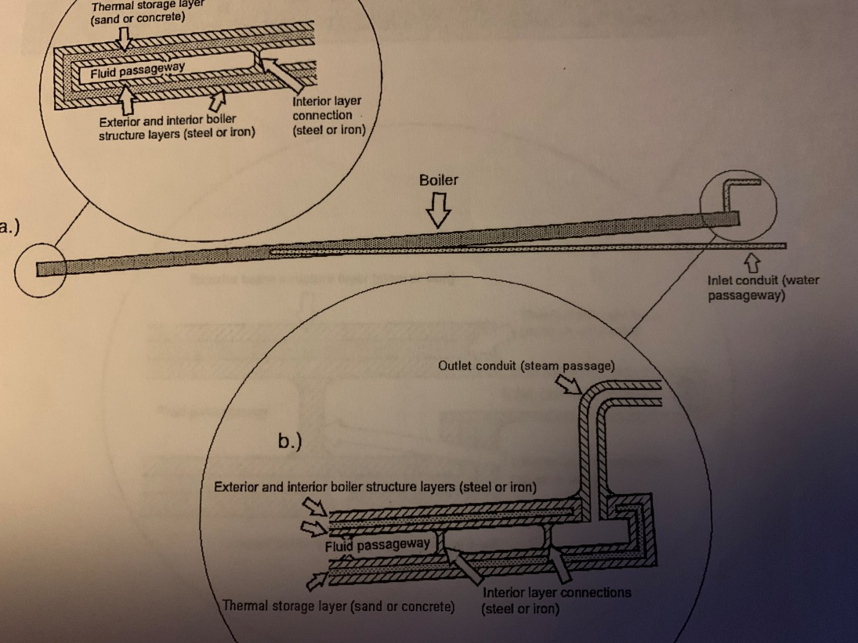
Figure 4
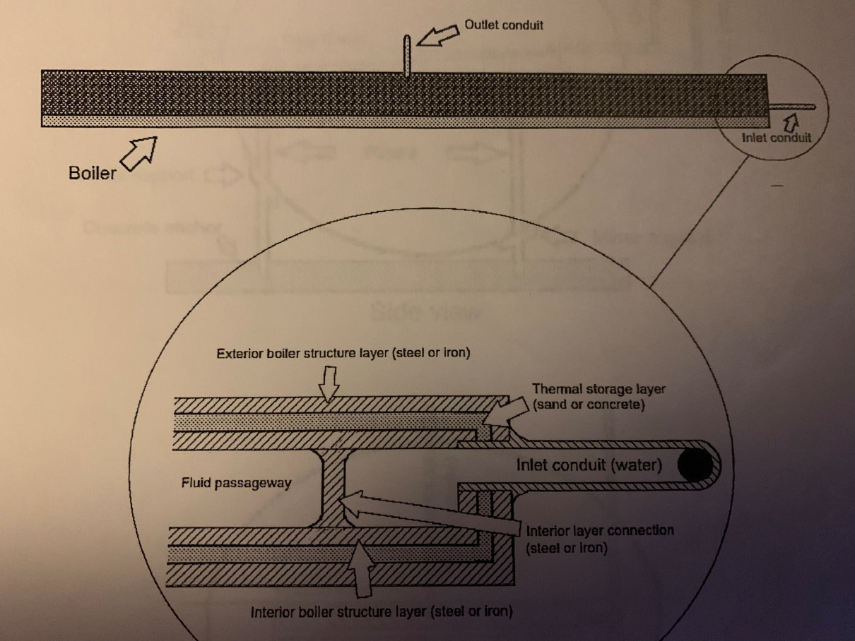
Figure 5

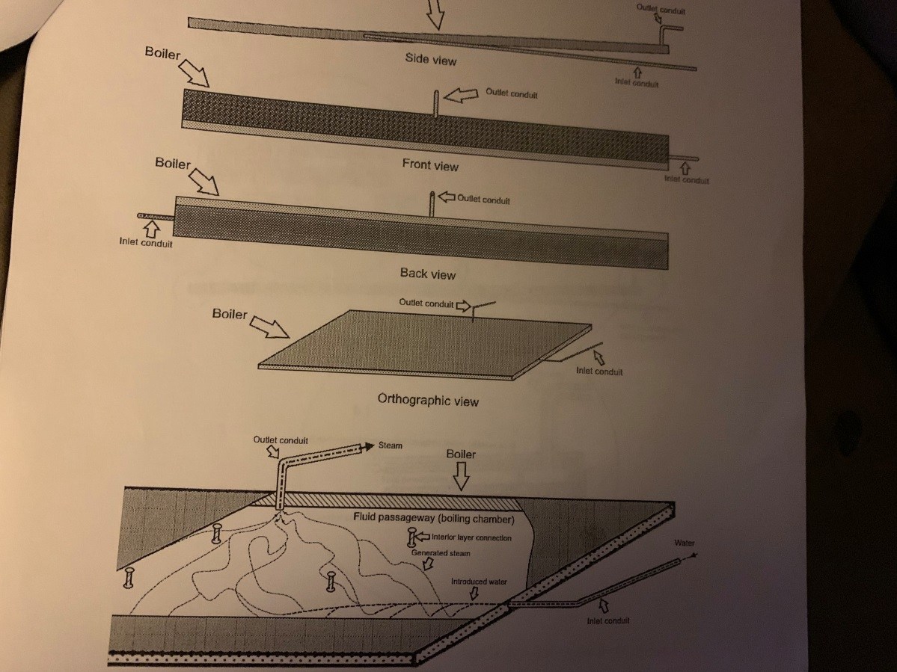
Figure 6 – Water being channeled into the boiler and turned into steam

