Technical Assistance Request
Conserval Systems Inc.
Buffalo NY
Contact John Hollick
E: jhollick@solarwall.com
Tel: 1-877-768-4328

SolarWall Power Tower
Conserval and its CEO, John Hollick, the inventor of the transpired solar air collector (SolarWall) is developing a revolutionary new concept which combines the best features of multiple renewable technologies into one Hybrid Energy Tower. The goal is to utilize low temperature heat from SolarWall panels to produce power. The concept also works with PV to capture the PV thermal energy.
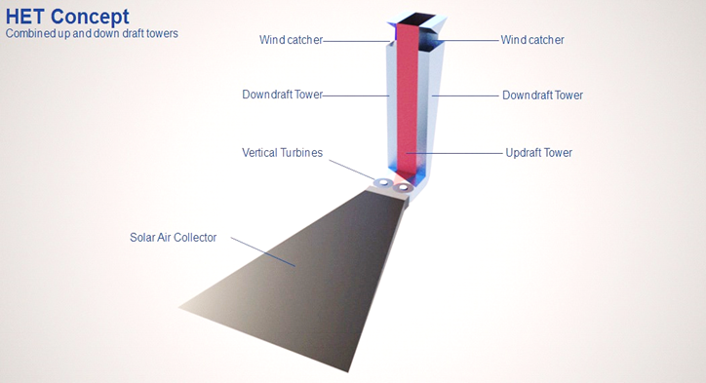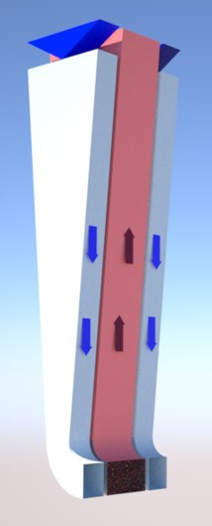

The SolarWall Power Tower includes transpired solar air collectors, solar updraft tower, wind downdraft tower, Venturi or diffuser chamber for turbines, ground thermal storage and optional integration of PV for recovery of wasted PV heat.
Two prototypes built to date confirm the much higher efficiencies compared with traditional solar updraft towers, but additional work is necessary to finalize the modular 250 kW target per 100’ tower

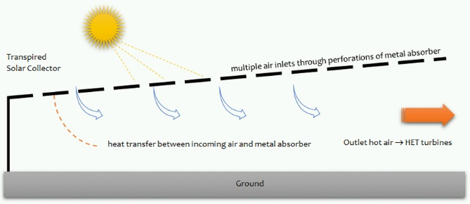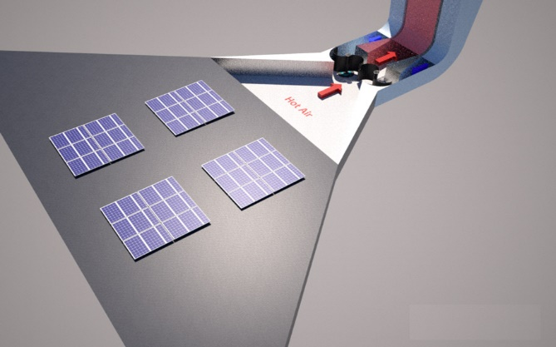

Heat from transpired collectors provide the driving force and can be coupled with PV arrays in a PVT configuration to recover the thermal energy and produce more power.

Components requiring further optimization include the vertical axis turbines and blades, design of the tower and connecting turbine chamber and better understanding of the air movements at the top of the tower and at the turbines.

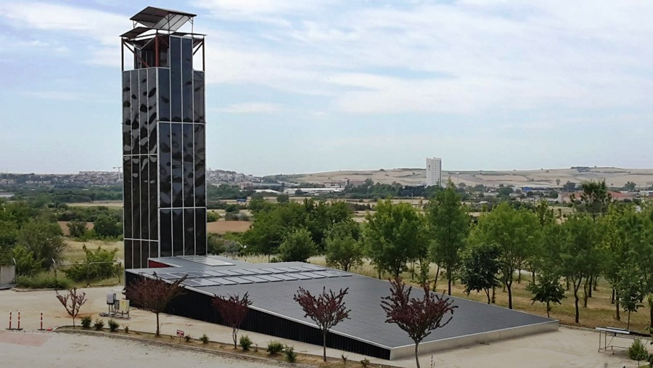

In the1990’s NREL worked with Conserval to develop software to optimize air flows and porosities in the SolarWall panels to achieve uniform air flow across the entire surfaces. NREL will be requested to review the solar design and make recommendations for optimizing the vertical axis turbine design with a Venturi or diffuser chamber receiving air flows from two directions as illustrated below.

Suppliers for the vertical axis turbines are being requested especially those interested in developing a solution for blades receiving both warm air and cold air from opposite directions.

Manufacturers of agricultural grain bins and towers may be well suited to building the solar towers as their experience in building similar structures in the agricultural areas is similar to solar tower construction.

NREL will be asked to participate in the GO phase to monitor the 250 kW demonstration installation.

PV farm developers interested in energy storage are encouraged to contact the Conserval team to consider a demonstration at one of their installations.

