Technical Assistance Request
- I need advisement as to which solar panels are the most efficient.
- I need advisement as to which energy storage systems are available.
Most of the energy storage systems on the market are not available in the USA.
- I need advisement as to which energy storage systems are the most efficient.
- I need advisement as to which inverter will best suit my purpose.
- Because I want this solar generator to be as user friendly and practical as possible, I need a utility grade inverter, I need an islanding inverter, I need an inverter that will allow Solarators to be stacked to increase capacity.
- I need advisement as to ventilation and heat management.
- I need advisement as to anchoring, and lightning suppression.

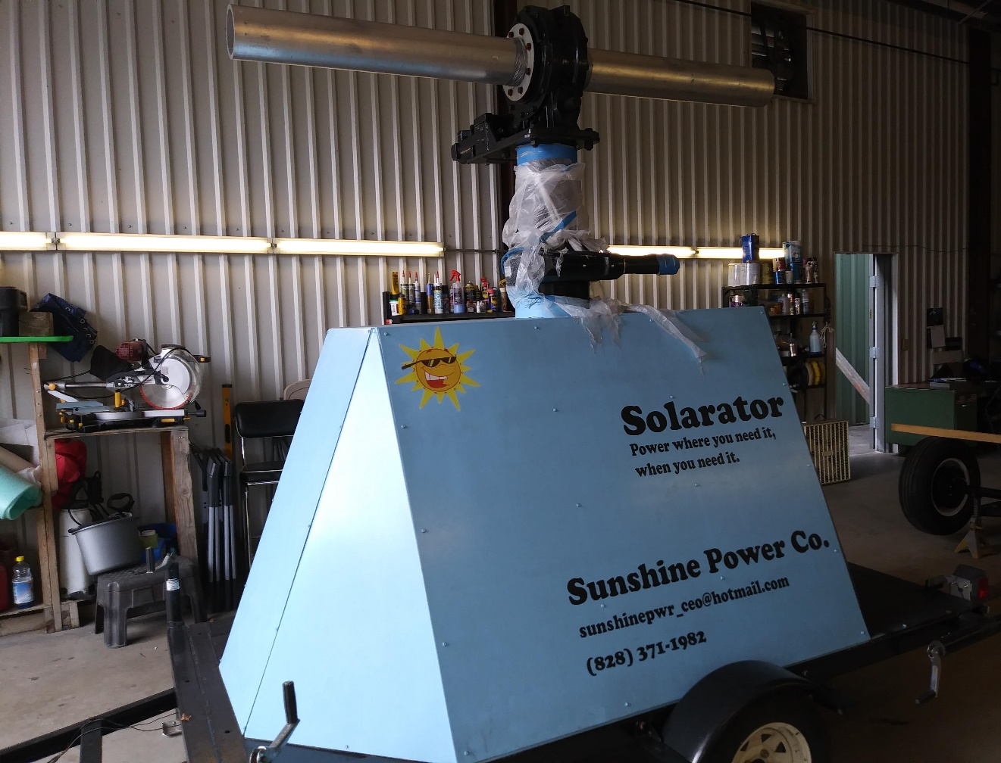

I have this much of it constructed already.
- I will need assistance in the form of equipment and a highly skilled welder for aluminum alloy (6160t6 aluminum alloy) to help me construct array.
- I will need help with tracking circuits.
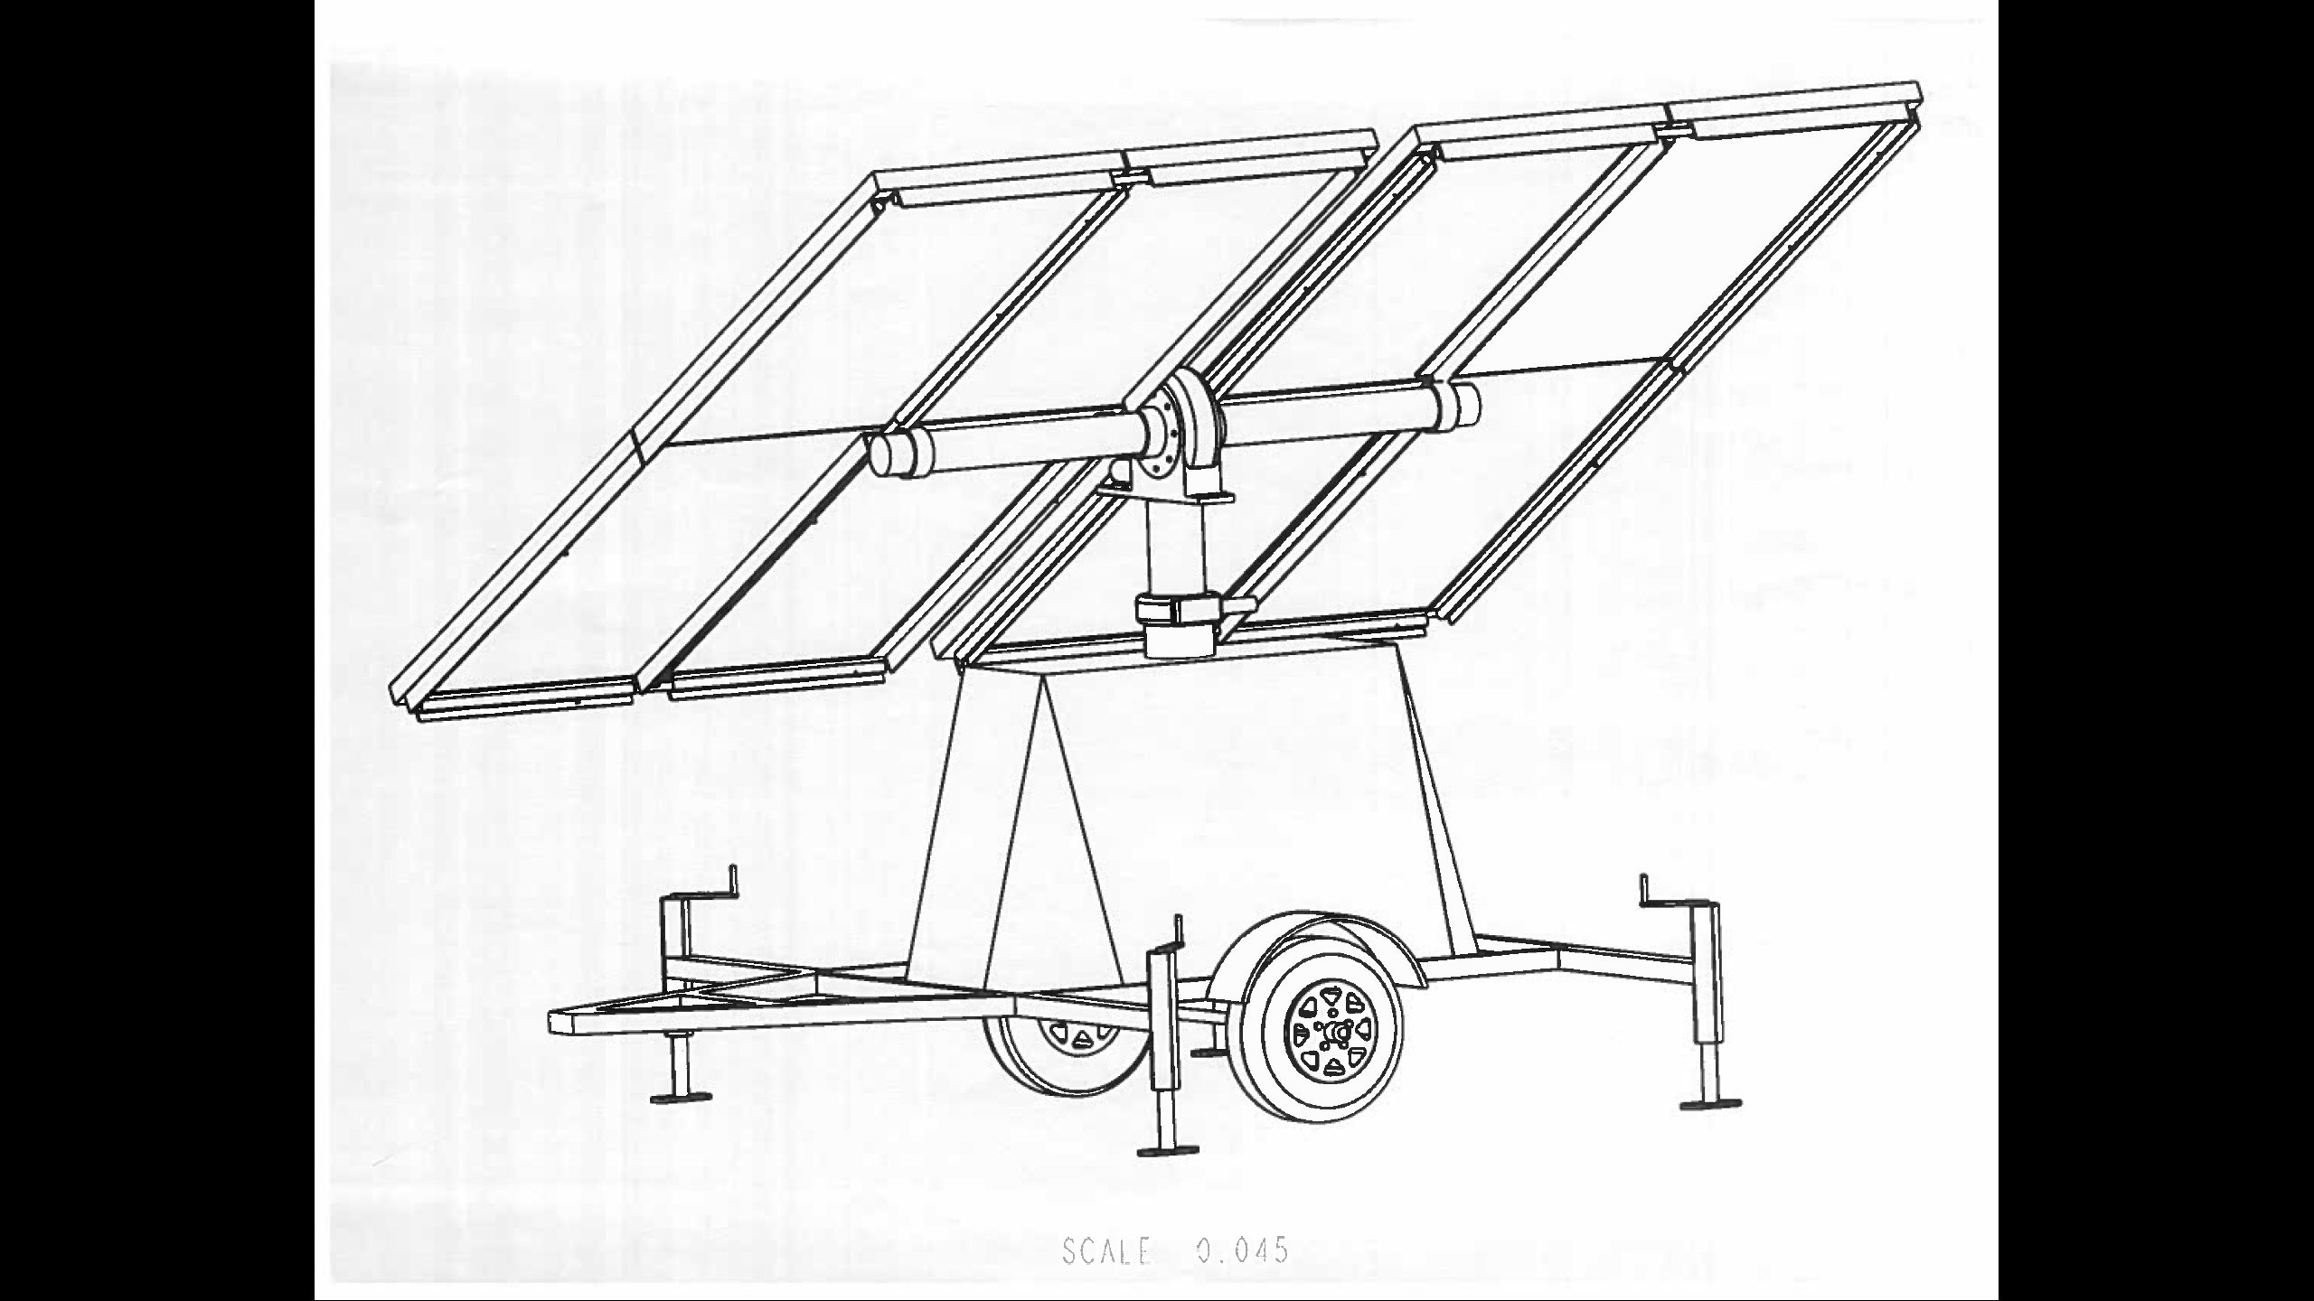
- This is what the prototype will look like when completed.

I will need help to test systems for functionality and capacities etc.
I will need help to produce a video demonstration.
My concept for the demonstration video is to produce a time lapse of the set up process.
I will then go on to elaborate about capabilities, capacities and practical uses, etc.

