Rhex

Mission Statement

At Rhex, we believe that people are more than ready to lead themselves - they only lack the means. Our mission is to affordably provide these means of sustainability one brick at a time. By giving our customers the push they need to build towards total autonomy with the powers of modern design and technology, we have faith that, along the way, they will build up themselves, and their community, into a fulfilling future, from the inside out.

Rhex
PRESENTS:
SolaRhex

draft zero

Authors
Daniel LaCosse

REMAINING BOUNTY
28,310 slices

Table of Contents

Summary
State of Market
Principal Issue
Proposed Solution
Physical Product Description
eCommerce Service
Management Service
Rollout Plan | Phase 0 (Product Development Timeline)
Financials Bounty: 500 slices
Phase 1
Survivalist Profile
Anticipated Reaction Bounty: 2,500 slices
Financial Projections Bounty: 1,250 slices
Phase 2
Activist Profile
Anticipated Reaction Bounty: 2,500 slices
Financial Projections Bounty: 1,250 slices
Phase 3 (Projected Impact)
Anticipated Reaction
Financial Projections Bounty: 1,250 slices
Appendices
Advisors
Slice Table
Survey Results Bounty: 1,500 slices
Customer Interviews & Transcriptions Bounty: 1,250 slices
Design Gallery
Technical Breakdowns
Component Cost
Hardware Bounty: 1,800 slices
Firmware
Central Server
Glossary of Terms

Summary

The levelized cost of electricity (LCOE) for photovoltaic systems is approaching parity with non-renewable alternatives, and yet behind-the-meter (BTM) renewable energy companies (REC) are waning due to well-meaning safety code regulation, lack of customer education, and an unbalanced electrical grid. By introducing a solar product that is...
- Modular
- Fungible
- Scalable
- Smart
- Standalone
- Easy to Market
- Easy to Install
...we believe we can be competitive with prices overseas and circumvent these safety regulations in some places.
At present our current strategy is to roll out the product in three stages. Firstly, to be battle-tested while being kept under wraps by a small market of Survivalists. Secondly, to be held up as a rallying flag of sorts by a somewhat wider array of Activists. Finally, to be sold to the mainstream average middle-class homeowner. Provided we make it to this final stage we believe this to be a $2 Billion market opportunity.

State of Market

Overview
Considering our product intersection, it’s important for us to consider the economic climate from a variety of layers and economic angles, those being first the overall US Energy sector, then Renewables, followed by Solar specifically and then finally so-called (behind-the-meter) BTM Systems. Finally we’ll look into the state of IoT, another important sector.

Energy
From Fidelity.com: The Energy Sector comprises companies whose businesses are dominated by either of the following activities: The construction or provision of oil rigs, drilling equipment and other energy related service and equipment, including seismic data collection. Companies engaged in the exploration, production, marketing, refining and/or transportation of oil and gas products, coal and other consumable fuels.

Market Cap | P / E (2017) | Y / Y | 5Y
S&P: $3.58T ($4.48T) | 26.00 | -6.49% | -13.59%

Critical Market Threats

Climate Change:

Let’s get this out of the way, we believe climate change to be a very real threat here (one of several). Many firms agree, including large clients like Walmart who are currently undertaking projects to drastically reduce the amount of carbon they consume (see: the Gigaton Project). Bloomberg estimates it would require an additional $5.3T investment over the next 4 years (2018-2022) to avoid breaking the Paris Accord 2°C limit — that’s over 1% of the GWP! Needless to say these “defections” by the likes of Walmart are a major concern to the larger players in the Energy industry as non-renewables are still the vast majority of the market cap (though a lot of the smarter players are already investing in renewables), and could explain the sector’s deflation, in addition to the large volume of overseas competition. We’re expecting lots of countries to start hitting peak carbon around 2025, with a max output being 14.1 Gt.

Renewables
Unlike the larger Energy Sector, Renewable Energy sources aren’t fuel based, and… are renewable?

Market Cap (?) | Sector Share | Y / Y | 5Y
$200B | 4.5% | Bounty: 20 slices | Bounty: 20 slices

Critical Market Threats

US Administration:

It’s no secret the current US administration is very anti-Renewables. “Clean coal” is a common saying. More of a soft cost than anything - but we’ve already seen their stance directly affect the Solar industry with respect to the Suniva decision.

Solar
Solar Energy is energy generated with the use of PhotoVoltaic panels; photons emitted from the sun strike the panel, moving electrons through it. Solar companies research, scale, manufacture and install these panels.

Market Cap (2015) | Sector Share | Y / Y | 5Y
$65B | 1.45% | Bounty: 20 slices | Bounty: 20 slices

Critical Market Threats

Tariffs:

Falling prices (see: Swanson’s Law) have been cause for steady solar growth - however, competition from overseas manufacturers has undercut the US Solar industry. Due to the Suniva trade decision last year this month the Trump Administration has imposed a 30% tariff on PV imports over the next few years.

Reverse Power Flow:

Management of energy generated from the new, more decentralized and uneven system of power generation is proving to be a strain on the US’ existing infrastructure. Any point in which the supply exceeds demand by about 30% or more we start to see “Reverse Power Flow”; regions in the grid where electricity starts flowing in the opposite direction, causing all kinds of problems. Some retailers are taking steps to prevent this by installing centralized storage facilities to help balance the grid in these instances - these kinds of energy arbitrage are crucial to unlocking further growth in the solar industry.

Behind-the-Meter Systems
BTM Systems are residential energy generation and management systems. Residential Solar, NEST thermostats are all consumer-grade products meant to be installed “Behind-the-Meter” with the intent of reducing the amount of energy monitored via “net metering” are examples of companies that operate squarely within this industry.

Market Cap (2018) | Sector Share | Y / Y | 5Y
$11.4B | .25% | +12.3% | +23.6%

Critical Market Threats

It’s been cited that “soft costs”; wage differentials, roofing/electrical standards, customer acquisition costs and a lack of competition adds almost $1.50/W to BTM systems, nearly doubling the cost of similar solutions found internationally.

Customer Acquisition Efforts: Bounty: 150 slices

Zoning: Bounty: 150 slices

Internet of Things (IoT) Bounty: 750 slices
What is the IoT industry?

Market Cap | Revenue (2017) | Y / Y | 5Y

Critical Market Threats

Principal Issue
In our first, self-report survey, reasons for not having solar were given as the following:

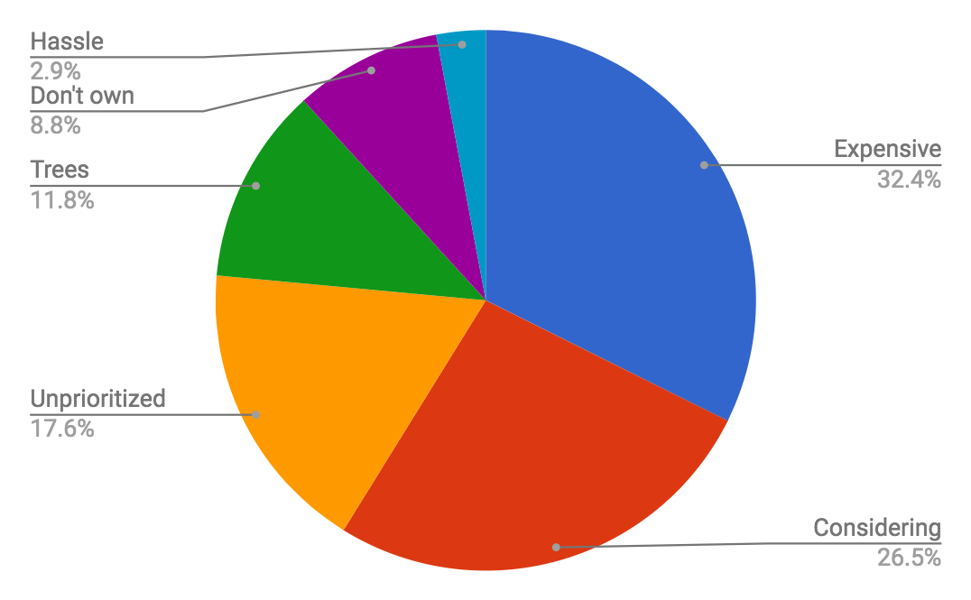
Surprisingly, not one respondent indicated that they had an issue with the appearance of the panels - and the majority cited solar as being unaffordable. Only one respondent acknowledged the difficulty of getting solar installed, implying to us that those “considering” aren’t aware of building and fire regulations. We’d also assumed we’d see more people prohibited by an abundance of trees, however ultimately the perception that a solar system is out of reach for the average consumer seems to be the driving force for the sample.

Of course we know this to not necessarily be the case (see: Swanson’s Law), and this lack of awareness is reinforced by the shift away from BTM tech in the market towards utility scale construction, who have left the residential market behind in fear of customer acquisition costs and the aforementioned regulations.

And no wonder the CAC is so high; many of the current offerings do not adhere to common sense marketing principles. In Walter Isaacson's biography of Steve Jobs he briefly enumerates over Apple’s three driving principles:

- Empathy - connect with the customer
- Focus - do one thing
- Impute - look as good as you are

Take the case study of Legion Solar, a relatively successful project that has offered a couple iterations on the DIY solar concept via Kickstarter. In their explainer there are so many components listed so as to become confusing. Inverters, optimizers, batteries, solar cells - even SolarCity has multiple components that need to be modified for each user’s unique configuration. This lack of focus and consistency makes it exponentially more difficult to tell a concise, clear story, and ultimately, more difficult to grab the consumer’s attention.

Proposed Solution
A modular, self contained panel that snaps to itself like a puzzle piece. It should contain not only the PV cells but a nano-inverter and batteries. This will allow us to market with focus and clarity, attributing one panel to “your laptop” three to “your fridge”, etc. Users will be able to buy as many as they can currently afford without having to take out a loan. We’ve talked to some officials and at the piece by piece scale, no electrical or building permits will be necessary [proof].

Physical Product Description

IMAGE Bounty: 2,000 slices

Quick Stats
20” from corner to corner, 17.28” edge to edge. From our current understanding these dimensions will give us the best coverage around and near traditionally-sized doors and windows, while still being small enough for most people to carry without issue.

Estimated weight: 9 lbs (4.08kg). Light enough for most anyone to pick up.

Peak power generation: 45 Watts, with a power reservoir of 100Wh. This is plenty enough to run a laptop, several LED lights, or a mini-fridge, with a couple hours to spare after the sun goes down.

Component | Rationale | Est. Cost at Scale
Military-Grade Plastic | Tough plastic that performs at high temperatures is critical not only for our beachhead market but also to nail down NEMA enclosure ratings (crucial for fire codes). | $2/kg
LiPO₄ Batteries | Lithium phosphorous batteries have the same energy density of traditional lithium ion batteries but without the fire safety risks. | $0.3/Wh
Custom Nanoinverter and PCB w/ WiFi chip | The Nanoinverter will not only perform its regular grid-sync duties at a smaller scale but also run our firmware to communicate with the other modules in the system, if present, so ase to orchestrate data collection and energy arbitrage with the central server. | $0.20/W
Polycrystalline Custom-cut PV Cell | Polycrystalline is easily assembled from scraps of unused silicon, making it manifest from recycled material - perfect for when we want to start to recycling these things | $0.42/W
Interlocking male-male snap safety connector | Contains both a live load-bearing wire and a couple isolated digital pins for intermodule communications. No leads are to be exposed at any point. | [Bounty: 1,000 slices]
Male power socket | For interfacing with a standard power outlet | $0.4/ea.
Total Material Cost: |  | $66.30
2%-5% Depreciation: |  | $2.32
Labor: |  | [Bounty: 750 slices]
10% Administrative: |  | $6.63
Est. Shipping Cost: |  | $15
Margin: |  | x1.4
MSRP: |  | $129

Costs are based on 2017 international PV statistics, Bloomberg
We wanna take a thin margin, here. Based on 1-for-3 Environmental Activist plan

Adapters. Bounty: 5,000 slices

90° tilt range ball bearing joint and tripod stand | - Able to meet the sun directly head on at the azimuth (~45° up from the wall) while still ensuring that the back of the joint will always maintain a circuit with the base without exposing the connector at any point.  - Allows main PV unit to be popped out without removing the base  - Different stands for different appliques | --

eCommerce Service
The entrypoint for new customers will live at some core site, like “makesun.org” - though we’ll offer slightly different copy or experiences for onboarding each customer type, including entry level URLs.

For example:
your.world for survivalists
solarhex.org for activists
rhex.com for savers

This is to set the tone for each customer, to suggest to them that this is a place they actually want to go and will be accepted. Additionally, the entrypoint to the ecommerce flow will vary by platform - platform detected by a bit of javascript on the initial page.

DESKTOP | MOBILE
Map View: The desktop site assumes that the client is at home. With geolocation data, we can estimate the effectiveness of each panel based on solar irradiance, cost of electricity, and weather data. The map form should allow the user to correct our guesses.  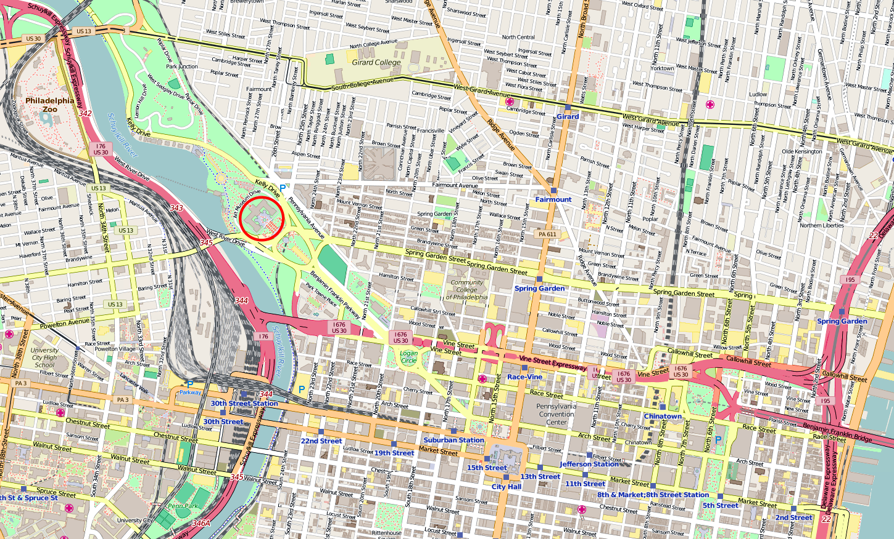  HEXUS  COPYRIGHT 2018  est. cost/kWh ?  13.4¢  Will hex work for me? >  QUICK FACTS | The mobile flow picks up later - we don’t know if where they currently are is at home.
Inventory view: Here, we enumerate over our products as units and, based on data, round to the closest appliance that set will power for this user. Hovering over any infographic will reveal more technical/savings information.  x1  x3  x12  HEXUS  X2.4 RoI  .675kWh ?  (laptop icon)  (small house icon)  Get started w/ hexus.  Move toward energy independence. | Mobile picks up here, showing default conservative guesses for equivalent appliances.  HEXUS  Tell us your address for more accurate estimates >  1  +  -  Should power one (appliance icon) [CONTINUE]
Mobile Map Search View:

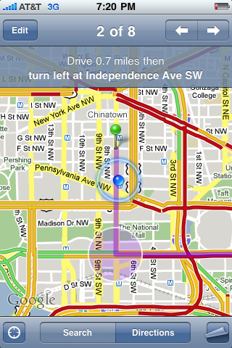
HEXUS
search...
confirm
Checkout view: Once the customer has made their selection, they must enter in their payment info via Braintree and password to create an account (we’ll prefill with best guesses based on what we know so far).  x3  $270 after federal rebate  (+/-)  forms…..  Scrolling progress  Menu  > User  Credit card  TOS/PrivacyPolicy  submit | HEXUS  > User  -- forms --  > TOS/Privacy  -- forms --  > a  $270*  3
Success view: The user is told the item has been purchased, we send the request to the dropshipping manufacturer, and invite them to download the DERMS/management electron app!  Success, User!  Your tracking number (or confirmation email) is HTETH34337879.  In the meantime, download the desktop app;  DOWNLOAD LINK  Get tax doc | Change order? | Success, User!  Your tracking number (or confirmation email) is HTETH34337879.  In the meantime link this to your home screen;  DOWNLOAD LINK  Get tax doc | Change order?

Management Service

This is not intended to serve as a comprehensive list of views.

Systems Map View


!!!
G01 ℹ

G02 ℹ

myusername@gmail.com

Inspect Unit

G01 ℹ

G02 ℹ

myusername@gmail.com

!!!

G02-C rename

status: offline ?

output 24hr 1w all

charge 24hr 1w all
identify

Add/Order Unit

!!!
G01 ℹ

G02 ℹ

myusername@gmail.com

+
Systems List View

G01

G02

myusername@gmail.com

A online 23W 75% charged +.46¢ identify
B online 35W 85% charged +.82¢ identify
C online 34W 80% charged +.90¢ identify
D online 40W 95% charged +.99¢ identify
A online 02W 15% charged +.01¢ identify
B online 22W 25% charged +.32¢ identify
💡

Profile/Settings View

myusername@gmail.com
X
Forms for changing username/password, address (moving?)

Ask for help!!! (map of nearby ppl + our phonenumber for returns)

Notification Contexts
Bounty: 150 slices
- Monthly Report
- System Failure
- Warnings -
  - A given unit isn’t getting enough light and needs to be moved.
  - A group has too many units and needs to be split up.
  - You’re not close to home and a unit was disconnected.
- Check-in to see if you need more units (for low unit customers only)

Rollout Plan

In summary, our plan is to begin by targeting Survivalists in North Carolina, then Survivalists in adjacent states, then pump momentum all over the East Coast overnight by switching stances to target Activists in those same areas.

Phase 0
Product Development Timeline

Stage 1 — Iterative Prototyping
Spring 2018 to Winter 2019

We’ve got top-tier software developers, a consumer-grade 3D Printing and CNC machine; this will prove out the concept. Costs at this point are largely time-based, estimated at 6-8 months.

Stage 2 — Patent Application
Spring, 2019

We’ll first write an initial high detail of our ideal working product’s hardware, firmware, and manufacture process. That will then get taken to a lawyer who we will work with to patent the whole system, each eligible component, and identify and change anything we might accidentally be infringing on. Legal Fees estimated to be around $7,500.

Stage 3 — Initial Manufacturing Run
Summer, 2019

Once our patent is filed we can take the designs to get quotes from drop-shipping manufacturers. We’ll use drop-shipping manufacturers to minimize risk, save on warehouse space, allow for flexibility of location, and start making an immediate profit. If we’re patent-guarded knockoffs can be defended against. These quote numbers will be used to determine size of customer seed round via Kickstarter and Massdrop.

Cost per unit determined in this stage: QA, Shipping

At this point, timeline becomes less clear - it all depends on how far we can stretch our chosen drop shipping manufacturer.

Stage 4 — In-House Module Assembly
2020+
As sales start to come in we can start to look for real seed money that will allow us to start building up our first Warehouse. In-house module manufacture allows us to launch our automated recycling service - super critical for the move to Activists. Ideally this occurs before the end of the current political cycle.

Cost per unit determined in this stage: Circuit Board Printing, Injection Molding, CNC, Module Assembly
Cost per square foot determined in this stage: Warehousing

Stage 5 — Complete Manufacture

Wafers are the most CO2 producing part of the process. From a PR and ethical POV it would behoove us to take the entire process in-house ASAP. Stage 4 will slowly slip into Stage 5 as we expand into permanent Warehouse locations at strategic points across the US. This will also allow us to at last stop cutting square cells and create contiguous hexagonal wafers.

Cost per unit determined in this stage:
Quartz, CO2-free purification (wafers only), Photolithography, Chemical Vapor Coating, Metal Contact Painting

Phase 1

Why begin in North Carolina?
North Carolina proved to provide an interesting cross section of properties in our analysis - net metering is supported there, cost of electricity remains relatively high, there’re a fair number of generously sized properties and DIYers, and solar radiance is fair. They’re also far less saturated than California in terms of solar competition.
Additionally, North Carolina is notoriously politically diverse (we’re from NC, we know), which makes it an interesting proving ground for us. The fact that we’re from NC is no coincidence - it’s more likely this solution came from the upbringing rather than the analysis being flawed (citation needed).
Finally, and practically, we own a home in Durham, NC; which could serve as an initial base of operations.

Why begin with Survivalists?
They may be fewer in number, but they will battle test our product. If they like it, we can be 110% confident that it works. It will force us to maintain a high standard. They should also prove loyal - and as we’ve shown they individually are willing to spend thousands on DIY/survivalist projects. This means proportionately less required customer support resources.
Additionally, they’re skeptical of the government and thus will actively try to avoid drawing attention to the product. As we build out a wide geographic base, we’ll fly mostly under policy radar. This will allow us to pounce on the east coast all at once when we’re ready to start targeting activists.

We’ll move out to states adjacent to North Carolina to keep shipping costs low, prioritizing states that we’ve evaluated to have the most relaxed zoning conditions. Then, once we have done our due diligence in a geographic critical mass, we can begin to target activists - hard. This will require a shift in advertising tone, a more sophisticated online store, and an ironed-out relief effort strategy.

Phase 1
Survivalist Profile
Reformat to reflect Activist Profile Bounty: 250 slices

The “doomsday prepper” wants to be prepared for anything. In that sense, this demographic is chalk full of high-functioning users. The need of the doomsday prepper is to be prepared for economic & infrastructural collapse, environmental disaster, property infiltration. They’re “high functioning” because many resort to taking things into their own hands, investing 100s of thousands of dollars in some instances to construct backup solutions themselves. Sometimes even endangering themselves and their family to do it.

Transcribe relevant interview segments Bounty: 400 slices

Approximately how many are there?
We’re currently running a survey to get a better more recent idea, but the facebook page for the eponymous national geographic show currently has 300,000 followers and, according to a survey the channel ran in 2013, about 1/3rd of americans claimed to know someone who was actively preparing for societal collapse. With Dunbar’s Number we can take that to estimate to somewhere between 300k and 600k - and, since we’re dealing on a per-household basis (avg. 2.5) 120k - 240k households.

What features would they value most?
Reliability & dependability — to them, energy preparedness is a life or death situation. A product that will weather any situation is of top priority to them, as in their eyes if it fails, so do they. A generator running out of gas or having a mechanical malfunction is a serious concern.

Privacy & covert installation — during the apocalypse, operating under the radar of any potential raiders is the key to survival. While many DPs may prefer generators, the noise and complexity of such a system could lead to a raid. Better to be quiet and unnoticed.

Tactical mobility — DPs are constantly on the move from one “bugout” location to another. The ability to quickly set up, teardown, and take an energy supply from campsite to campsite would be ideal.

Customer specific modifications
Camo paint — In the interest of remaining convert, a tinted model could prove to be a lot less noticeable.

Data independence — To provide the best experience to the DP, we should consider not collecting data in certain sensitive contexts (for instance, allowing the user to whitelist data transfer from trusted routers).

Customer Lifecycle

Discovery

Avenues to discovery will have to be word of mouth, retail, or, in the best case scenario, being featured on a doomsday prepper-esque television program. Honestly getting this product in front of potential DPs will involve a lot of footwork.

Evaluation

Evaluation will likely be equally as difficult, as the DP will administer increased scrutiny above the average consumer. I’m not above giving out test devices in the hopes that they’ll purchase more to add to their system later.

Purchase

Once the DP is sold, however, I expect them to be all in. They’ll power their compound and then some.

Use Experience Bounty: 150 slices

Bonding Bounty: 150 slices

Advocacy
Being a particularly isolated bunch, I don’t expect them to do a whole lot of advocating, but they will form financial backbone to bootstrap off of.

Phase 2

Why follow up by targeting Activists?
They won’t buy hardly as many (I’m thinking 1-3 per household to start) but the intent is that they’ll live up to their name - they’ll start to push the product on people who are more apathetic (the individuals in our surveys who haven’t really thought about solar but wouldn’t mind saving a little money).
If we offer to send units to areas of need as units are sold commercially, we’ll incentivise activists to further advocate for our product. Assuming we’re covering wide enough a geographic area, we’ll spring up wide local support overnight - policy makers should be unable to keep up, and should policy start to change to push our product out, we can leverage the activists to put ethical pressure on local lawmakers.

At this point, the activists will help to facilitate any marketing efforts we have, carrying momentum/brand identity into a household name.

Phase 2
Activist Profile

“Activists” by our definition are individuals driven by some degree of idealism - they’ll go out of their way for a cause they believe in. “Going out of their way” is not measured by degree - as long as the person is willing to modify their behavior or develop better habits (proactively sharing on facebook, recycling), they’re an “Activist”. The kinds of activists we’ll be looking at in particular are of an environmental bent. Not mutually exclusive with “Survivalist” (see: doomsday preppers, season 3 episode 3).

Evidence
Of the two surveys we run, one was behind this ad:

About 0.5% of people who saw the ad actually clicked through to it. Not all of them completed the survey (it was quite long and made no attempt to sell itself), but they were at least willing to “take action” on the idea. Actually, the fact that people completed it at all was amazing.

Later, we ran a paid SurveyMonkey poll, 37±5% of respondents self-reported that they’d gone out of their way at some point for the environment. Of those, [TODO] were non-HOA homeowners.

Transcribe relevant interview segments Bounty: 400 slices

Additionally, if you look at recent Google Search results, there’s been quite an uptick recently in “climate change fight”-related queries.

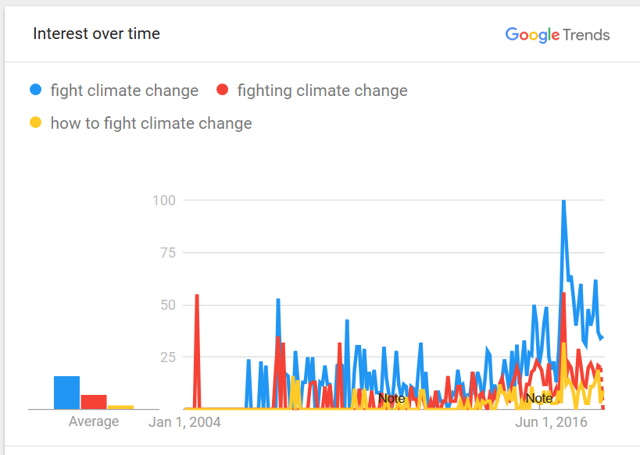
Based on this information, we believe that roughly [Bounty: 50 slices] amount of households, with moderate confidence, are “Activists”, and that that number is growing.

Behavior Hypothesis
We hypothesize that these people want to help fight climate change, but lack any actionable steps to do so. Because of the (perceived) financial barriers present in actually investing in carbon reducing measures, the remaining actions are:
- Fighting deniers
- Attending rallies
- Donating in small amounts to orgs who do this work.
Given a solution we believe the Activist would most want that solution to contribute as little to the carbon footprint as possible. They’d also want to know how much of a difference they’re making (and could make) - both directly and indirectly (by supporting us).

Lifecycle
Discovery: This would ideally occur via some “viral” campaign, or through a fellow activist.

Evaluation: Before purchase, the activist would want to know that they (or a relative) would be capable of setting such a system up. Additionally, the more aware breed of Activist will have to consider whether or not the system produces zero carbon, or at least is a net reduction in carbon.

Purchase: We anticipate they will purchase the product in quantities smaller than their DIY Survivalist counterparts, in accordance with their level of income.

Use: Naturally, the activist will want to display the product to demonstrate they’re making a difference and that others can, too. Their use could supplement our marketing strategy.

Bonding: As we report to the activist how much the work they’ve done is chipping in, and they hear of our partnership work with non-profits overseas, the connection should deepen as it becomes clear we really mean well.

Advocacy: Displaying the product in easy to spot locations, plus posting about their work with us online via social media .

Research Required
At this point, while we’ve talked to at least one individual in NC who might fall under this classification, it would be best to talk to a few more individuals via the Craigslist-Amazon-Gift-Card approach (ideally ones who self-identify as Environmental Activists) to really pin down this customer profile. Questions to follow up on:

- Do you feel unable to help fight climate change in any meaningful way?
- If there were a way, who would you tell about it? Would you try to rope them into it?
- Do you donate to environmental organizations and how much? Do you trust these orgs to use your money effectively?
- Did you know there’s carbon released in the creation of solar panels?

Phase 3
Projected Impact

Following our rollout plan, we’ll use an S-curve to plot out market adoption across customer segments in each region as we move forward. Looking at the current product life cycle of household appliances, one can find it takes about 12 years to reach 100% adoption (bloomberg). Modern technology has only accelerated this process, however we’ll take the 12 year figure in the interest of remaining conservative.
Additionally converted customers don’t persist, so we’ll take adoption to be non-cumulative. Therefore, adoption will look something like the following:

% Adoption | Time (in years)
2.50% | 4
13.50% | 6
34% | 8
34% | 10
16% | 12

With this in mind, we can proceed. Taking our research into account, let’s say that each DP converted powers their entire home, while each Activist converted purchases three units (this will come into play later when we introduce the 3 for 1 donation deal to spark growth).
Beginning with the NC beachhead markets. Even though NC over-indexes on DIY, taking the proportion of estimated DPers, we have about 4329 households there, contrasted with 20546 activist households

 | Y2 | Y4 | Y6 | Y8
Preppers | $281,517 | $1,563,983 | $8,445,507 | $21,270,166
Preppers | 98.2 | 545.58 | 2946.11 | 7419.83
Preppers | -0.05 | -0.3 | -1.63 | -4.11
Activists |  | $198,791 | $1,073,469 | $2,703,553
Activists |  | 69.35 | 374.47 | 943.1
Activists |  | -0.04 | -0.21 | -0.52
Clippers |  |  | $13,252,709 | $71,564,626
Clippers |  |  | 4623.04 | 24964.4
Clippers |  |  | -2.56 | -13.84
Total | $281,517 | $1,762,773 | $22,771,685 | $95,538,345
Total | 98.2 | 614.93 | 7943.62 | 33327.33
Total | -0.05 | -0.34 | -4.4 | -18.47

Green number is EDIBTA, yellow is kW installed, red is tons of carbon theoretically saved. Right now the amount that each prepper has to spend is a bit more than id like but we’ll refine that as we get a better picture of what our cost structure looks like. Extrapolating that to a USA rollout looks like the following:

 | Y4 | Y6 | Y8 | Y10
Preppers | $11,702,880 | $65,016,000 | $351,086,400 | $884,217,600
Preppers | 4082.4 | 22680 | 122472 | 308448
Preppers | -2.26 | -12.57 | -67.9 | -171.02
Activists |  | $8,263,883 | $44,624,970 | $112,388,812
Activists |  | 2882.75 | 15566.85 | 39205.4
Activists |  | -1.6 | -8.63 | -21.74
Clippers |  |  | $550,925,550 | $2,974,997,972
Clippers |  |  | 192183.33 | 1037789.99
Clippers |  |  | -106.56 | -575.4
Total | $11,702,880 | $73,279,883 | $946,636,920 | $3,971,604,384
Total | 4082.4 | 25562.75 | 330222.18 | 1385443.39
Total | -2.26 | -14.17 | -183.09 | -768.16

Mind you the green number is only revenue - if by that point we’re taking $7 per unit sold, that only amounts to $215m in accounting profits (profits not including worker salaries)

Cumulatively this would be talking almost a gigaton of carbon out of the air per year.

RN there’s 1Billion without power, and the UN’s trying to get universal access by 2030. The 3-to-1 wouldn’t finish that off but it would put a good dent in it: 12 million units or 12% of that goal could be met.

Phase 3
Anticipated Reactions
Bounty: See Table of Contents

SolarCity
Our most well-funded competitor, though they’ve been tackling the HOA market (only 30% of homeowners?) - our recent polls have shown individual homeowners are shifting away from how solar looks and towards how much it costs, which SolarCity doesn't seem to be mitigating. (Est. Price comparison - this is how much it would cost them to respond to us).

Executives

[TODO]

Anticipated Reaction

[TODO]

IKEA
Our most likely competitor. They’re in the same price range, have an eye for design, and know how to market themselves. I’m honestly a bit worried about IKEA. IKEA is the main reason we need IP protection, our actual offering will be what distinguishes us. I suppose there’s also the “reliability” factor, IKEA has a bit of a reputation for making throwaway furniture.

Executives

[TODO]

Anticipated Reactions

[TODO]

RenFactory
Out of dozens we looked at, our closest competitor - http://www.renfactory.com/products/finished-products/solaris-pop/.

Thankfully they’re a) based in Europe (though still a challenge if we want to go international) and b) don’t appear to have the software chops on hand to compete.

Executives

[TODO]

Anticipated Reactions

[TODO]

Runner up; PLX devices.

Lawmakers
Considering the current political climate, we’re starting to see not only solar tariffs being imposed on foreign exports (see: the Suniva decision) but net metering being rolled back in certain areas. Thankfully, the modular nature of our solution helps us to remain adaptable abreast of any policy changes. First of all, there’s the ability to leverage activists in areas where the changes start to clearly favor current lobbyists, but we can swap out units for better units with more battery so they can last longer on their own, without having to sell their elec. At manufacturing rates. Additionally if the 30% rebate is lifted we can count on Swanson’s law to keep the cost even and down.

Advisors

Note: None of these are presently confirmed.

Jeffrey LaCosse, PhD  Email:  Number: | 

Sed fermentum ligula in ante congue venenatis. Vestibulum lobortis eu nibh at fringilla. Nunc quis varius enim, a sagittis mauris. Aenean lobortis consequat diam, at iaculis lorem pellentesque porta. Nam sed semper justo, vitae varius risus. Suspendisse potenti. Sed vitae dolor odio. Aliquam erat volutpat. Morbi dapibus, purus sed lacinia sollicitudin, enim erat sodales enim, eu lacinia magna purus ac diam. Donec tincidunt neque rhoncus, porta erat a, blandit ex. Donec varius lacinia orci, id ornare turpis mollis ut. Maecenas volutpat tortor quam, a rhoncus augue eleifend ac.

Khurram Nasir-Gore

Email:
Number:

Sed fermentum ligula in ante congue venenatis. Vestibulum lobortis eu nibh at fringilla. Nunc quis varius enim, a sagittis mauris. Aenean lobortis consequat diam, at iaculis lorem pellentesque porta. Nam sed semper justo, vitae varius risus. Suspendisse potenti. Sed vitae dolor odio. Aliquam erat volutpat. Morbi dapibus, purus sed lacinia sollicitudin, enim erat sodales enim, eu lacinia magna purus ac diam. Donec tincidunt neque rhoncus, porta erat a, blandit ex. Donec varius lacinia orci, id ornare turpis mollis ut. Maecenas volutpat tortor quam, a rhoncus augue eleifend ac.

Rodney Otadoy,

Email:
Number:

Sed fermentum ligula in ante congue venenatis. Vestibulum lobortis eu nibh at fringilla. Nunc quis varius enim, a sagittis mauris. Aenean lobortis consequat diam, at iaculis lorem pellentesque porta. Nam sed semper justo, vitae varius risus. Suspendisse potenti. Sed vitae dolor odio. Aliquam erat volutpat. Morbi dapibus, purus sed lacinia sollicitudin, enim erat sodales enim, eu lacinia magna purus ac diam. Donec tincidunt neque rhoncus, porta erat a, blandit ex. Donec varius lacinia orci, id ornare turpis mollis ut. Maecenas volutpat tortor quam, a rhoncus augue eleifend ac.

Niyati Shah,

Email:
Number:

Sed fermentum ligula in ante congue venenatis. Vestibulum lobortis eu nibh at fringilla. Nunc quis varius enim, a sagittis mauris. Aenean lobortis consequat diam, at iaculis lorem pellentesque porta. Nam sed semper justo, vitae varius risus. Suspendisse potenti. Sed vitae dolor odio. Aliquam erat volutpat. Morbi dapibus, purus sed lacinia sollicitudin, enim erat sodales enim, eu lacinia magna purus ac diam. Donec tincidunt neque rhoncus, porta erat a, blandit ex. Donec varius lacinia orci, id ornare turpis mollis ut. Maecenas volutpat tortor quam, a rhoncus augue eleifend ac.

Michael Szeremi,

Email:
Number:

Sed fermentum ligula in ante congue venenatis. Vestibulum lobortis eu nibh at fringilla. Nunc quis varius enim, a sagittis mauris. Aenean lobortis consequat diam, at iaculis lorem pellentesque porta. Nam sed semper justo, vitae varius risus. Suspendisse potenti. Sed vitae dolor odio. Aliquam erat volutpat. Morbi dapibus, purus sed lacinia sollicitudin, enim erat sodales enim, eu lacinia magna purus ac diam. Donec tincidunt neque rhoncus, porta erat a, blandit ex. Donec varius lacinia orci, id ornare turpis mollis ut. Maecenas volutpat tortor quam, a rhoncus augue eleifend ac.

Design Gallery

Makesun
Makesun was our longest-running design concept. At present we’re looking to move on from it for two reasons: lack of brand extensibility and focus on pseudo DIY over true DIY for more mass-market appeal.
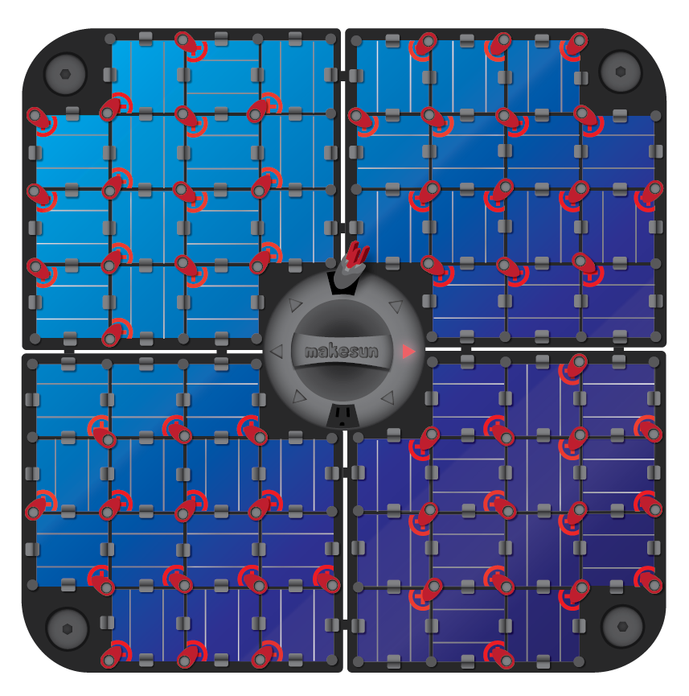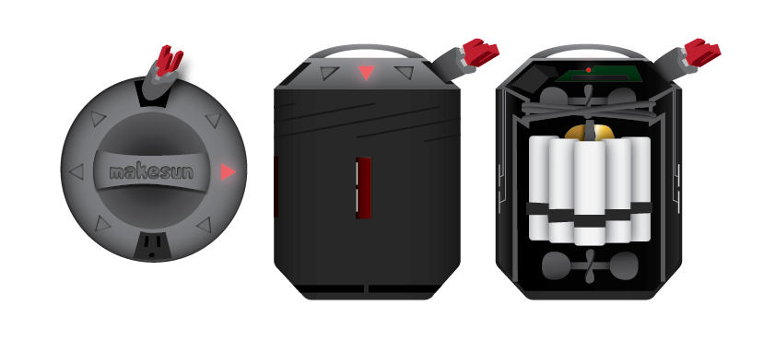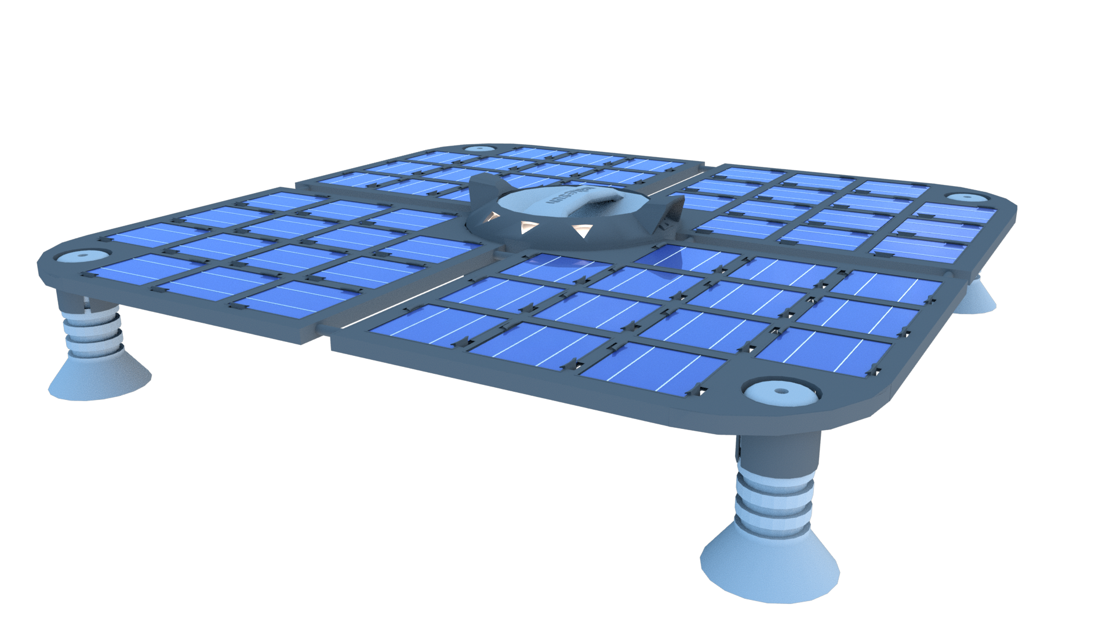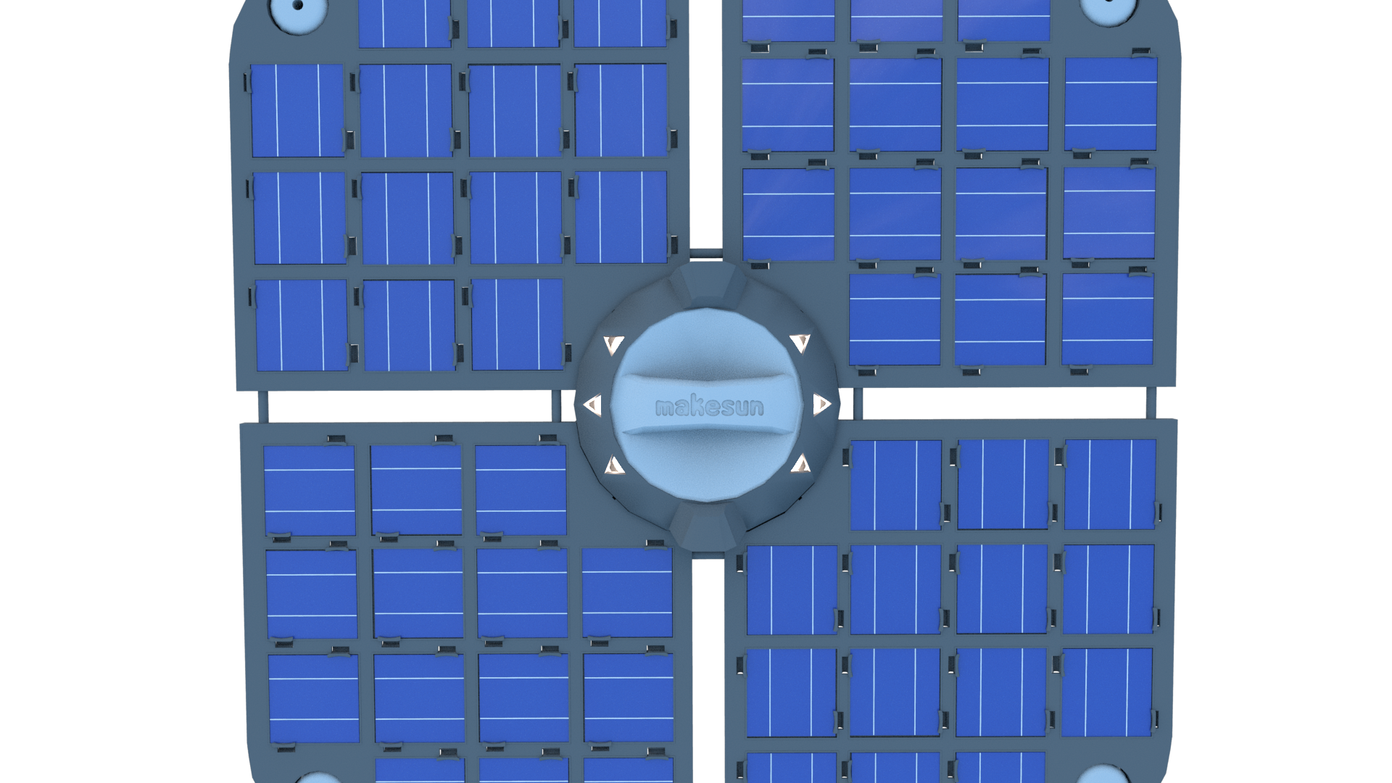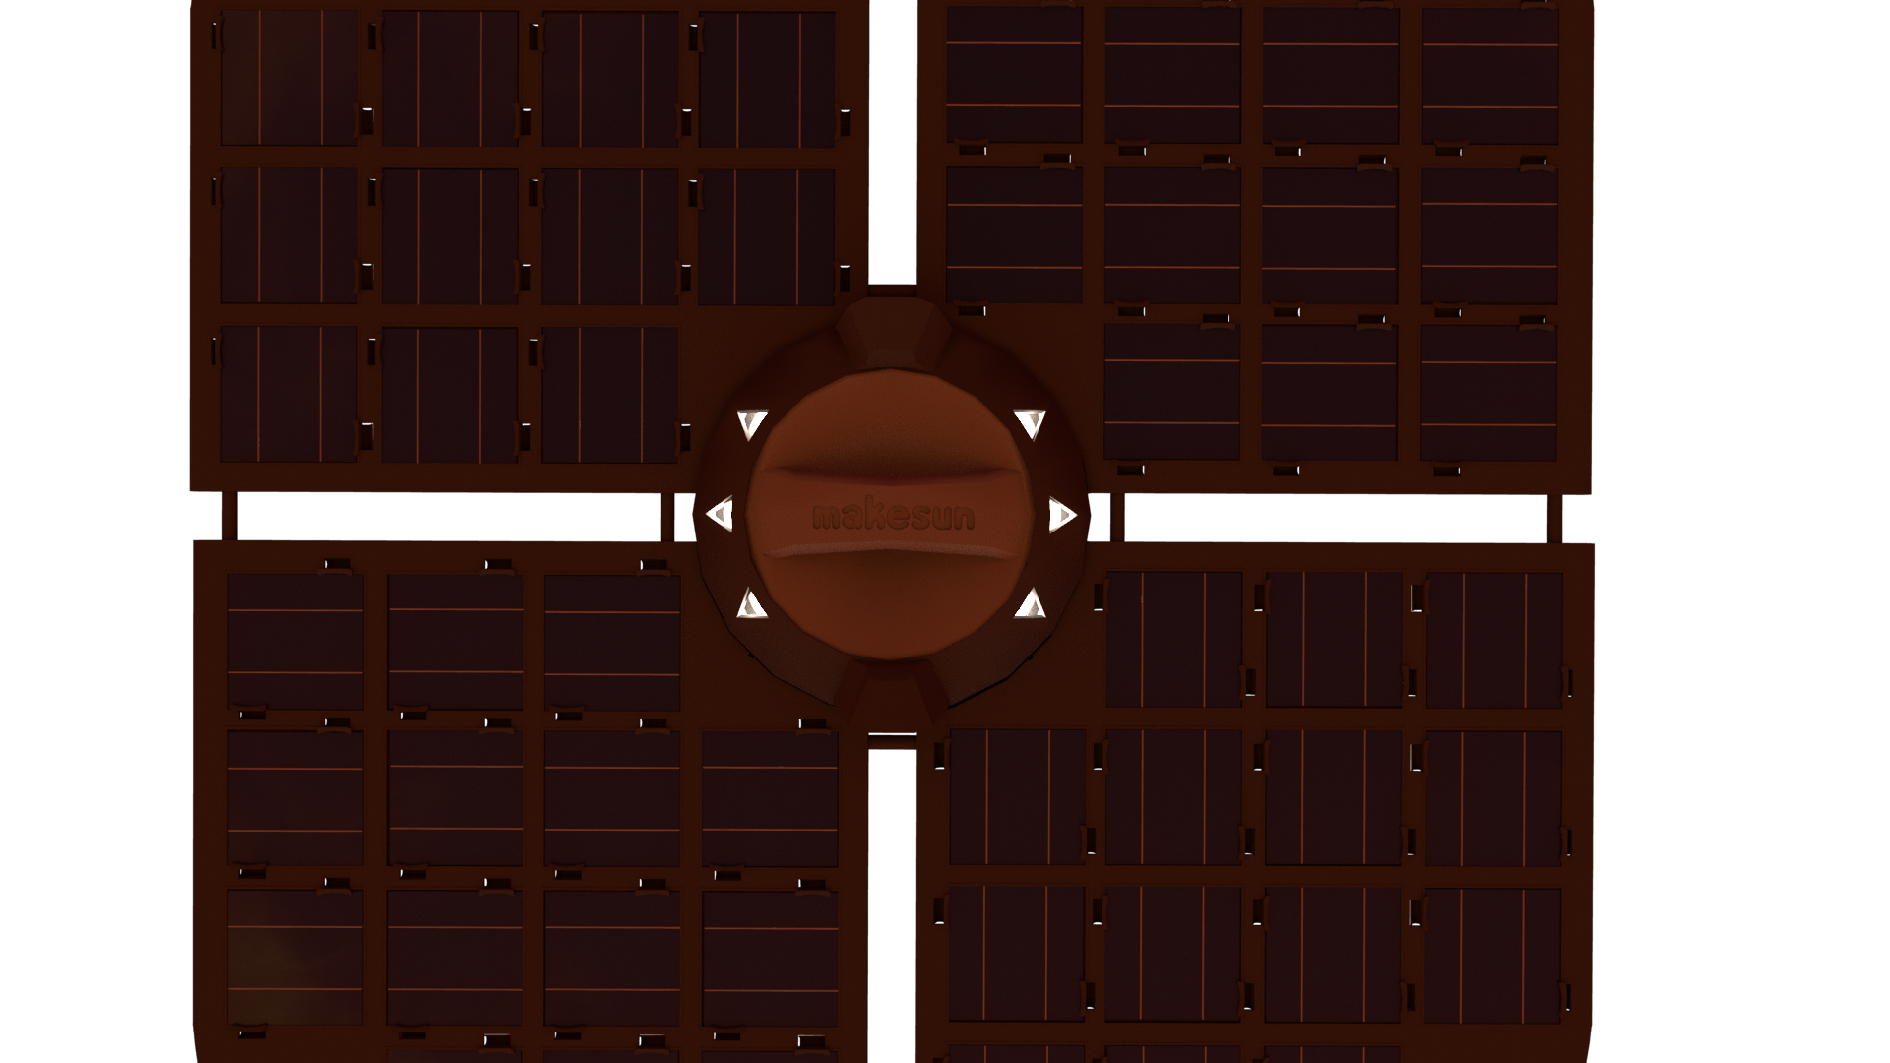
Greenscale Labs
Greenscale Labs was one of the first attempts at breaking away from the makesun concept.


RHex
RHex is our most recent breakaway attempt.



Technical Breakdown
Component Cost Analysis

Economies of scale dictate that as we are manufacturing more units, the individual cost of each individual unit will go down. Additionally, according to Swanson’s law, the cost of PV is only getting cheaper, and at a predictable clip. It’s our mission to leverage these facts and reinvest those increasing savings further and further into our mission statement and eventually backwards integrate into carbon independence. Below we’ve done an in depth analysis of the main components we’ll be ordering at first, the kinds of each, and a pricing breakdown to drive our rationale.

Batteries
The priciest and yet most impactful part of our offering. Based on some initial analysis, the cost per watt comes to the following:

Units produced | Drone | LiPO4 | Mobile
10000 | $0.24 | $0.48 | $0.88
100000 | $0.15 | $0.47 | $0.87
1000000 | Bounty: 20 slices | Bounty: 20 slices | Bounty: 20 slices

Drone Batteries: Li batteries designed for impact and dangerous situations - traditional Li batteries don’t really cut it.

LiPO4 Batteries: A new, emerging technology safe enough to be used in cars - the safest of all the kinds mentioned here, yet retaining the energy density of more traditional lithium ion batteries. It has about 4x the lifetime of those batteries as well!

Mobile Batteries: High-quality Li batteries used in mobile phones. Have the longest lifetime, purportedly.

Solar Cells Bounty: 1,000 slices
Microcontroller/Breakout Board Bounty: 1,000 slices
Housing Material Bounty: 1,000 slices

Technical Breakdown
Nanoinverters [BLOCKED]
Bounty: See Table of Contents

Inverters convert dc to ac

Microinverters have a microcontroller for making sure the phase of the ac aligns with the phase of the grid

The smallest that are made are by enphase

We need the same microcontroller but with a smaller relay and transformer - probably won’t save a whole lot. But we’ll also install extra firmware on the controller for the leader-follower stuff

Technical Breakdown
Firmware

Software languages come in two major flavors - languages optimized for execution time (the actual time it takes to execute a piece of code) and developer time (the time it takes for a developer to write that code). Our initial firmware concept will be written in the IoT framework JohnnyFive with TypeScript, which will optimize for developer time - our personal philosophy is to tend towards development time in most cases and address execution time problems as they arise.
This allows us to keep our developers productive, abreast of technical debt, and as high-impact as possible. Additionally, much of our stack will be written in TypeScript, which will keep common code highly reusable. As performance problems do arise in the firmware, it then makes sense to breakout into C/C++.

Firmware requirements
Principally it will be the firmware’s job to assign roles to each Hex unit. This will be done at first via a forked version of the MIT License consensus protocol majority.js; effectively, each Hex will cast votes on which of its neighbors should take a particular role. Roles have certain tasks/commands they’re meant to complete; these tasks are stored in a queue on each device. If no neighbor is a viable candidate, no votes are cast by that Hex. At present there are two roles: the Leader and the Sentry.

Hex Cohort Leader
There should only be one Leader per Hex group. Typically the Hex with the strongest WiFi signal or who has the direct line to the wall outlet should be chosen. It’s this Hex’s job to communicate with the server and propagate commands from the central server to the rest of the cohort.

Command Examples:
- SYNC - broadcasts the current phase of the AC to the cohort
- SELL - commands the cohort (or sub-cohort) to dump their stored electricity into the grid
- BUY - commands the cohort/sub-cohort to charge their batteries
- INVALIDATE - invalidates a hex unit as offline. This hex is no longer to be voted for.

Hex Cohort Sentry
A leader can also be a sentry. You need as many sentries as are “overflow states” in the system.
Elect hex with fewest neighbors, also furthest from one another. Also ones that have an empty task queue. Draw sub-cohort boundaries via voronoi cell.
The sentries will compile and sanitize data in real time (as tasks), then send reports in sub-realtime to the leader to be broadcast to the server.

Hex Follower
Regardless of role, each Hex will stream wattage and voting data to its corresponding sentry in real time. Realtime voting implies that roles are constantly changing. If the follower was recently a leader or sentry, flush the task queue.

Fault Tolerance
This need for constant communication to ensure true modularity (so that any Hex can be removed at any point and the system can continue to operate) is what drove us to choose the honeycomb pattern. In this pattern, it’s true that any two adjacent units will always be fully touching:

X
X
✓
✓

You might think you could cut the corners of the squares to add some contact area, but that results in the following pattern…

gap

...which would then require some sort of peg or medium to facilitate corner-to-corner communication.

Technical Breakdown
Server-Side Orchestrator

The server side, centralized computer will be concerned with a few tasks:
- Orchestrating strategic energy arbitrage.
- Ingesting Weather Forecast APIs to intelligently enhance said arbitrage.
- Incorporating a dditional factors into when power is rolled out: “Time of Sale”, residential circuit load, etc.
- Conducting consumer level A/B deployment tests.
- Troubleshooting.

Arbitrage
Arbitrage signals - rather, the need for arbitrage to occur - will come probably externally at first, then internally as we scale up. Initially it makes the most sense to just sell supply at peak demand prices (generally during the night), but that’s the naive approach.
When and if we begin to partner with local Utilities (e.g. Duke Power) they can lean on us for support when their systems are unbalanced or under heavy load in exchange for official support, grid mapping (GIS), and lobbying power. This is a particularly spikey problem in NC, we’ve been advised. They told about the unique logistical nightmare they had to deal with during the most recent eclipse.
Once at a certain degree of market penetration, it becomes important that we cover our own tracks from a DERMS perspective. One mechanism proposed: two or more HEX systems on opposite ends of the same local grid exchange power back and forth, dropping a little energy back into the system each time. This allows us to avoid reverse power flow and hold onto generated supply for longer (so that it lasts until peak evening prices).

Weather
Various events reduce solar irradiance temporarily. Clouds by 80-90% (according to Musk). Solar eclipses/obstructions reduce irradiance sharply and almost down to 0. By consuming APIs such as the AccuWeather Enterprise API we can estimate, day to day, the remaining expected total solar radiation and send commands to Leader units on whether to buy, sell or hold accordingly.

Additional Sale Factors
The wholesale and retail price of solar fluctuates from hour to hour (you can see the current wholesale price of electricity in your area with this ticker.) In several states, this “time of sale” does matter and is tracked by your meter. Leveraging this, we can look at pricing trends to suss out the best time four to our units charge themselves from the wall outlet or spit their charge back out again.
An additional factor: Most US circuits have a limited amperage of 15-20 amps. We can detect the amount of load currently on the circuit - however what we don’t know is the limits of whichever circuit and it’s up to our customers to inform us, otherwise we’ll have to assume the worst and leave sufficient overhead in case a high-amperage appliance turns on (like a blender). Most temporaneous appliances don’t exceed 7 amps of draw, so assuming a limit of 8 amps minus standard draw (with no other information) seems safe. This still allows for an entire kilowatt array to operate on one circuit and most homes have several; however, should we begin to dangerously approach too many units on the same circuit the server will begin to take those connected units offline and only use them for arbitrage.

A/B Testing
Now, if a unit is offline or getting particularly low power it’s usually going to be due to poor placement. The setup process should initially encourage users to put different units on different circuits. Then we can start to get an idea of the house - which sockets are on the same circuit, which are the most shaded. Once the server has gathered enough data it can single out 2 or 3 circuits that are optimal and the user can concentrate those units if they want to get the most out of their system. In effect this is a sort of rudimentary A/B testing process.

Troubleshooting
Finally, things will go wrong. In this process the server should be able to determine the following scenarios based on the raw data provided by leader panels:

- If one cluster is getting a lot more per unit than another
- If a unit is making less than its neighbors consistently
- If a “wave” of lower power goes over some units (shadow)
- If a unit is disconnected unexpectedly (useful for security)

In the event of one of these failures, the server will send a push notification to the user and then walk them through a troubleshooting process. Ideally a blinker will exist on each unit that the server can trigger so that the user knows which panel is which.

Glossary of Terms
2°C Target
The Copenhagen Agreement - an Accord come to by the United Nations in 2009 - states that it recognizes "the scientific view that the increase in global temperature should be below 2 degrees Celsius". The Agreement strives to meet this challenge.

DC-DC Optimizer
An electronic circuit or electromechanical device that converts a source of direct current (DC) from one voltage level to another.

Deep Cycle Rule
Starter batteries (e.g. most automotive batteries) are designed to deliver short, high-current bursts for cranking the engine, thus frequently discharging only a small part of their capacity. Using only half these battery’s stored charge extends their lifespan considerably.

DERMS
A “Distributed Energy Resource Management System” - a piece of software for managing the flow and safe distribution of electrical sources to their respective consumers.

Electrolysis
A technique that uses a direct electric current (DC) to drive an otherwise non-spontaneous chemical reaction. Can be used to turn water into fuel cells for long-term energy storage.

GIS Bounty: 20 slices
Geographic Information Systems Grid ??? - The map of the local electrical grid.

Guarantee of Origin
An EU policy in which an electric utility must certify that the electricity provided to the consumer comes from where the utility says it does.

LCOE
The “Levelized Cost of Electricity” - an economic assessment of the average total cost to build and operate a power-generating asset over its lifetime divided by the total energy output of the asset over that lifetime.

The “Merit-Order Effect”
A way of ranking available sources of energy, especially electrical generation, based on ascending order of price.

MMBtu
A traditional unit of heat; it is defined as the amount of heat required to raise the temperature of one pound of water by one degree Fahrenheit. Stands for “British Thermal Unit”.

Net Metering
A US policy by which the consumer is only charged by their net meter reading - effectively allowing the consumer to sell generated electricity back to the utility at retail, rather than wholesale, rates through the grid.

Offshore Wind
Refers to specifically to wind farms that reside on the ocean, where there’s more wind. Effective where the increased cost of transmission is offset by the production added.

PMU
Phasor Measurement Unit - a device which measures the electrical waves on an electricity grid using a common time source for synchronization.

PPA
A “Power Purchase Agreement” - a contract between landowner and utility where the landowner still owns the land, but not the power-generating asset, and in exchange, the utility sells power to the landowner at a reduced rate.

PV Cell
An electrical device that converts the energy of light directly into electricity by the photovoltaic effect.

REC
Renewable Energy Corporation - A company in the Renewable Energy space.

RPF
Reverse Power Flow - a phenomenon that occurs in an unbalanced electrical grid whereby the intended flow of electricity begins to reverse, causing considerable damage to the system.

Safety Codes
A concatenation of Building, Fire, and Electrical codes - locally enforced measures in the US that facilitate safe construction.

Socket Parity
A condition that, when met, states that the LCOE of a BTM system is on par with all non-renewable alternatives.

Swanson’s Law
Similar to Moore’s Law - states that the cost of photovoltaic cells will halve roughly every two years.

Thin Film
A second generation solar cell that is made by depositing one or more thin layers of photovoltaic material on a substrate. Film thickness varies from a few nanometers (nm) to tens of micrometers.

Time-of-Sale System
A more sophisticated electrical market that, through next-generation metering devices, respect the current price of electricity at time of sale when the consumer is reimbursed.

