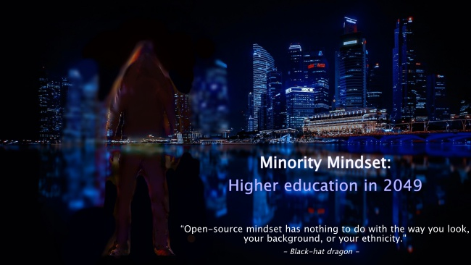

Minority Mindset:
Higher education in 2049

It is the year 2049 and this future world is known as the Decentralized era. In this world, the new technology was created specifically to break paradigms and connect everyone. We live in a “smart world” where the Internet of Things (IoT) changed the way we live.

Satoshi Nakamoto is the name of the secret society that believed that a world without government would be better. That’s why they created Bitcoin, which is the cryptocurrency that everyone uses and the government can’t control it. These cypherpunks re-architected the way people interact with each other. Their ideas are now a reality because now people can protect themselves and their interests without interference from the Government using strong online privacy and cryptography. These cyberpunks made the networks safer for privacy and its unhackable and decentralized technology rules our world, which is called blockchain technology.
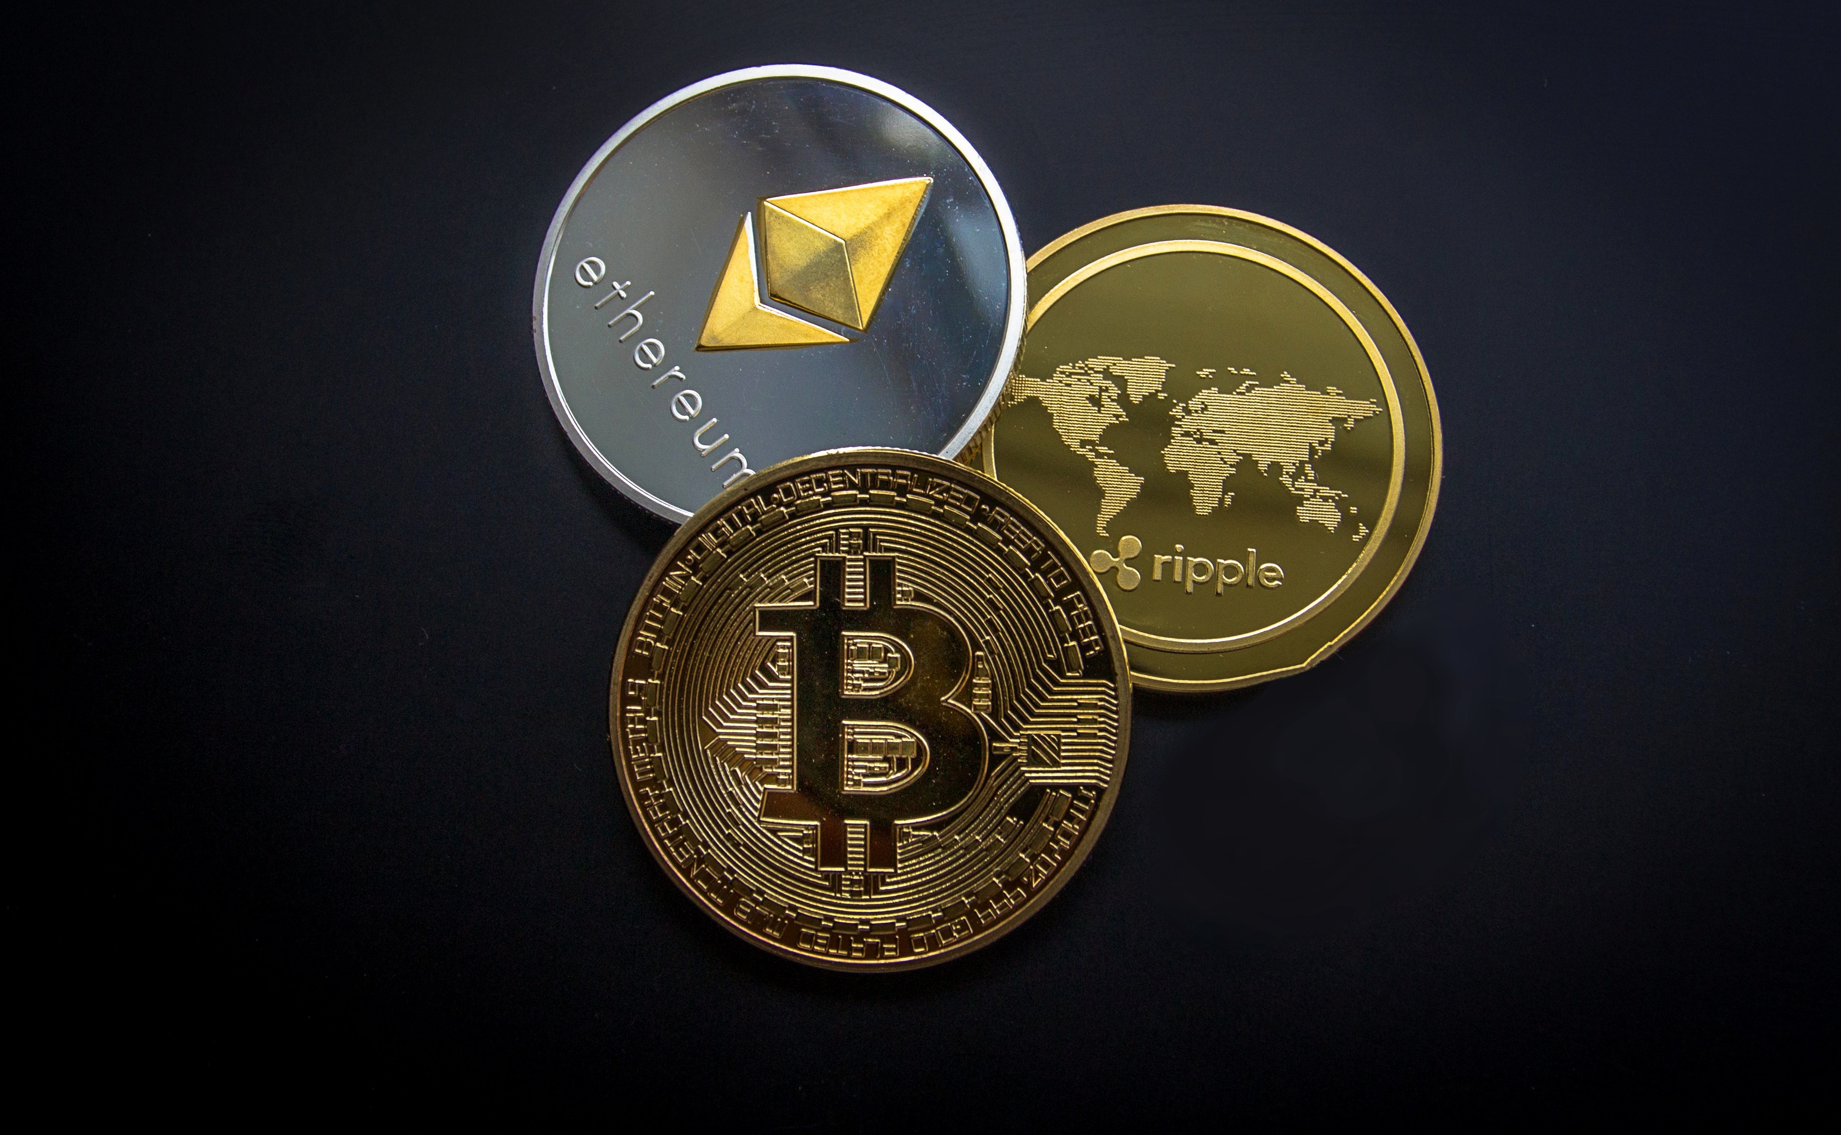
Now, we live in a world where every system uses blockchain technology. Bitcoin is our cryptocurrency that we use to buy everything without worrying that the government rules our money. Blockchain is a distributed ledger technology, which means that it has a digital ledger that records transactions. In fact, there are millions of computers that have a copy of the blockchain and the function of each computer is to solve "complex algorithms" to validate a transaction, which is in a block with other transactions. In fact, each block is linked to the previous block, and that’s why it’s called blockchain. So, this technology is unhackable because it’s impossible to hack millions of computers at the same time.

The blockchain technology rules our world. I mean, it is used blockchain technology for everything. The big corporations are using blockchain for tracking their products in the supply chain. Hospitals are using blockchain to store health’s information of their patients. Even the government is using blockchain. Yeah, removing the government from the picture was the reason this technology was created, and now they are using it in their systems. Funny, isn’t it?

In this smart world, we are all connected, but our personal data is stored in the blockchain. In my smart city, we have the Internet of Things (IoT). This means that we are able to control (with our cell phones) the computers, electronic devices, cars, home appliances, and much more. So, we are able to control every electronic device using our cell phone or we can ask our personal bot to do it for us. The self-driving cars can take you wherever you want. Since everyone has a self-driving car there are no car accidents. Isn't that amazing?

In this new era, young people like me go to the smart universities, which are using blockchain for many different things and uses high-end tech as well. These smart schools use deep-learning system to detect if you are a student or not, recognize harm actions, detect if there is anything off, and so on. In fact, my father owns a smart university. He told me that blockchain technology changed the way universities works. First, blockchain is used to authenticate the university diploma itself. So, companies that want to hire someone could check if he/she has its diploma in the blockchain. Second, blockchain and cryptocurrency are used in the universities for their administrative system. Third, blockchain is used to store information on a private blockchain. Fourth, blockchain is used to store student's homework and exams in order to prevent plagiarism. The information is stored permanently on the blockchain, and it is deep learning technology to find out if someone cheated on homework assignments or exams. Fifth, blockchain technology is used to store grades and another student’s information in order to prevent to be hacked because once it is on the blockchain it can’t be changed or removed.

I go to a smart university, which it has different crews. First, we have the blockchain crew that tries to hack the system. Second, the deep-learning crew that tries to fool the system with its super-smart technology. Third, the augmented-reality crew; it seems that they live in another world. Fourth, the game crew that plays games all the time. Fifth, the divergent crew.

Let me explain you. First, the blockchain crew knows everything about blockchain and they know how to “hack” the system with their smart bots that fool the system.

Second, the deep-learning (DL) crew. This group is full of rich kids that have the best high-end DL technology that their fathers can buy them. Actually, I’m the leader of this DL crew. Everyone calls me the black-hat dragon. Why? That's something I will never tell you. We have these AI bots that do the homework for us. These AI bots are able to create original stories, solve complex math problems on their own, create original art, make our homework, translate our homework, and even make jokes. We always have good grades because our deep learning gadgets made our homework.

Meanwhile, other kids have normal deep-learning gadgets that help them with their homework. These normal gadgets are able to “explain” many things such as math, literature, science, physics and so on. These AI bots are like our own personal teachers. The normal gadgets can be used to create stories or art. These AI bot can translate our homework better than “Google translate”. The same happens with the homework, if we try to use this technology to do the homework for us, it won’t be 100% original. So, another deep learning system could detect that our homework is a "copy" of others. In fact, my smart university uses chatbots to give school information. So, you can ask a chatbot anything about the school and it will respond you.

Furthermore, there are many guys that have self-driving cars that use deep learning technology. The public transportation uses this technology for autonomous driving too.

The writing/reading learners and auditory learners use DL technology to learn better. For example, you can ask a question about your homework and the chatbot could explain it to you.

Third, there is the augmented reality (AR) crew. This crew lives in another world. They basically use this technology for everything. I mean they are very visual people that learn better using this technology. If it wasn’t for this technology, I think they could fail school. They use their AR glasses to visualize the concepts that they see in class. For example, a medical student can use augmented reality technology to visualize a human-body model in order to learn human anatomy. Another example, it’s that a student could use AR technology to visualize a physics problem, and that would help him to resolve it.
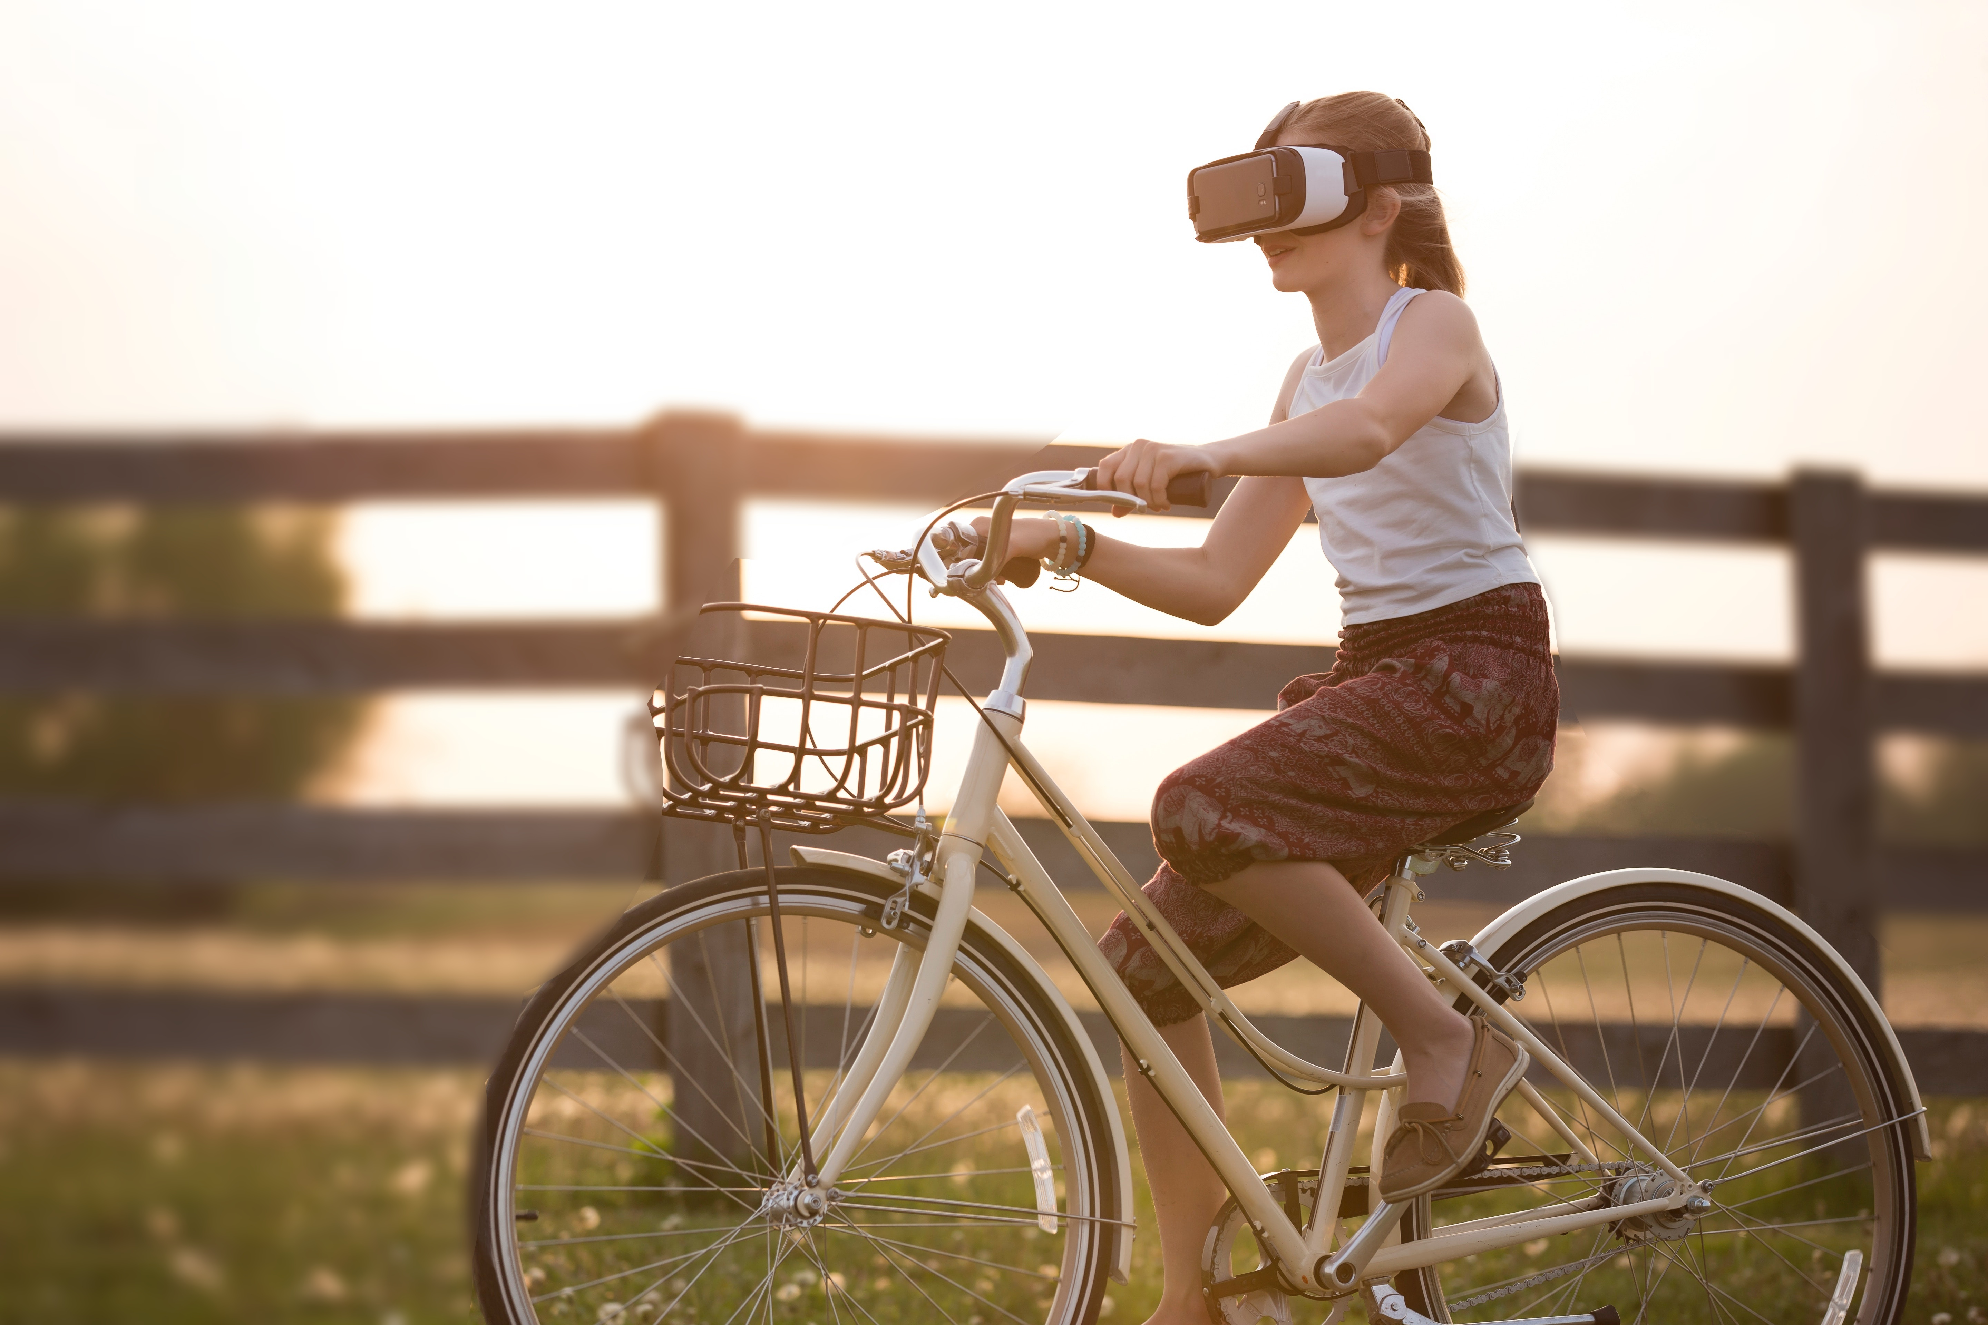

The AR crew doesn’t even bother to come to school. They use they AR glasses and their mixed reality rooms in their homes to simulate that they are in the classroom with the other students. There are even international students that are not here in the school, they are in their own countries using AR glasses and mixed reality rooms to takes classes. So, using this technology, they are able to “see” in real time their teachers and classmates, while they are in their homes or its own schools. This technology helps them to learn better because they can watch how the teacher explains the class in real-time, and they are able to participate in class in real-time.

So, the visual and kinesthetic learners use AR technology to learn better using this technology. The kinesthetic learners can move while they are learning and that helps them to learn better instead of being sitting all the time.

There is the game crew. This crew is playing all the time, even in class, they are playing. They use "gamification" to learn something while they are playing a game. For example, if they are learning about computer programming. They would have a "game" for learning a computer language. At each level of this game, they learn something new about this computer language and they need to code something to pass a level.

There is the divergent crew. These guys mix technology, as they want. For example, they can use gamification and mixed reality together to create the best educational games. Can you imagine that? Using a mixed reality game of robots for your robotics class.

So, the kinesthetic learners use the gamification technology and augmented reality to learn better.

Finally, there is the divergent crew. They mix technology for their classes. For example, they use 3D printing for creating their prototypes for their mechatronic classes.

The divergent crew has access to their own AutoML, which is a machine learning system that creates another machine learning systems. This thing is able to learn on its own without any human supervision. Schools are using AutoML to create a personal “tutor bot”. A tutor bot is like a combination of tutor and school counselor. So, this bot can learn everything about a student in order to guide him in their student career, teach him, learn about anything to teach a student, communicate with the student, and being his or her personal assistant. This means that a tutor bot is able to optimize student’s curriculum.

So, deep learning is used to create the perfect path for each student. This means that the next Tesla won’t spend more time on gym classes.

These tutor bots are crazy gadgets. In fact, these bots understand our slang because they are using advanced natural language processing algorithms. Indeed, these bots have their own language that they developed by their own and the humans can’t understand it. But, these bots don’t only understand out slang, they understand our emotions because they use emotion AI.

So, a tutor bot is like a personal assistant that knows everything and guide you to success based on your personal data. But not everyone has one because they are expensive. In fact, not everyone can afford a tutor bot or even a doctor bot, which are better than human doctors.

As you can imagine, the educators are using deep learning to optimize curriculum, predict remedial steps for every student, and improve the methods of teaching. Deep learning bots can predict the journey of each student and suggest an academic journey that would best cater to his or her interest and strengths.

For example, deep learning is used to find the best career, courses, learning opportunities, and activities for each student. In the case of educators, they are using deep learning to find the best way to guide and teach each student, so this deep learning system uses the information of each student and other student’s information as well to find the best options that best cater to their strengths and interests.

Artificial Intelligence (AI) changed the way the students and teachers interact. Mixed technology changed the way virtual students take classes. They just have to use their AR glasses and a mixed reality room to come to classes and interact with the actual students. In the case of actual students, they don't take extra classes with its professors anymore; instead, it is used a tutor bot that is able to explain the homework.

Furthermore, our homework is stored in the blockchain (to avoid plagiarism). So, our professors must use the blockchain to check our homework and run a deep learning app to check if we copy our homework.

But not only our homework is in the blockchain, the classroom resources are stored in the blockchain too. We must query every assignment and classroom resource in the blockchain.

In this smart university, there are many students including virtual students. In this era, there are more virtual students in school from other countries than actual students. Blockchain technology and Satoshi Nakamoto’s philosophy really changed our world and our economy. Not only the education is available for every person in the world, the tuition doesn't change every year due to an economic crisis. This means that every person is able to afford the smart university that they want.

In this era, Blockchain and deep learning technology are used to prevent plagiarism, so we must do our own homework. So, the educators evaluate our homework and capstone projects based on our answers, logic, creativity and the way we solve problems. In many classes, the capstone projects weight more than the homework assignments and exams.

In this decentralized era, the curriculum of each career has tech classes. For example, my friend L.C. is a medical student; she takes medical classes along with her robotics and AI classes. Nowadays, robots make surgeries because they are better than humans. Furthermore, there are “doctor bots”, which are bots that diagnose ill people using deep learning technology. Indeed, L.C. takes robotics, tech, and AI classes.

Another example is my friend Tyler, who is a marketing student. He uses deep learning to find the best models that minimize costs. Furthermore, he uses automation tools for its campaigns. Indeed, bots and chatbots are used in marketing for client service. So, he takes tech and deep learning classes.

A most interesting example is my friend Stanley, who is an artist. He uses blockchain technology to store his artwork in the blockchain. Indeed, he writes his own smart contracts scripts to sell his art. In fact, he creates art using Deep art, which is deep learning technology that is able to learn the style of artists. For example, it can be used deep learning to copy Picasso’s style and change photos to look like a Picasso painting. In addition, it can be used Deep art to create an original artwork. However, he takes tech, programming, and blockchain classes.

In fact, there are many artists that use deep learning tools (including natural language processing tools) to create new art like original songs, poetry, tv scripts, novels, music, and so much more.

Another example is my friend Elle, who is a weird lawyer student that always says that "the law is reason, free from passion". In this decentralized era, lawyers write and use smart contracts for everything; these smart contracts are scripts written in a programming language that are used to transfer digital assets such as digital properties, cryptocurrency, and so much more. So, a lawyer must know how to code a smart contract and know a lot of techs because we have a blockchain-based economic system. It means that she took a lot of techs, programming, and blockchain classes.

In fact, robots are used everywhere from healthcare to construction. So, many engineers and medical students take robotic classes. Furthermore, just because Blockchain technology is used everywhere and we use smart contracts on the daily basis; we take programming and tech classes. The same happens with AI and deep learning technology; most of us take deep learning classes to create applications for our jobs.

Satoshi Nakamoto’s philosophy doesn't only remove the banks and government from our economic system, it removed the old mindset that only privileged people could have access to a higher education.

The Satoshi Nakamoto’s society had an “open-source mindset”. They write code because they know that they have to do it by themselves because no one else is going to do it for them. Their code, knowledge, and philosophy are free for all to use, worldwide. They don’t care if someone doesn't like what they write. They know that software can’t be destroyed and that a widely dispersed system can’t be shut down.

Many cypherpunks and tech guys follow the “open-source mindset”, and many of them are Professors in many universities around the world. They are true believers that the "open-source mindset" has nothing to do with the way you look, your background, or your ethnicity. It's a mindset. So, they give their knowledge, expertise, and philosophy for free. They offer virtual classes for free. They changed the higher education.

Nowadays, everyone can access to a higher education because Satoshi Nakamoto changed our economy and our mindset. We live in a world with equity rights. If someone can't afford a higher education, he or she must receive aid for it. We live in a world without an economic crisis. We live in a world with a better mindset.

