SA-LED and WWF Growing Future Environmental Leaders
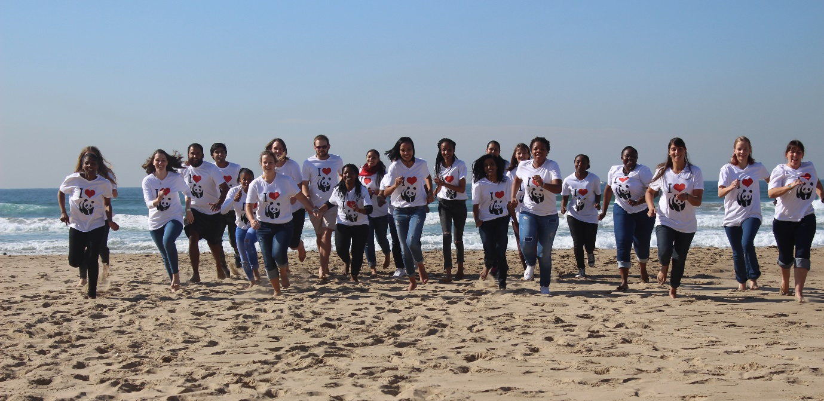
Graduate interns in WWF’s Environmental Leaders Programme at a career development workshop in Durban held in June 2017. Credit: WWF-SA

South Africa –Low Emissions Development Programme (SA-LED), in partnership with the World Wide Fund for Nature South Africa (WWF-SA), is providing aspiring post graduates an opportunity to network and learn about careers for the environment. This was accelerated at recent workshops held at the start of the 12-month WWF internship programme.

Recognizing the lack of awareness amongst graduates around the nature and scope of green jobs in South Africa, WWF-SA provides a bridging opportunity for post graduates through its Environmental Leaders Graduate Internship Programme. The internship provides budding future leaders with a platform to launch and grow their green careers, but more importantly, promote green growth in South Africa.

As part of this programme, SA-LED is hosting one of the 50 WWF interns from the Environmental Leader Graduate Internship s Programme who will be working with the team on a variety of LED projects. SA-LED also funded the two career development workshops taking place in Cape Town and Durban for the interns involved in the programme. These workshops provide aspiring Ecologists, Taxonomists, Environmental Economists, Green Urban and Regional Planners and Environmental Engineers, to name but a few, with an opportunity to engage in a networking and career development learning space. These workshops expose them to what respective organizations are doing to support sustainable growth in South Africa as well as encouraging them to find their own career niche in contributing to sustainable development.

Interns from 10 universities in the country are employed by 18 organisations, all with an environmental focus, where they are each supervised by a dedicated and trained mentor. Through this programme and mentorship, interns receive practical workplace-based experience to grow and develop their technical, professional and leadership capabilities. Several interns commented on how they were struggling to find jobs and this internship has given them the opportunity to network and learn from experienced professionals.
“Interns get the opportunity to learn about careers in their respective fields of study and network with key professionals in career fields of their choice. This significantly opens up opportunities for these new graduates to access and enter into the world of working for the environment,” says Dr Glenda Raven, Senior Manager of WWF’s Environmental Leaders Programme.

While attending the Cape Town workshop in Pringle Bay, one intern remarked, “I feel so hopeful and it is so encouraging to see how much work is being done by my peers to create a more sustainable environment. We are all doing something so meaningful.”
Another intern observed the importance in the overlap of work everyone is doing, “the introductions we are having now makes collaboration truly possible.”
SA-LED is committed to promoting green growth in South Africa and this includes providing aspiring young graduates studying in the field of sciences an opportunity to grow their careers and learn how to protect the environment in which we live. Not only does this help grow the green economy in South Africa, aspiring graduates learn practical ways to promote sustainability in the careers they have chosen to pursue.

Written by Anabel Tennassie-Goossens
USAID SA-LED Program
14 June 2017

