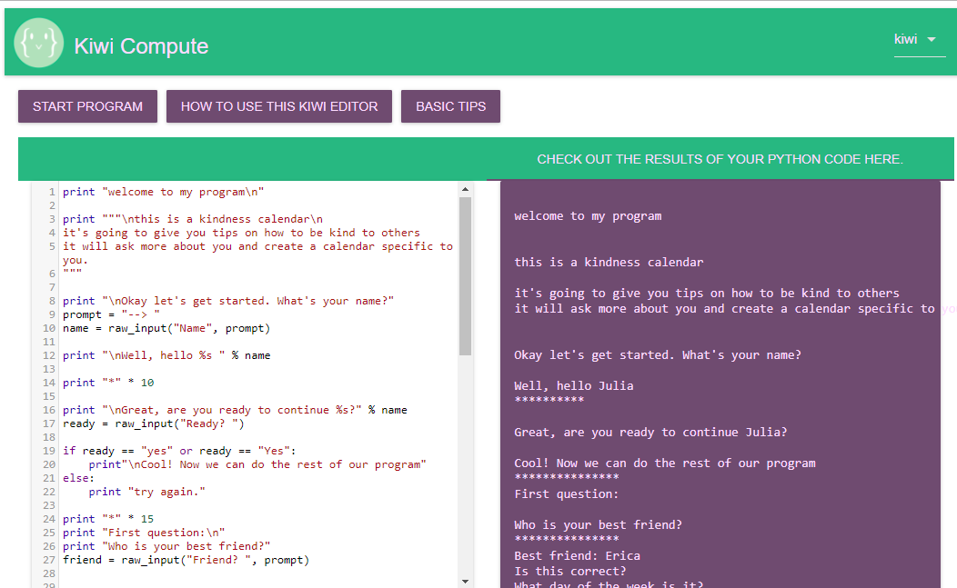
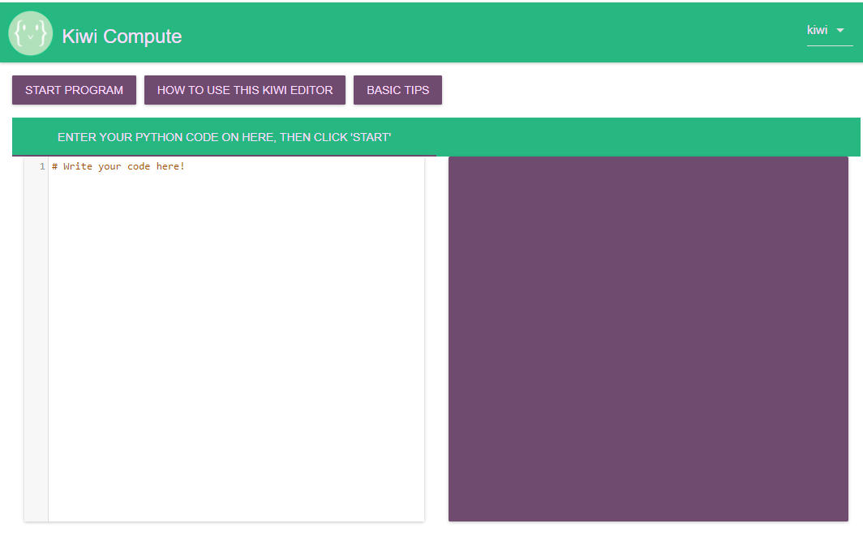
Kiwi will build a new app that is similar and allows code to run in the browser. However, Kiwi will add lessons and steps to learn specific concepts.
Kiwi’s current application allows middle schoolers to run Python in the browser to make it easy for students to pick up quickly.

