Describe your solution.
ClinTrial Refer: Building Networks - Breaking down Barriers
Improving Access – Driving Trial Performance
• How will you do it?
The Haematology Clinical Research Network (HCRN) is a network of clinical trial unit managers and coordinators throughout the Australian State of NSW, with an aim to identify and conduct quality projects to improve haematology clinical trials practice in NSW. One of the team’s core objectives was to develop strategies to break down cross-referral barriers between hospitals. We decided to enhance trials recruitment by developing an App, ClinTrial Refer, in conjunction with a Web Designer/App developer.
With feedback from end-users (clinicians, trial managers & patients) App specifications were refined with successive iterations. With key search filters of Disease, Location & Sponsor, the App is easy to navigate. Useful features include: listing of inclusion/exclusion criteria; direct links to ClinTrials.gov and anzctr.org.au; a lay summary; alert notifications. Real-time data entry into a streamlined database ensures currency of trial information at the fingertips of the user.
• How does it work?
The trial unit managers from 18 sites deliver updated data on their recruiting trials to the app manager. This data is entered into a password-protected web-based database. This means that trial data in the App is current and comprehensive. There is a contact email, where doctors can email from their smartphones for information immediately. Time spent by the App manager to keep it up-to-date is about 30 mins per month. Free to download, doctors & patients can access this data anywhere, all the time.
• What does it look like?
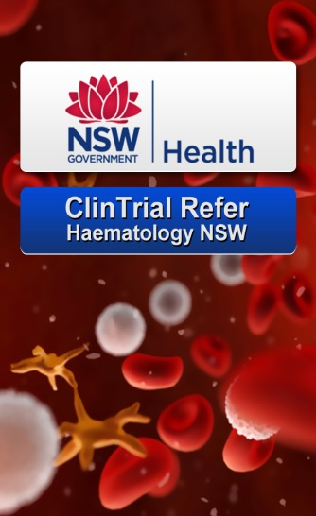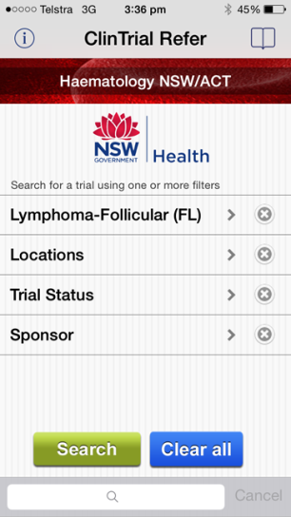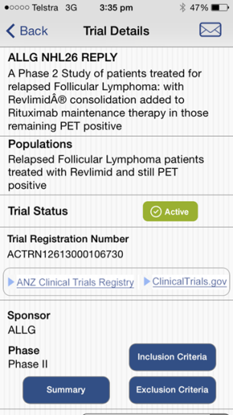
• How will you implement it?
We launched it at Innovations conferences. We have submitted conference abstracts and promoted it at haematology meetings. Cancer consumer groups such as Lymphoma Australia and the Leukaemia Foundation Australia as well as the Cancer Institute NSW, Australia and Australasian Leukaemia Lymphoma Group: the national clinical trials collaborative have/will help to increase awareness of it. We were interviewed about ClinTrial Refer on the Radio National Health Report. http://www.abc.net.au/radionational/programs/healthreport/clintrialrefer-app/5693826
• Where will you implement it?
It was implemented in Haematology in NSW Australia. However, it is a template for Apps in other geographic areas and disciplines. It has already been adapted for other haematology collaborative throughout Australia & New Zealand, and for other cancer disciplines such as the Radiation Oncology, Adolescent Young Adult, Melanoma and Prostate & Genitourinary Cancer collaboratives, with other groups set to go live. The National Australian Lung Cancer and Gastrointestinal Cancer Trials Group has also expressed interest in ClinTrial Refer.
• Who will be involved (stakeholders)?
The main stakeholders are haematologists, Clinical Research Coordinators, and patients. All will have free access to current recruiting trials. Within a broader roll-out of ClinTrial Refer clinical researchers and patients within any tumour stream or geographic location internationally are potential stakeholders.
• How much will it cost to create the solution (an estimation)?
Approximately $30,000 to expand the App to other users and develop additional tools to enhance its implementation – such as a within-App ClinTrial Recruit function to provide instant recruitment records.
• How much will it cost to implement the solution (an estimation)?
$4000
• How many people will be impacted?
Google analytics estimates that there are about 2000 users of ClinTrial Refer. However, beyond these users numerous patients with cancer - from rural & urban NSW, private & public haematology- will be impacted. We estimate about 40 extra cross-referrals for clinical trials with 20 additional patients recruited to haematology trials per month, just within Haematology NSW. With eight other Apps now available and unlimited potential for others in the making, the App has the potential to influence many thousands of patients internationally with individual local Apps developed across any cancer trials portfolio.
• How long will it take to create the proposed solution?
2 months
• Why will it work? Why is it viable?
Expansion of ClinTrial Refer will work because the initial local haematology App is already working well and we have learnt how (and how-not) to develop such an App. As one of our users stated “Like all great ideas, ClinTrial Refer is brilliant in its simplicity.” As their patients benefit from increased access to emerging therapies, and with reciprocity of referral by haematologists across our State, the App is facilitating major cultural change and collaboration. We are discovering that haematologists will cross-refer and patients will travel. The single physician/hospital model of care is being challenged in a new era of collaboration.

