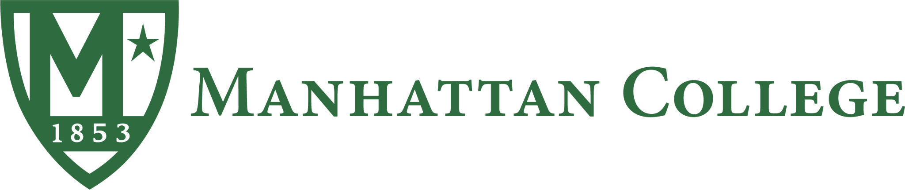

MARINE ENERGY COLLEGIATE COMPETITION 2024
Community Connections Outreach Report
Go With The Flow
Faculty Advisors
Dr. Bahareh Estejab [Mechanical Engineering]
bestejab01@manhattan.edu
Professor Winston S. Peters Jr. [Business Development]
wpeters01@manhattan.edu

Undergraduate Students
(Engineer Team Lead)
Melanie Christine Garcia - Mechanical Engineering
mgarcia06@manhattan.edu
Aaron Andrade - Mechanical Engineer
aandrade03@manhattan.edu
Anthony Z Behpour - Mechanical Engineering
abehpour01@manhattan.edu
Evans K. Appoh-Sam - Mechanical Engineering with Concentration in Aerospace Propulsion and Applied Mathematics, and minor in Mathematics
eappohsam01@manhattan.edu
Kevyn Duran - Mechanical Engineering
kduran01@manhattan.edu

(Business Team Lead)
Belisabel Batista - Global Studies Co Major With Finance And Management Major bbatista01@manhattan.edu
Karen Flores - Finance Major with a minor in Economics
kflores03@manhattan.edu
Contact: Manhattan.edu | 1+(718)862-8000 | 4513 Manhattan College PKWY, Bronx, NY 10471
Table of Contents

Introduction 3
After Action 4
Challenges 4
Student and Local Community Engagement 5
Marine Energy Club 5
Project Invent 6
Preston High School 7
SWE for Scouts 8
Host Industry Event 10
Interviews 11
Future Outreach 13
Social Media 13

Introduction
Community outreach plays a pivotal role in advancing the field of marine energy. As this emerging field of renewable energy continues to evolve and expand, fostering strong connections with local communities and various stakeholders becomes increasingly crucial. Not only does community outreach promote increased awareness of marine energy as a green energy alternative but it also serves as an educational tool for students as a potential career path.

The Manhattan College team stands at the forefront of imperative endeavor, recognizing the vital role of community engagement in propelling the marine energy industry forward. Composed of 7 undergraduate students in a multitude of undergraduate disciplines in Mechanical Engineering and Business.

After Action
After the mid-year deliverable, the team focused more specifically on the solutions to the chosen challenge topics and how to take action to address them. Some potential solutions found were to implement community-led initiatives to showcase marine energy technology in local areas, promote policies that ensure equitable access to marine energy resources for all communities, particularly those rural isolated communities, and launch public education communications materials to raise awareness about the marine energy industry.

Out of the proposed actions from the MECC 2024 Rules Document, the team focused on Student and Local Community Engagement and Hosting Industry Events to address the chosen topic area and engage the community about marine energy.

To foster student and local community engagement, the team implements a series of targeted initiatives aimed at creating meaningful connections and raising awareness about marine energy as well as bringing awareness to the solutions proposed. One key action involved the establishment of a new club on the college campus called the Marine Energy Club, generously funded by the Hydropower Foundation under the WaterPower Club program. This club served as a hub for students interested in marine energy to come together and learn about the industry as well as share ideas. Additionally, the team organized events for the engineering department to showcase the progress of our device. Furthermore, the team prioritized engaging with local schools and educational programs through presentations at Preston High School and with Project Invent. The team also partnered with the Society of Women Engineers (SWE) to provide a hands-on learning experience connecting wind energy to marine energy during a SWE for Scouts event.

Challenges
Some of the challenges the team faced based on the actions taken were establishing the Marine Energy Club and engaging the community and students. While the club was successfully established under the Hydropower Foundation, it was difficult to receive funding from the foundation which in turn affected plans the MECC had for the club. We were unable to accomplish our goal of having 50 members by the end of the year as well as host a field trip to the RITE project created by Verdant to give the members a learning experience of marine energy technology. As well as being unable to provide an actual marine energy experiment to the Girl Scouts for the SWE for Scouts event due to financial constraints. However, the club was able to maintain interest from present members and future members and secure the funding for next year's team to keep the club established. Also, we were able to use the resources provided and connect wind energy to marine energy for the SWE event.

Student and Local Community Engagement

Marine Energy Club
The Marine Energy Club was established at the beginning of the fall semester with the MECC Manhattan College team as the board of the club. Throughout the academic year (2023-2024), we were able to successfully hold 4 club meetings and events. Within each meeting or event, the number of attendees ranged from 15-40. The Marine Energy Club was successful in gaining 20 members, which were mostly sophomores, juniors, and senior mechanical engineering students but the club had a small demographic of business students. Along with club meetings and events, we participated in Mechanical Engineering Day hosted by the American Society of Mechanical Engineers Club to speak and promote our club.

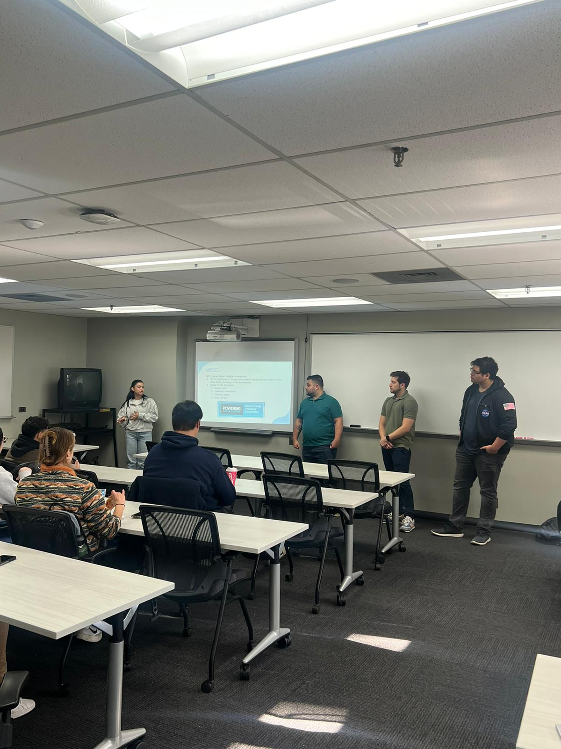
Image 1: Introductory Meeting for Marine Energy Club
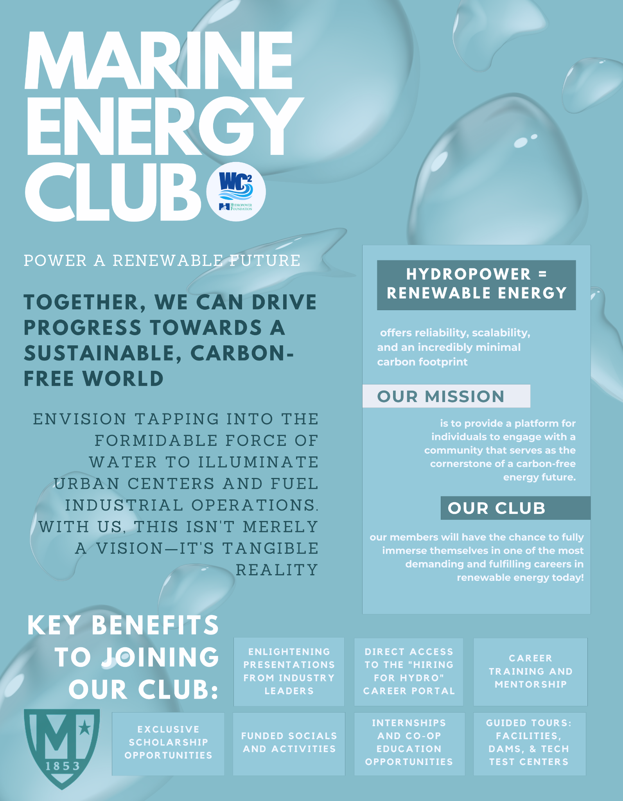
Image 2: Marine Energy Club Poster for ME Day

Project Invent
We were able to collaborate with Project Invent to host a virtual presentation focusing on marine energy and educational resources to understand the technology used in the industry. Project Invent is a nationwide organization that supports high school students with the skills to succeed through invention. They provide supplies, curriculums, and learning opportunities to promote innovation and engineering. With a virtual presentation, keeping students engaged was crucial, therefore with the use of REDI developed by NREL we were able to effectively demonstrate different types of technology that can power a small island. Four out of five of the engineers contributed to this presentation, we also had a total of 10 educators who had a class of 30 students watching the presentation.

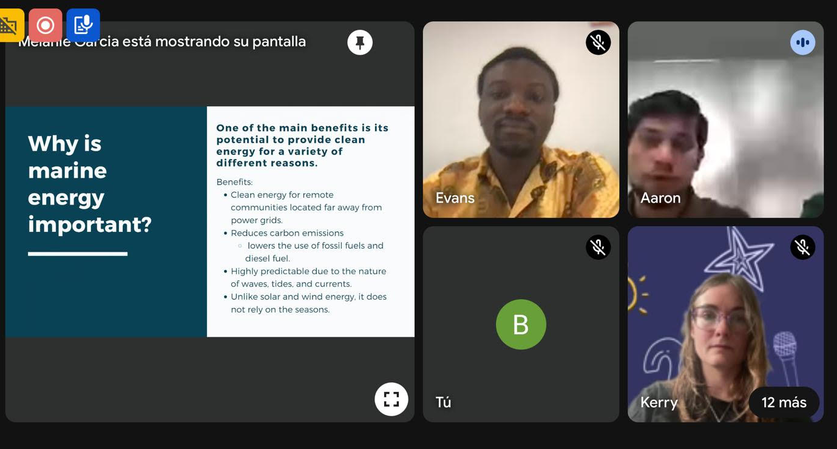

Image 3: Presentation with Project Invent

Preston High School
Preston High School is an all-girls private Catholic high school located in Bronx, N.Y. Our team of engineers along with our business students created a thorough presentation on the different types of renewable energy and emphasized marine energy. We also provided an interactive learning experience using REDI, Jeopardy, and the Marine Energy Adventure Game developed by PNNL and DOE. Four out of five engineers presented to a classroom of 31 physics high students.

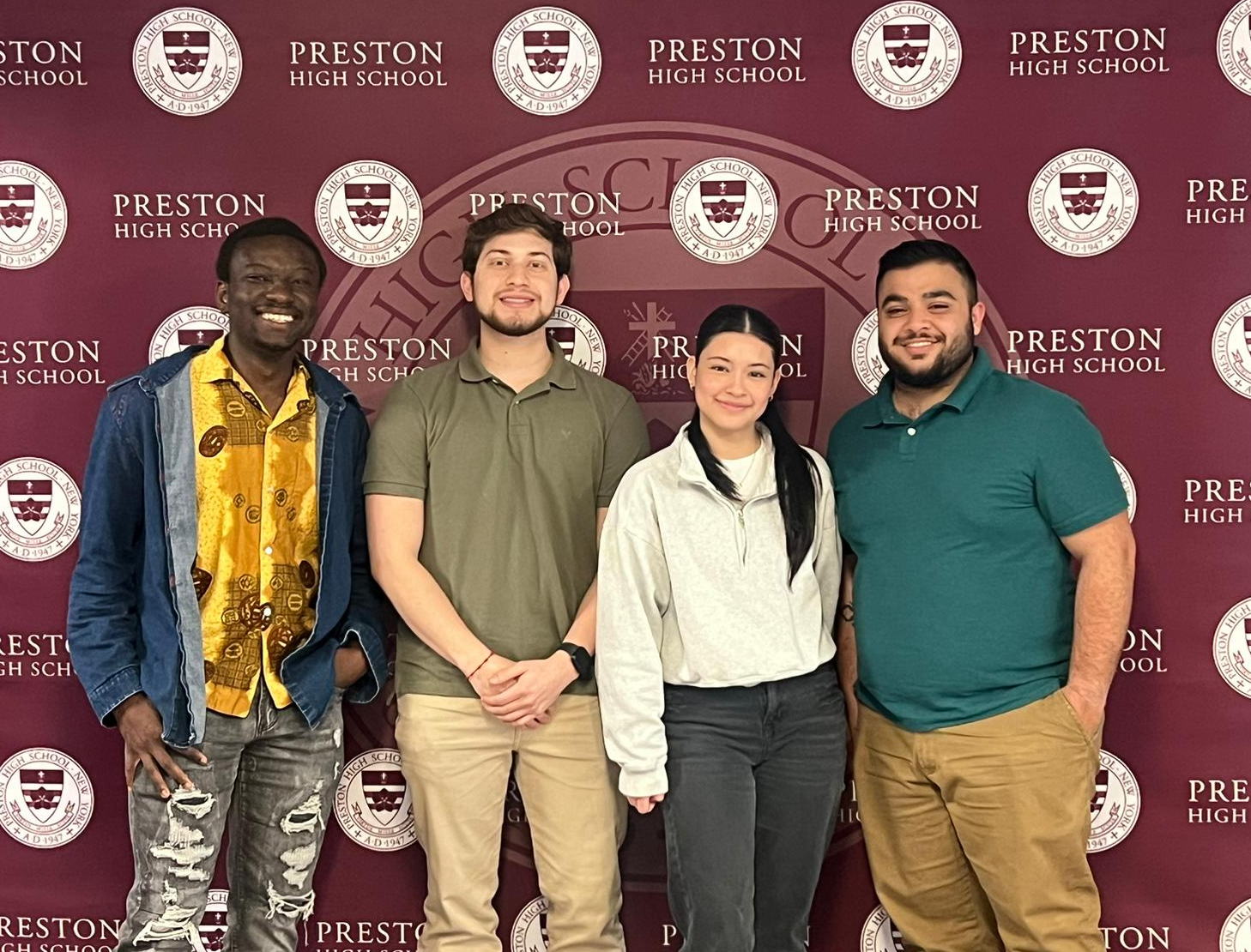
Image 4: Manhattan MECC team at Preston High School

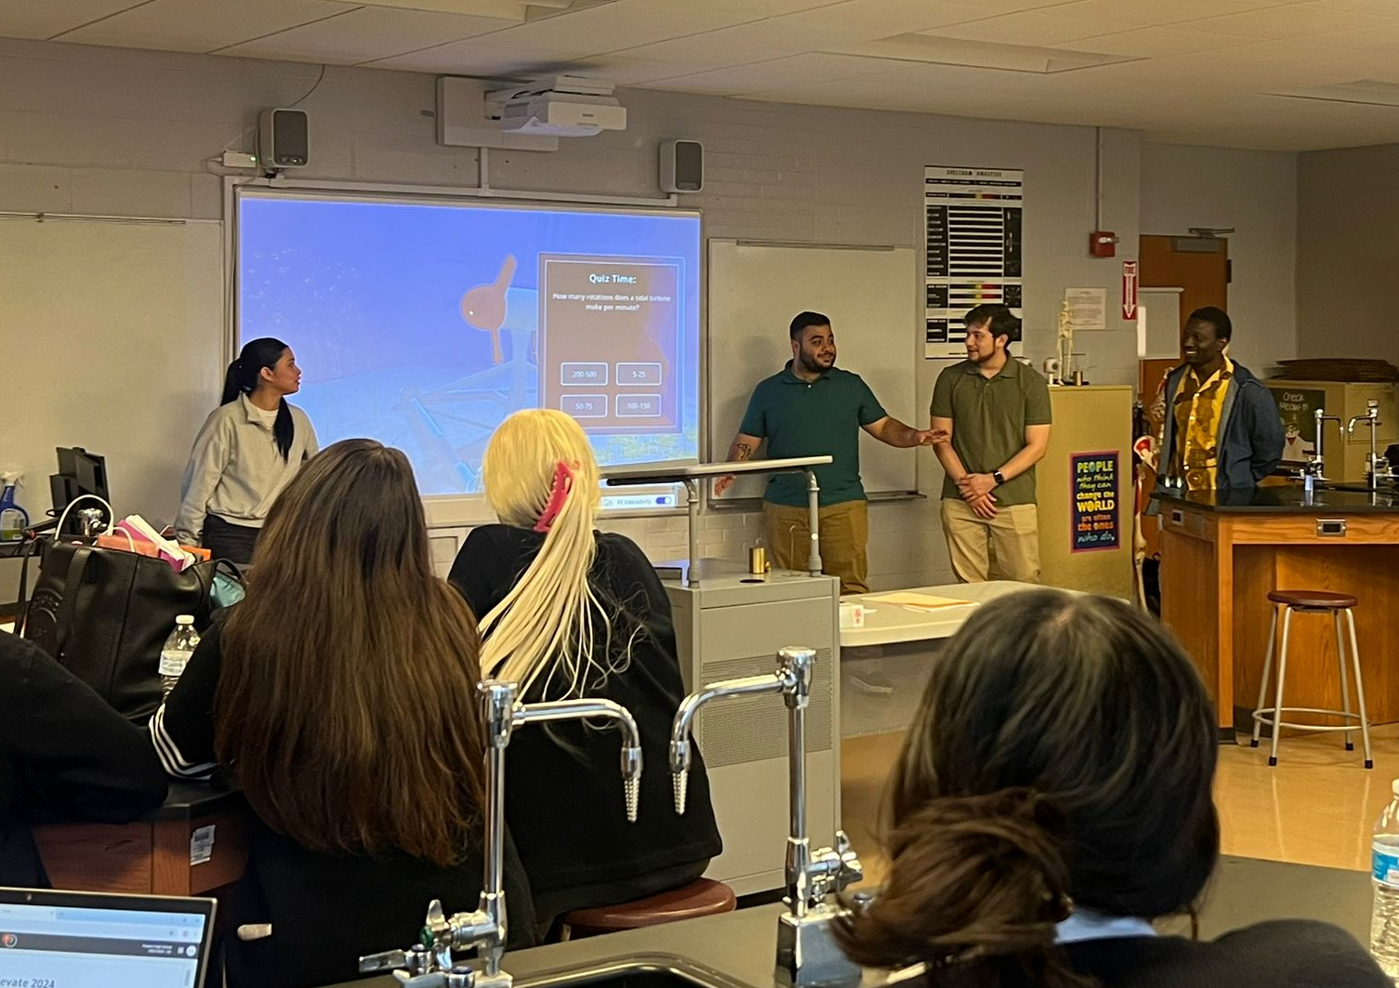
Image 5: Presentation in Physics Class

SWE for Scouts
The Society of Women Engineers Club at Manhattan College has hosted its take on SWE for Scouts for the past two years. As the only female engineer, Melanie Garcia, team lead of the MECC team, participated as the head coordinator for the mechanical engineering module for the event. With the help of the rest of the team, we developed a hands-on activity for the young Girl Scouts to learn about renewable energy. The experiment was to build a wind turbine out of craft materials. The event was held for two weekends, each day hosting 30-40 girls for a maximum of 80 girls. Only Melanie Garcia was able to participate, as well as with the help of female engineers who are members of the Marine Energy Club.

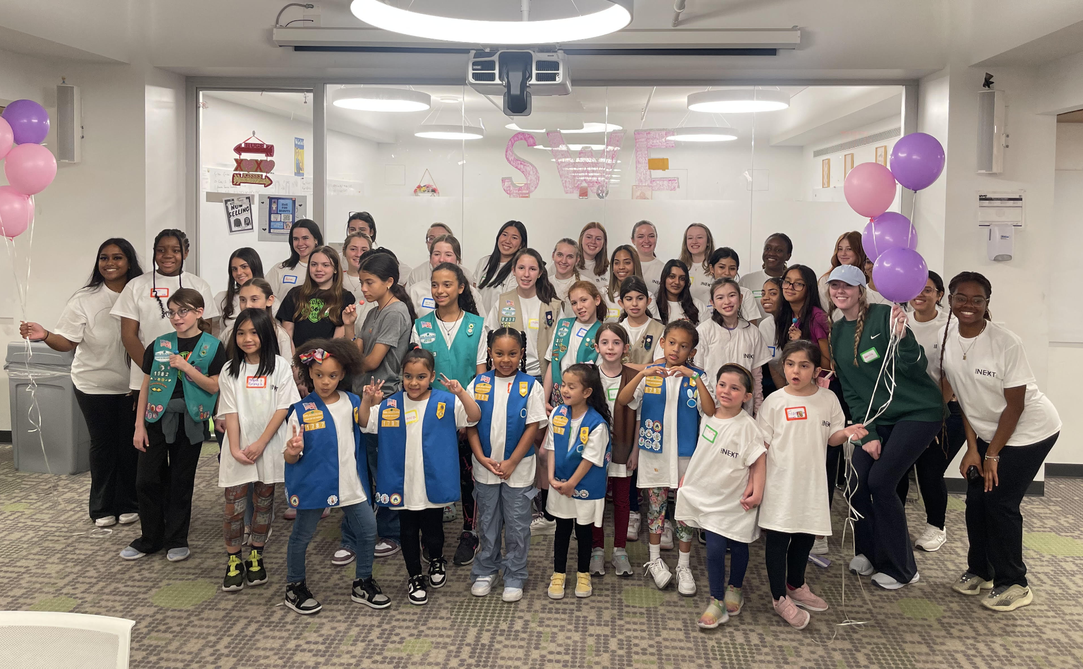
Image 6: Manhattan College SWE for Scouts

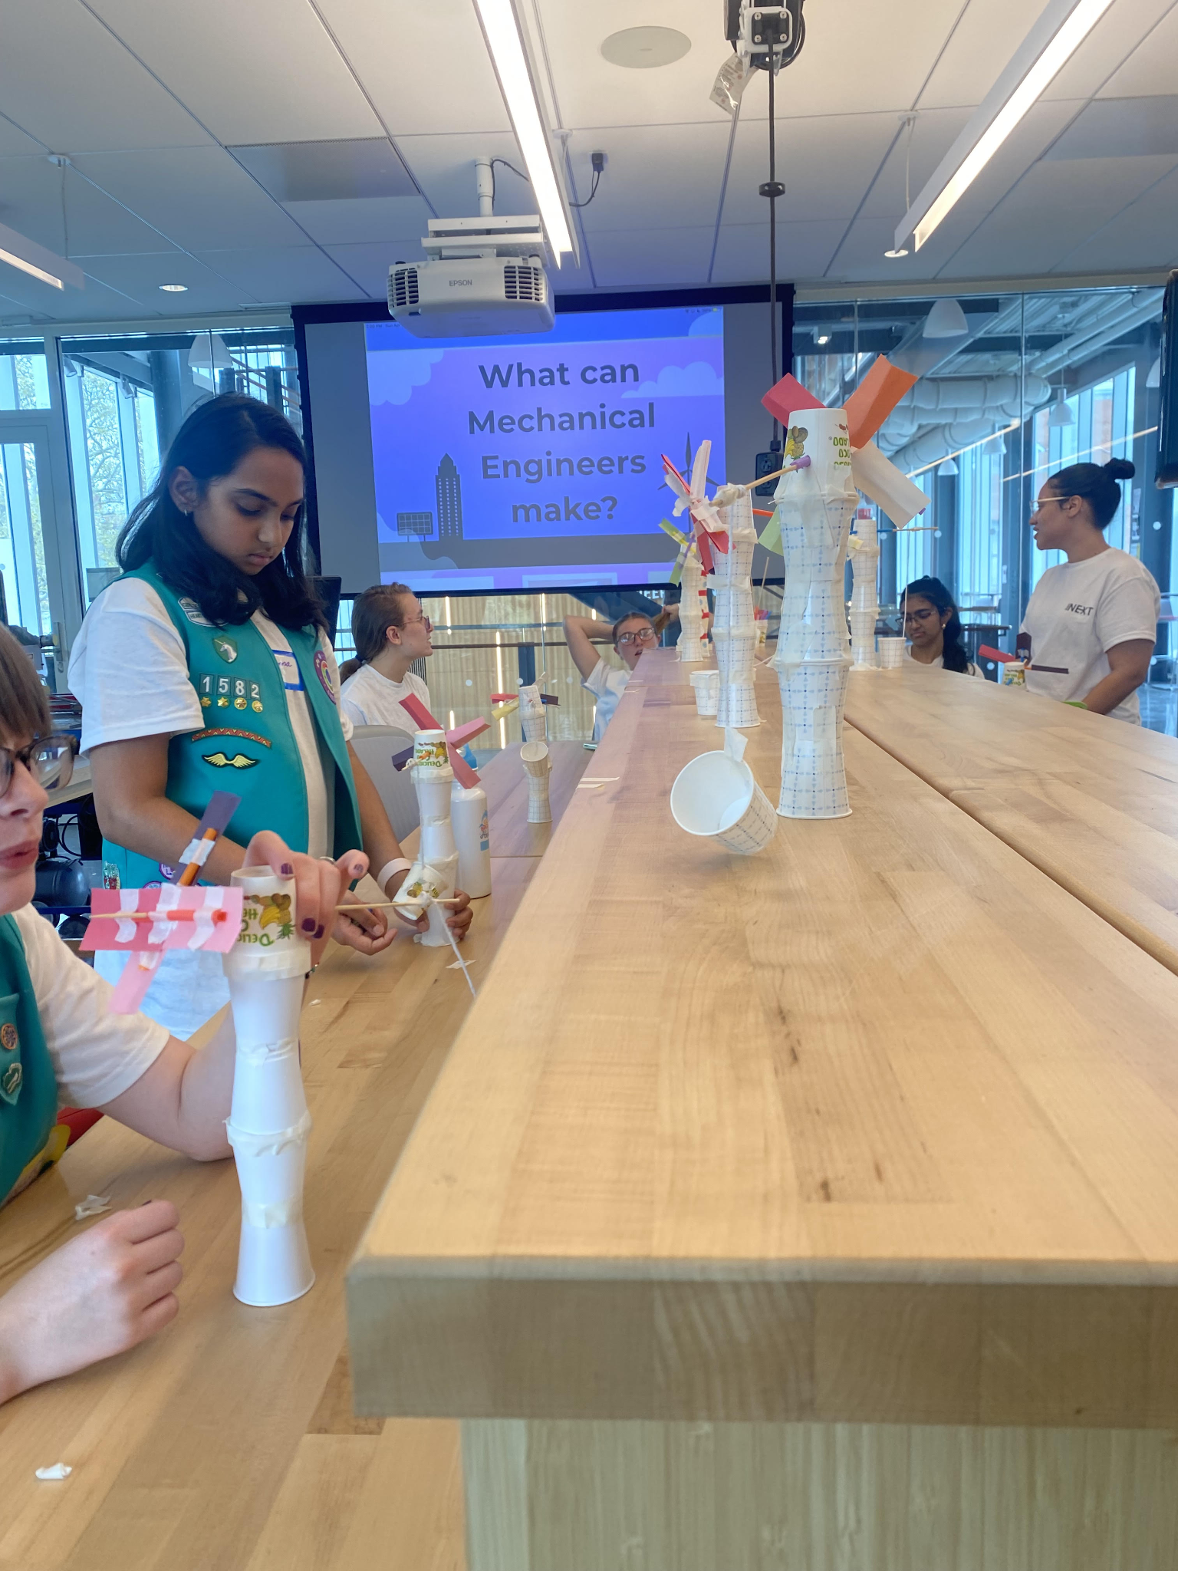
Image 7: Mechanical Engineering Module, Wind Turbine

Host Industry Event
From the Marine Energy Club, the team was able to collaborate with the Hydropower Foundation and they provided a guest speaker Russ Sanfordfrom Kleinschmidt, a consulting engineering company specializing in hydropower. This event was open to all students regardless of major, however, all those who attended were mostly mechanical engineers with a small demographic of business students, with a total of 20 attendees. All members of the MECC team participated in the event. The team asked Russ Sanford to give a presentation on the importance of marine energy and its future while being able to include technology demonstrations.

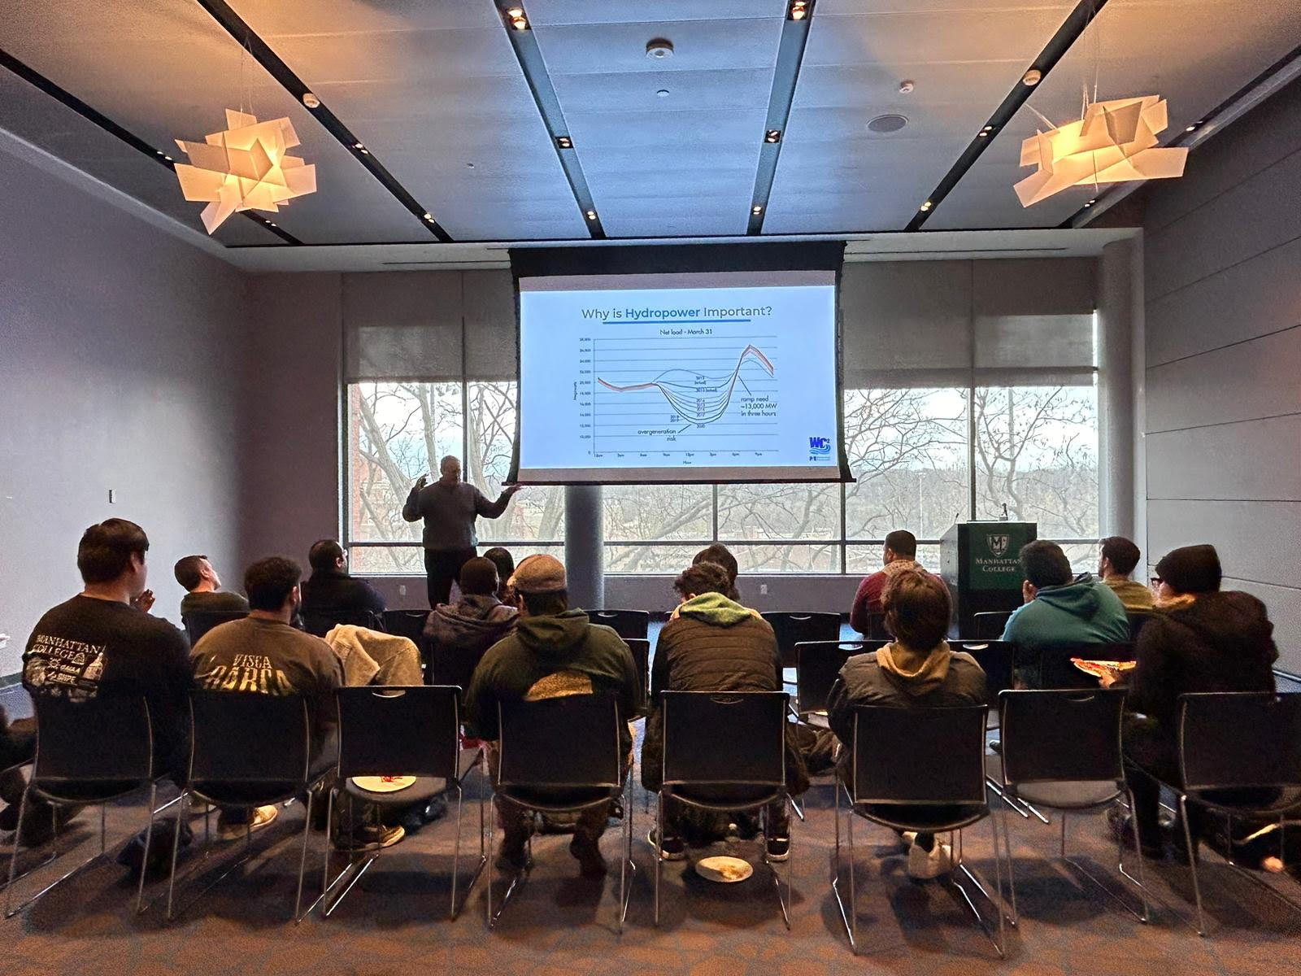

Image 8: Marine Energy Club, Guest Speaker Russ Sanford

Another event that the MECC team held was presentations among the mechanical engineering department to get an insight into what our design was and our progress throughout the year. Two presentations were held, one being in December and the other being in May. Anyone was welcome to attend, however, only mechanical engineering students attended, with a total of 40.
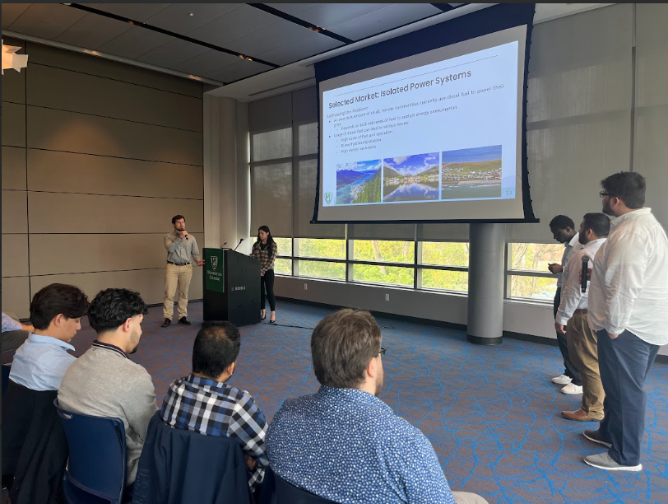

Image 9: Team presenting for Department about MECC

Interviews
To gain a better understanding of the Marine Energy Industry, our team members contacted several industry professionals and interviewed four (4) to expand on our knowledge and understanding of the Marine Energy Industry from last year's competition with the guidance of this year's industry professionals. As a result, our team gained a better insight into the various operations that go with creating and adjusting technology within the marine energy industry. As well as understand where our device would be best implemented, and who would greatly benefit from it. Furthermore, table 1 showcases the industry professionals we interviewed for this year's competition with their contact information along with a detailed description of how our interviews went with each industry professional.

Reflection
Reflecting on the Community Connections Challenge as a whole, the team recognizes the significant strides made in building connections between the marine energy industry, academia, and local communities. Through the establishment of the Marine Energy Club and targeted outreach efforts, such as events showcasing the device's progress and educational presentations, the team successfully reached its goal.

Table 1. Communications with Industry Professionals

Name | Company | Position | Contact
Dr. Ali Khosronejad | Atlantic Marine Energy Center  Stony Brook University | Co-Director  Associate Professor | ali.khosronejad@stonybrook.edu
Dr. Fang Lou | Spellman High Voltage  Power Electronics Laboratory  Atlantic Marine Energy Center  Stony Brook University | Director  Associate Director  Empire Innovation Associate Professor | fang.luo@stonybrook.edu
Joseph Klein | Verdant Power | CEO and Board Member | klein@verdantpower.com
Russ Sanford | Kleinschmidt | Co-Chair | Russ.Sanford@KleinschmidtGroup.com

Industry Professional 1:
Name: Dr. Ali Khosronejad
Affiliation: Co-Director at Atlantic Marine Energy Center (AMEC)
Discussion: Industry Professional Interview Transcript

Industry Professional 2:
Name: Dr. Fang Lou
Affiliation: Associate Director of Atlantic Marine Energy (AMEC)
Discussion: Industry Professional Interview Transcript

Industry Professional 3:
Name: Joseph Klein
Affiliation: CEO & Board Member of Verdant Power
Discussion: Industry Professional Interview Transcript

Industry Professional 4:
Name: Russ Sanford
Affiliation: CO-Chair Kleinschmidt
Discussion: Industry Professionals Interview Transcript

After we conducted our interviews, we compiled all the information on a separate document that we continuously look back to, to add perspective to our project. Furthermore, our team has gained interviewing experience and enhanced their communication skills by interviewing the industry professionals that we contacted. Not only this but now we have a steady number of industry professionals whom we can approach with any questions by us or our community. We have learned a lot and gained a lot of knowledge, for which we are thankful for their expertise and wisdom throughout our whole project.

Future Outreach

In our efforts to continue our outreach beyond the competition, we have contacted a couple of other organizations and institutions we would like to present our presentation to, in hopes of facilitating a broader connection between the community, the youth, and the marine energy industry. Furthermore, our team has a pending presentation with another educational institution called Cardinal Hayes, a high school located in the Bronx, New York where our team will be presenting to a group of students about a week after the competition. Our team was also able to schedule a meeting with Senator Jackson for mid-June, who is the senator of the 31st Senate District of New York and the Chair of civil service and pensions. Besides this, we also contacted other congress personnel and were able to meet other congresspeople for June as well. We also wanted to further our connections with other industry professionals, therefore we have scheduled even more interviews, so that we may share the knowledge that was shared with our team through our outreach and social media.

Social Media
Our social media accounts have grown significantly more as we promote our project within our school and community. We have a steady growth of likes and shares ranging between 10 to 50 likes and shares per post, with an average follower count of close to 160 followers and growing. We are also focusing our efforts on creating a new website different from our previous website to post our Helical Water Turbine concept along with last year’s concept, our outreach, and our contact information so that more people will stay informed and be able to reach us if they have any questions.

INSTAGRAM: MECCMC2024
TWITTER (X): MECCMC2024
PREVIOUS YEAR’S WEBSITE: FLOW CHARGER CONCEPT
CURRENT WEBSITE PENDING

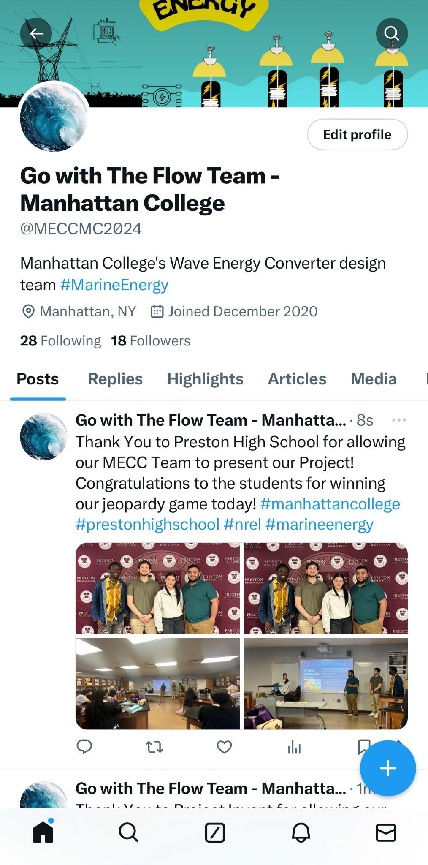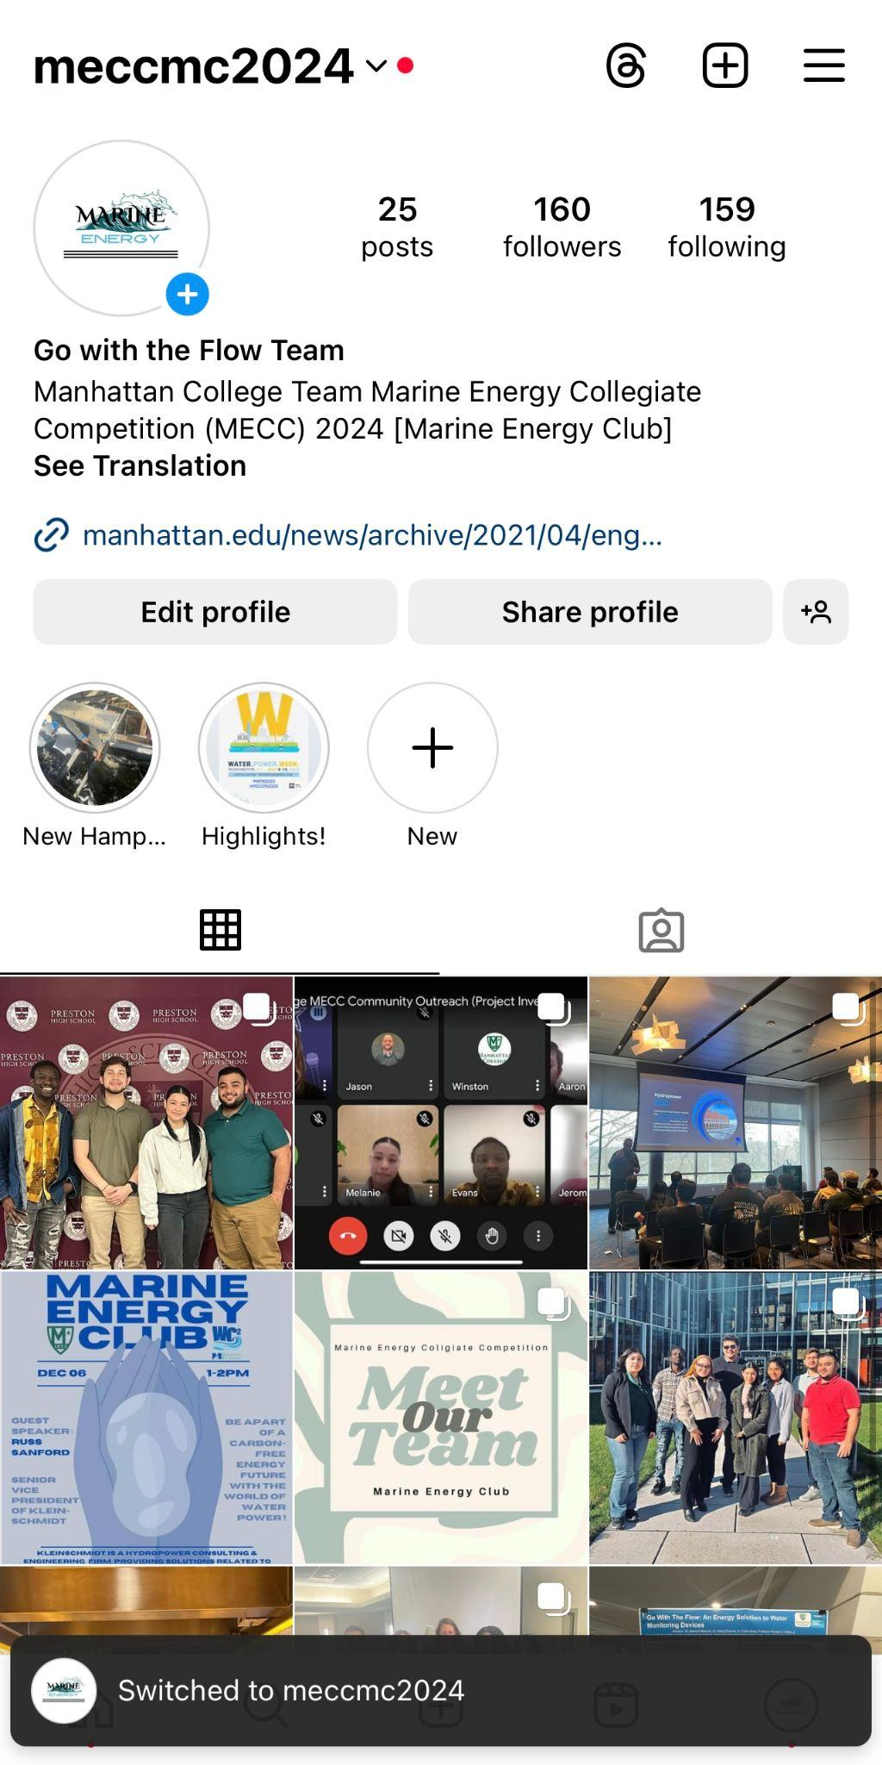
Image 10: Our Twitter (X) and Instagram Accounts

