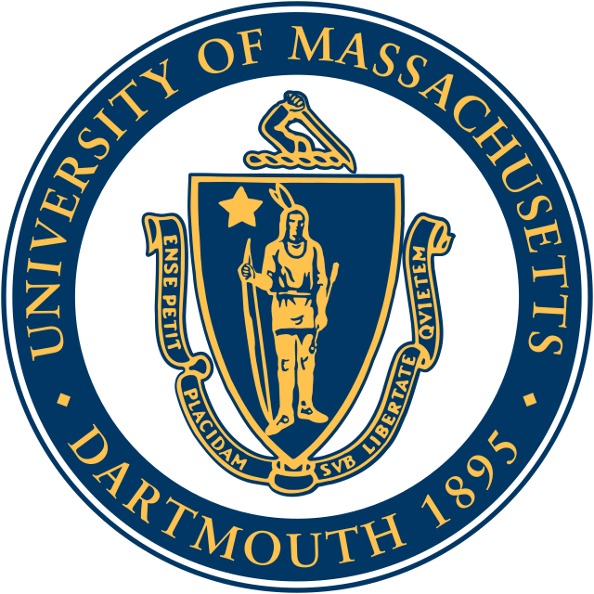

SMADWEC
MECC 2024
Community Connections Challenge

After Action Report
Overview of actions taken to address the challenge topic since the mid-year deliverable.
To have a full understanding of how environmental justice and sustainability are both important on its own and in relation to the project at hand, the community connections team interviewed various people who work in the space. Interviewees included those in the practices of higher education, civil engineering, and offshore wind. Interview answers were then used to gain insights and knowledge on environmental justice and sustainability to integrate them into the team’s business plan. Along with the interviews, the team created and posted on a LinkedIn page with the purpose of garnering a following of those interested or involved in wave energy and lifesaving appliances.
Discussion of challenges the team faced, how these challenges were mitigated, and lessons learned.
The largest challenge faced by the team was finding those in the industry who were able to schedule and take time from their days to help answer questions. Using those that the team has worked with in the past allowed us to get a collection of professionals who had the opportunity to aid in this objective. Another challenge was easily expressing the project objectives in a way that was not too lengthy or confusing to the interviewee. To mitigate this issue, we prepared a short explanation of the overall MECC project and the sub-project they were being interviewed for.
Description of how these actions met the team’s high-level outreach goals and impact to the marine energy community.
Through our continuous efforts in conducting targeted interviews, we successfully met our high-level outreach goals by utilizing dialogue and collaboration with key stakeholders in the environmental community. By engaging with professionals from various fields, we were able to gain valuable insights that inspired our project's approach to environmental justice and sustainability. Additionally, by sharing our ideas and findings with industry professionals, we aim to stimulate discussions and initiatives aimed at promoting sustainability and environmental responsibility in the industry.
Reflection on Community Connections Challenge.
The Community Connections challenge served as an essential system for fostering collaboration and learning within the environmental industry. Throughout this process, we not only increased our network of industry professionals, but also gained a better understanding of the complex issues and opportunities surrounding environmental justice and sustainability in maritime energy development. Moving forward, we are dedicated to using the insights acquired from this challenge to promote innovation and positive change in the maritime energy industry. Additionally, one of our interviews gave us valuable insight into product lifecycles and how the cradle-to-grave/cradle-to-cradle systems were important to learn and implement in our plan.
Up to 10 photos or social media images that depict their outreach activities.
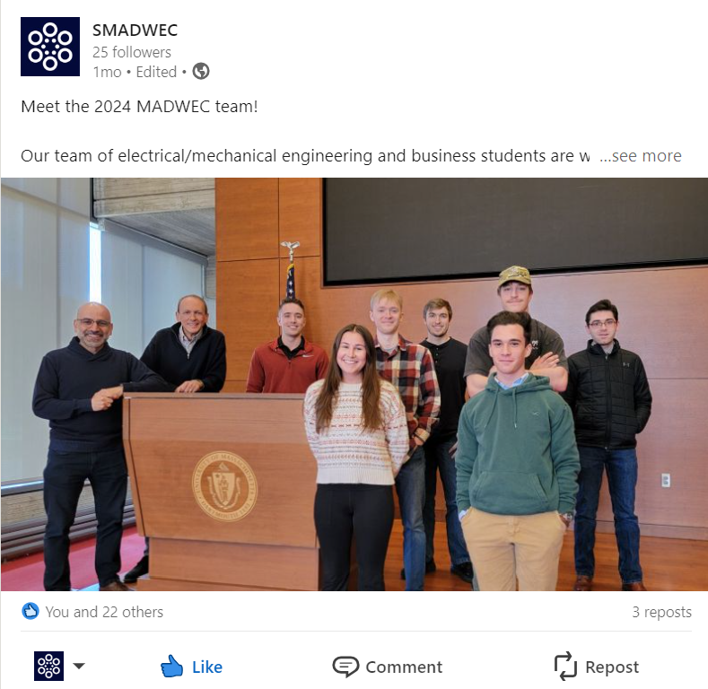
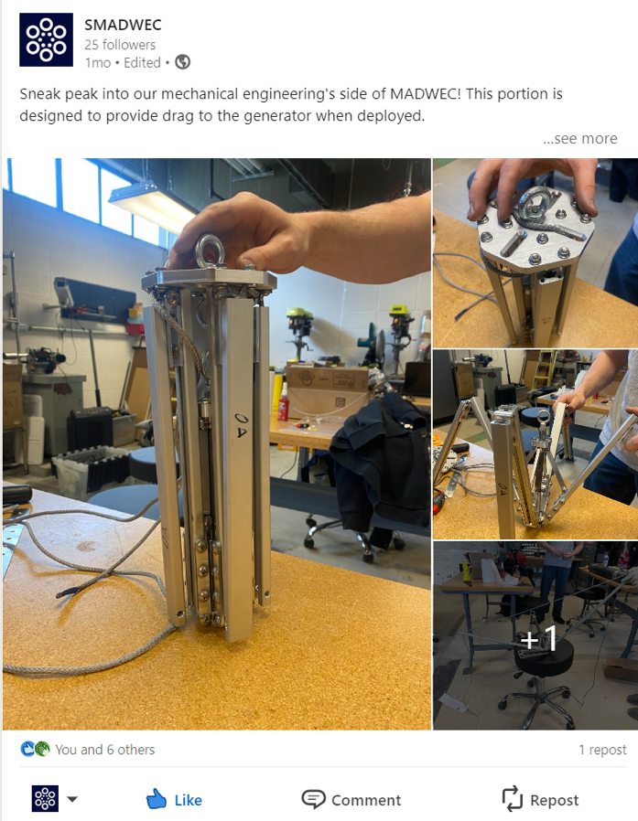
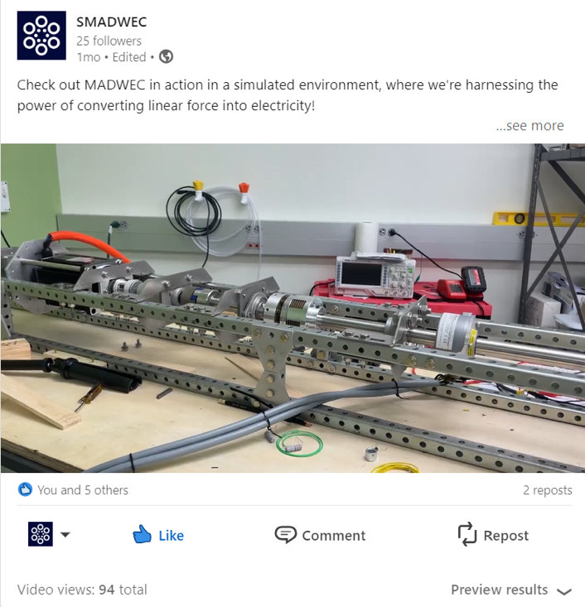
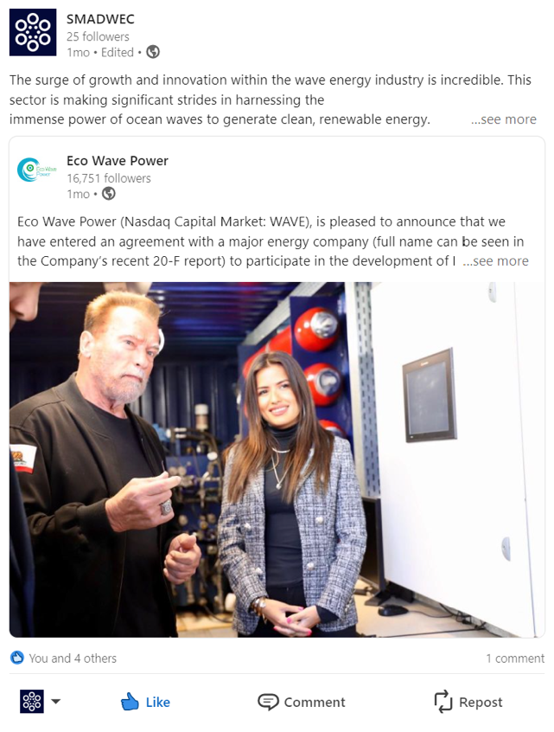
Metrics Report
Industry interviews outcomes, including:
  - Number and types of interviews.
Three interviews were held with industry professionals. Held in person, online video calling and through email.
  - Metrics on team and participant attendance at interviews.
Both members of the community connections team were present at all interviews. Both members developed questions and participated in the discussion surrounding the interview topic.
For each interview completed, provide contact information for each interviewee, including:
    - Full name, company affiliation, and email address.
    - Origin of the relationship (i.e., professional or alumni).
    - Sector in the marine energy industry.
    - Response regarding if this person would be open to continued participation in future MECC events
Khalid Kamhawi, CEO of Ithaca Clean Energy, provided substantial experience in alternative energy production in our discussion. During the interview, Dr. Kamhawi spoke about the complex relationship between environmental justice, sustainability, and the renewable energy sector. He stressed the essential need of providing fair access to sustainable energy resources while minimizing environmental damage. Dr. Kamhawi also provided insights into current achievements and upcoming trends in the renewable energy environment, highlighting possible opportunities and difficulties. Despite the busy schedules of industry professionals, Dr. Kamhawi demonstrated a strong commitment to supporting initiatives such as the MECC, highlighting the collaborative spirit required to drive positive change in the marine energy community.
Dr. Nefeli Maria Bompoti, an expert in environmental civil engineering, shared essential insights into sustainability and its relationship with renewable energy programs. Dr. Bompoti emphasized the significance of fairness and community participation in environmental decision-making processes, drawing on her research and professional experience. She underlined the importance of considering both social and technical consequences in renewable energy projects. Although no contact information for future participation was supplied, Dr. Bompoti's ideas enriched the team's grasp of environmental justice principles and their application to marine energy production, contributing to a more comprehensive approach to sustainability.
Jamie Jacquart, Assistant Director of UMass Dartmouth Sustainability operations, offered extensive expertise about offshore energy production and its implications for environmental justice. Throughout the interview, Mr. Jacquart emphasized the importance of public awareness and education in creating sustainable practices, notably the use of renewable energy sources. He emphasized the issues of misinformation and the role of higher education institutions in promoting informed decision-making. Mr. Jacquart's commitment to sustainability and readiness to participate in projects such as the MECC demonstrated the importance of collaboration in promoting positive change within the marine energy industry.
Action outcomes, including:
For communications materials
  - Number of page clicks.
Page views: 144
  - Number of viewers.
Unique visitors: 58
  - Location of viewers.
59.7% Greater Boston
11% San Francisco Bay Area
9% Springfield MA
20% Other
  - Locations where materials were distributed.
Social media posts were disseminated through LinkedIn.
Outreach strategy outcomes, including:
- Number of persons engaged through outreach.
Total Engagement on LinkedIn: 67
Interview engagement: 3 professionals
- Types of outreach.
Outreach was conducted over social media as well as personal interviews with industry professionals in environmentalism and sustainability
- Reflection on outreach strategy, best practices, and lessons learned.
Overall, the team is happy with the overall outcomes of the social media and hope that it can be used as a springboard to further improve the publics knowledge of marine energy and of SMADWEC
Social media strategy outcomes, including:
- Metrics on social media account growth.
The LinkedIn page started off well using our network to accentuate the page's growth, with the first post receiving 900 impressions. Using the immediate influx of views, the team drove followers from the teams' professional connections and gained some from the large network seeing the post.
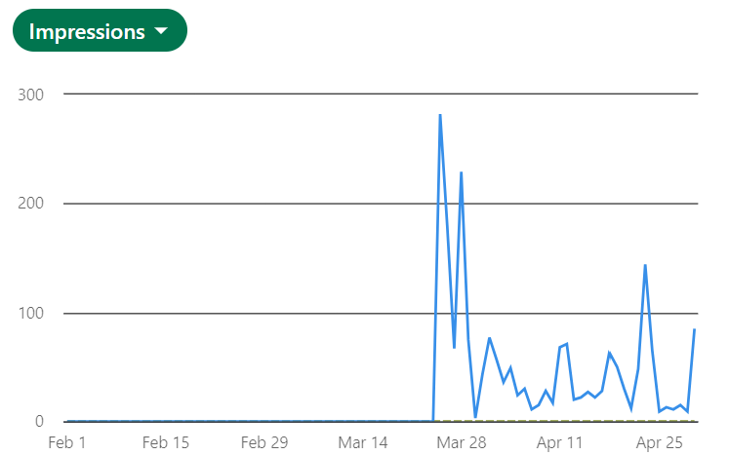
Engagement has largely stayed consistent with postings typically receiving around a 10% engagement rate. Overall, the team had a positive opinion on the engagement of posts as there were a variety of reactions and comments in reference to the marine and more specifically wave energy industry.
- List each platform with number of followers, number of posts and likes, and how this grew throughout the year.
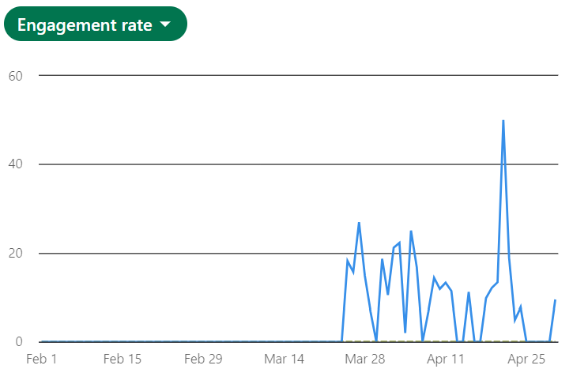
The community connections team solely created a social media account on LinkedIn because of its industry-oriented platform and to give the team a focus instead of diversifying across multiple platforms. In total, the page received 25 followers in the 2 months it has existed, with 9 posts and 67 engagements. The team expects to see more growth in the coming years as more developments in technology become available to publicize to the community. The following of this page could then be used to build further connections in the space to drive growth in commercialization.
- Reflection on the team’s original social media plan versus results attained, lessons learned, and best practices
Our team was interested in creating more original content for SMADWEC in the time we were allotted. Though we were unable to due to minimal changes in the SMADWEC design, therefore much of the content produced was secondary to articles in marine energy space. Overall, we were able to shift our focus from purely original content to content that shared information about the overall industry. While these posts did receive lower engagement, they allowed us to post more frequently and gain a following more quickly.

