MARINE ENERGY COLLEGIATE COMPETITION 2024
Business Plan and Technical Design Report

“Harnessing the flow of water with little disturbance to on water activities, due to its small vertical footprint, and to the aquatic life for remote locations.”

Faculty Advisors
Dr. Bahareh Estejab [Mechanical Engineering]
bestejab01@manhattan.edu
Professor Winston S. Peters Jr. [Business Development]
wpeters01@manhattan.edu

Undergraduate Students
(Engineer Team Lead)
Melanie Christine Garcia - Mechanical Engineering
mgarcia06@manhattan.edu
Aaron Andrade - Mechanical Engineer
aandrade03@manhattan.edu
Anthony Z Behpour - Mechanical Engineering
abehpour01@manhattan.edu
Evans K. Appoh-Sam - Mechanical Engineering with Concentration in Aerospace Propulsion and Applied Mathematics, and minor in Mathematics
eappohsam01@manhattan.edu
Kevyn Duran - Mechanical Engineering
kduran01@manhattan.edu

(Business Team Lead)
Belisabel Batista - Global Studies Co Major With Finance And Management Major bbatista01@manhattan.edu
Karen Flores - Finance Major with a minor in Economics
kflores03@manhattan.edu
Contact: Manhattan.edu | 1+(718)862-8000 | 4513 Manhattan College PKWY, Bronx, NY 10471

Table of Contents
Table of Contents 1
1. Executive Summary 3
2. Business Plan and Analysis 3
2.1 Introduction and Value Proposition 3
2.2.2 Technology Developer Stakeholders 7
2.2.3 Regulators Stakeholders 8
2.2.4 End User Stakeholders 8
2.2.5 External Stakeholders 9
2.3 Market Analysis & Opportunity 10
2.3.1 Market Opportunity 13
2.3.2 Market Challenges / Market Gap 13
2.3.3 Market Landscape 13
2.3.4 Competitive Analysis 14
2.3.4 Product Market Fit 14
2.3.4 Pricing Strategy 15
3. Product & Operations (development & operations) 16
3.1 Design Concept 16
3.2 Design Description 16
3.3 Management, Deployment & Maintenance 16
3.4 Product Challenges 17
3.5 Management & Maintenance 17
4. Financials & Benefits Analysis 17
4.1 Financial Viability 17
4.2 Ancillary Financial Benefits 18
4.3 Operating Expenses 18
5. Design 19
5.1 Original Concept 19
5.2 Our Design 21
5.2.1. Incorporation of Environmental and Sustainability Factors 22
6. Hydrofoil Profile Selection 26
6.1. NREL Hydrofoils 26
6.2. RISØ-A Hydrofoils 27
6.3. NACA 27
7. ANALYSIS 29
7.1. Hydrokinetic Analysis 29
7.2. Cavitation Analysis 33
8. Results And Discussion 35
9. Computational Fluid Dynamics 36
10. Challenges of the Design Process 37
11. Build and Test 38
11.1 Concept Development 38
11.2 Design Process 39
12. Conclusion and Future Work 42
References: 44

Executive Summary
The Manhattan College MECC team is proud to enter its third year of competition with a fresh design and renewed enthusiasm. Comprising seven undergraduates from mechanical engineering and business backgrounds, our team presents a comprehensive report detailing research, development, and testing phases of our innovative hydrokinetic device. The Manhattan College team has taken on the task of optimizing a helical water turbine, initiated by HatchTank Co., to generate renewable energy compatible with river size and flow, while minimizing disruption to wildlife and transportation networks. This technology would be an amazing opportunity for remote communities that are not connected to major grids, providing reliable power, reducing energy costs, and promoting sustainable solutions for the environment.

The original design was split into three stages, an inlet, an entrainment stage, and the blades and generator. Our main focus on this project was optimizing the third stage of the project. We decided to change the profile, pitch length, and orientation of the blades, to improve the torque, which would thereby increase the power output. In our design improvements were also made with environmental considerations, making changes to the third stage that will make the turbine safer for surrounding aquatic life. We were able to get a base level of results by using a Matlab code that would estimate the power, torque, and lift of each of our blade profile options, but we were unable to finalize this decision as we did not physically test our turbine.

Business Plan and Analysis

2.1 Introduction and Value Proposition
Climate change has had a longing impact on all parts of the world, to reduce this concern, most countries including the U.S. have turned to renewable energy to mitigate the growing issue by reducing greenhouse gas emissions and their dependency on fossil fuels, placing a critical importance on other forms of renewable energy like energy from river tides. Energy from river tides can be harnessed through tidal turbines and barrages, to generate electricity through the kinetic energy of flowing water without producing harmful emissions. By understanding the power of harnessing the energy from river tides, we can create a more reliable and sustainable source of energy that creates new job opportunities, stimulates local economies, and creates more energy security throughout the world including isolated power systems.

The journey towards a low-carbon future dependent on renewable energy seems to be underway in developed countries, however, in remote communities, there isn’t as much progress. There are more than 190 communities in remote areas of Alaska that are not connected to population centers by road or power grids. As a result, these communities are dependent on diesel-powered microgrids at a cost significantly higher than the national average, sometimes more than $1/kWh. According to the National Renewable Energy Laboratory, these isolated communities in Alaska have microgrid power systems from 200 kW to 5 MW.. These regions have emerged as fertile ground for renewable energy solutions, especially hydrokinetic power.

Hydrokinetic power plays a crucial role in the renewable energy landscape due to its ability to harness the natural power of flowing water to generate electricity efficiently and reliably. Many of the remote communities along the coastline have the potential to implement hydrokinetic installations. Since there is always a constant current throughout the four seasons, these hydropower turbines can generate power for remote communities constantly. Unlike solar and wind energy, it does not have to rely on weather conditions or seasonal changes for these turbines to generate electricity. Furthermore, the usage of diesel fuel can be mitigated since there is always access to clean energy from regions with rivers.

2.2 Concept Overview

In 2023, our focus was to explore the potential of marine renewable energy to meet the energy needs of maritime markets while contributing to the transition to a sustainable future. Our team, Go With The Flow 2023, devised a small-scale river flow energy harvester for easy implementation and compatibility with existing environmental monitoring buoys, particularly the Duro Buoy. Our goal was to develop a module that could augment power capabilities in an eco-friendly manner, reducing the need for frequent battery changes and system maintenance.

Building upon our previous endeavors, our 2024 exploration is to advance our assessment of the potential of marine renewable energy to meet the energy needs of the blue economy. Our Go With The Flow 2024 team focused on enhancing and improving The Helical Water Turbine project which is a pivotal component of the PikePower Free Current Turbine initiative initiated by HatchTank Co. Recognizing the proliferation of major cities around bodies of water as a strategic opportunity, comparable to the successful deployment of the tidal turbines from the RITE Project by Verdant Power. Our primary focus was on identifying the optimal hydrofoil shape, blade length, chord length, and angle of attack. The aim was to fine-tune these parameters to maximize torque, thereby boosting power output and reducing the likelihood of mechanical failure and constant device maintenance. Our design is divided into three key stages: the inlet, the entrainment stage, and the blades along with the generator. Following extensive research by our Go With The Flow Team, it became apparent that the Helical turbine is better suited for remote communities, such as those in Alaska, reliant on diesel power. Taking inspiration from the successful implementation of RivGen in Igiugig, Alaska. Our team identified numerous advantages to deploying the helical water turbine in remote communities, it promises to provide clean power, establish microgrids, and offer cost-effective solutions to residents. Therefore, we chose to concentrate on refining the third stage of the concept design to better suit isolated community microgrids and the marine environment.

2.3 Relevant Stakeholders

Our Go with the Flow team project goal was to gain a deeper understanding and insight into the Marine Energy Industry and its various sectors. Thankfully our team was fortunate enough to connect and interview a variety of industry professionals within the Marine Energy Industry. As a result our team gained a better insight into the various operations that go with creating and adjusting technology within the marine industry. As well as understand where our device would be best implemented, and who would greatly benefit from it.

Table 1. Communications with Industry Professionals

Name | Company | Position
Dr. Ali Khosronejad | Atlantic Marine Energy Center  Stony Brook University | Co-Director  Associate Professor
Dr. Fang Lou | Spellman High Voltage  Power Electronics Laboratory  Atlantic Marine Energy Center  Stony Brook University | Director  Associate Director  Empire Innovation Associate Professor
Joseph Klein | Verdant Power | CEO and Board Member
Russ Sanford | Kleinschmidt | Co-Chair

Industry Professional 1:
Name: Dr. Ali Khosronejad
Affiliation: Co-Director at Atlantic Marine Energy Center (AMEC)
Discussion: Dr. Ali Khosronejad is a civil engineer associate professor at Stony Brook University. Khosronejad suggests that hydrokinetic turbines can be groundbreaking technology for remote communities. Especially to rural communities in Alaska which have rivers nearby and are able to implement the devices to produce electricity. With such opportunities, the federal government and local governments are the more important supporters of the technology. The federal and state are important stakeholders in pushing the marine energy industry to get to the point where wind and solar power are, so that private sectors and smaller entities can start using it. Khosronejad believes that by 2023, the industry will get to the point where there will be more funding and it will become more affordable because there will be more design and equipment available for rural communities to buy and install.

Industry Professional 2:
Name: Dr. Fang Lou
Affiliation: Associate Director of Atlantic Marine Energy (AMEC)
Discussion: Dr. Fang Luo is an electrical engineer associate professor at Stony Brook University. In the interview, he spoke about how marine energy can be an important source to build local microgrids. Technology like a hydrokinetic turbine can empower isolated communities like those in Alaska that do not have the access to a large power grid. Technology as such is important depending on where and how you can maximize the utilization of the tidal flow. Stakeholders like the federal government (DOE), but more specifically the Water Power Technologies Office (WPTO) provide systematic evaluation before any technology is deployed to consider the overall impact of the technology. The government is one of most important stakeholders if not only stakeholders because they are providing guidance by helping the industry and the whole society to de-risk the deployment and development of the technology.

2.2.1 Technical Design Stakeholders

Hatch Tank Co. is an employee owned and independent company that strives to create a better world through positive change by offering a diverse team of individuals to develop your ideas and visions into reality. They are focused on a variety of sectors like metals and minerals, energy, and infrastructures with service capabilities of various specialized individuals. They are located in a variety of places around The United States, but their New York base location is in Amherst, New York. Hatch Tank Co. created the initial design for The Helical Water Turbine Project as pictured in FIGURE 1 where the design is split into three main stages. This design was taken and redesigned by Asterion, a energy company, who enhanced some of the water turbine capabilities to adjust to the structural challenges the turbine might have if placed in a strong river tide as pictured in FIGURE 1.

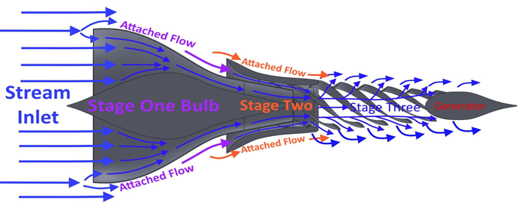
FIGURE 1. Hatch Tank Co. Original Design

The ultimate goal of our engineering team was to enhance and improve the original design of The Helical Water Turbine by focusing on stage 3 of the process since Asterion focused on stages 1 and 2 of the design. Focusing on the tapered blades would allow for more water flow to interact with blades closer to the generator, and would minimize the wake effect caused by the blades. This would hopefully increase the torque put onto the blades, and thereby increase our power output. Another major focus of our project was finding a more effective hydrofoil, and changing the angle of attack, chord length, and pitch length. Our redesigned Helical Water Turbine aims to create a more sustainable, marine friendly turbine that can be placed in strong water tides and decrease the mortality of marine wildlife.

______________________________________
${}^{1}$“Hydropower & Dams.” Hatch, https://www.hatch.com/Expertise/Energy/Hydropower-and-Dams.

2.2.2 Technology Developer Stakeholders
There has been an increase in demand for the development of new innovations to harness renewable energy as more private and public entities within the world want to decrease reliance on fossil fuels so as to hopefully reduce our carbon footprint and create a more sustainable, environmentally friendly world where we depend more on other types of renewable energy sources like marine energy. These new marine technologies are a complex process that require expertise in various fields, which include: naval architects, mechanical engineers, electrical engineers, marine engineers, hydrodynamic engineers, and software developers. Technology developers who specialize within any of these fields of expertise assist in developing new technology and improving existing technologies. In order to create these new and improved innovations, Technology developers must work closely with other stakeholders to navigate the complexities around renewable energy in order to have a product that meets all the requirements and regulations imposed by other entities to ensure the safety, cost effectiveness and reliability of such advanced machinery, which is why technology developers have a significant stake in the development of new innovations.

2.2.3 Regulators Stakeholders
The US Department of Energy (DOE) is a key stakeholder, because it is responsible for advancing the national, economic, and energy security of the United States through the implementation of policies and programs aimed at promoting the development and deployment of clean energy technologies. The DOE invests in research, development, and demonstration of new clean energy technologies and works with industry, academia, and other stakeholders to accelerate the deployment of these technologies. The DOE's Office of Energy Efficiency and Renewable Energy (EERE) is specifically focused on accelerating the adoption of clean energy technologies and promoting energy efficiency in buildings, transportation, and industry. The DOE is also involved in the development of regulatory and policy frameworks that promote the adoption of cleaner energy technologies. For example, the DOE works with other federal agencies to develop and implement regulations that promote the use of renewable energy sources, such as wind and solar power, and to establish energy efficiency standards for appliances and other products. Overall, the DOE is a critical stakeholder in the development of cleaner energy production in the United States, with a key role in advancing research and development, promoting adoption of clean energy technologies, and establishing regulatory and policy frameworks that support the transition to a more sustainable energy system.

2.2.4 End User Stakeholders
Our redesigned Helical Water Turbine, is designed to suit the needs of private and public entities like government organizations, government programs, and private corporations (i.e. energy companies). This positions both state and federal programs as significant stakeholders in the development of marine energy solutions in remote communities. Some of the programs that we considered as part of our end user stakeholders are programs that are focused on implementing new forms of renewable energy. Our biggest end user stakeholder is The Department of Energy (DOE) who recently announced a project called the Energy Transitions Initiative Partnership Project (ETIPP) in which they are initiating nine new projects with remote and island communities building local energy systems that are sustainable, resilient, and reliable year-round, creating an opportunity for devices like our enhanced Helical Water Turbine to provide a more sustainable and an efficient way of converting the tidal waves energy into electricity.
Other end user stakeholders that we have considered to be significant for our project are programs such as the Rural Energy for America Program (REAP) who as stated on their website help agricultural producers and rural small business owners make energy efficiency improvements and renewable energy investments. In addition to (REAP), we also considered The Village Energy Efficiency Program (VEEP) which wants to implement energy and cost-saving efficiency measures in high-energy-cost Alaska communities by implementing a legislature to reduce the per capita consumption of energy efficiency. Furthermore, The Renewable Energy-Village Energy Efficiency Program (RE-VEEP) incentivises the Alaska Energy Authority’s VEEP program by awarding grants to renewable energy projects that can reduce energy consumption.
Another program that we considered to be significant is The Alliance in energy and environment with the Andean region (AEA) Program, which focuses on contributing and developing solutions to sustainable energy for rural markets through a business aspect. In addition to all these public entity programs we have also considered energy companies such as Con Edison, Bloom Energy, Power Secure, BoxPower, Schneider Electric, Eaton Corporation, Alpha Struxture, and other energy companies that provide energy to many communities throughout the U.S., especially ones in isolated communities.

2.2.5 External Stakeholders
As we promote our Helical Water Turbine to our end user stakeholders, our ultimate goal is for these stakeholders to use our technology to advance their research and provide safe, secure, and cost-effective new forms of energy to their consumers who are our external stakeholders.
We separated our external stakeholders into two categories: our primary and secondary external stakeholders. Our primary external stakeholders are rural and isolated communities throughout the U.S. that haven’t had much exposure to other forms of renewable energy and our secondary external stakeholders are local communities throughout the U.S. that have had more exposure to other forms of renewable energy. For this report we will only be focusing on our primary external stakeholders.

To expand more on our primary external stakeholders, we look towards Alaska which stands out in the advancement of microgrid technology, particularly those fueled by renewable energy sources. The harsh climate and isolated geography of the communities make it challenging to solely rely on traditional energy sources. Consequently, Alaska has been compelled to explore alternative energy sources such as water turbines. We look towards isolated communities such as Alaska because of their high energy costs compared to the local communities around the United States average cost. As you can see in TABLE 2, as presented by the EIA’s Alaska Profile on energy consumption, you can clearly see that Alaska is incurring higher than usual costs related to energy, somewhat more than the U.S. average. This is important because by identifying the costs related to energy we can pinpoint what communities need to explore other forms of renewable energy in order to reduce energy costs.

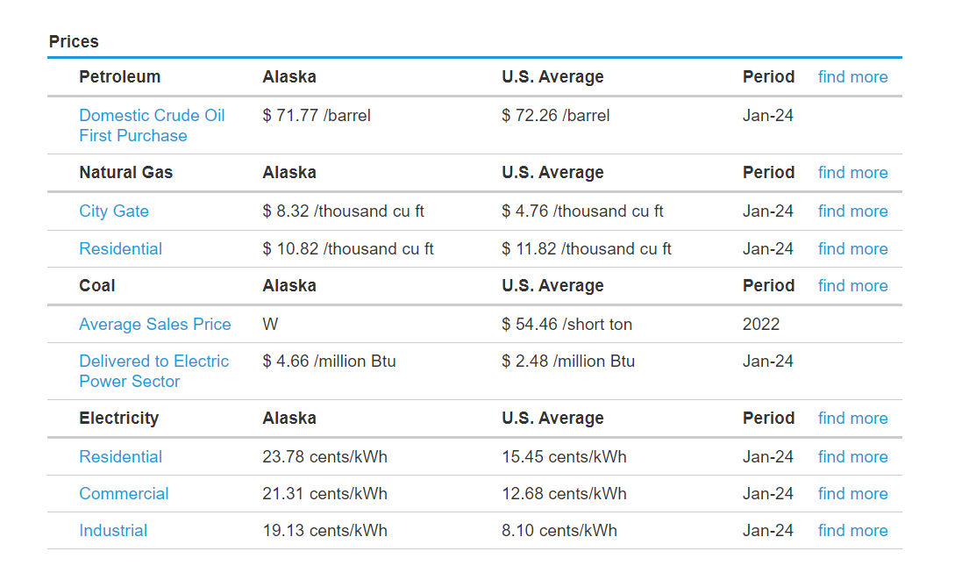
TABLE 2. Price Comparison between Alaska & The U.S. Avg. (EIA)

2.3 Market Analysis & Opportunity
For years many countries including the U.S. have been relying on fossil fuels to produce energy to power the world. Therefore leading to catastrophic environmental issues like climate change, and pollution, indirectly causing health issues between energy consumers and environmental exhaustion & depletion of goods. In order to resolve this growing issue, many countries including the U.S. have looked towards different renewable energy alternatives such as hydropower energy.

Hydropower is one of the most prominent forms of renewable energy options within the market. Estimates for the global hydropower market valuation vary significantly. Some sources, like Precedence Research, suggest a market size of around USD $222 billion in 2022, reaching over USD $380 billion by 2032 with expected growth projections varying between 2% - 4% each year as indicated by IRENA (The International Renewable Energy Agency). Within the coming years, hydropower is expected to grow at a steady rate, due to many factors. Three of the main factors pointed towards this steady rate according to IRENA are an Increase in Demand, Developing Economies, and Pumped Storage Integration. These factors are credited to our world wanting to move towards a more sustainable future. Therefore, hydropower is one of the most sought after renewable energy alternatives, given that hydropower is a cost-effective and reliable low-carbon source of clean renewable energy therefore increasing the demand for hydropower throughout the world. Not only this, but as stated by IRENA, as more economies grow, the more demand for energy will rise towards other forms of renewable energy like hydropower due to its dependability, accessibility, ect. Moreover, hydropower’s ability to store energy creates an exemplary source to integrate with other forms of renewable energy like solar and wind power.
To put hydropower into perspective compared to other forms of energy within the United States, hydropower produces only 10% of electricity in the U.S. while fossil fuels and other renewable energy sources make up the rest of the electricity. According to the EIA (The U.S. Energy Information Administration), the U.S. primary energy consumption varies between energy sources. In Table 3, you can clearly see that 33% of energy consumption comes from natural gas, 36% from petroleum, 13% from renewable energy sources including geothermal, hydroelectric, solar, wind, and biomass, 10% from coal, and 8% from nuclear electric power but if you refer to Table 4, you can see that there is a discorrelation between the production of energy and the consumption of energy, meaning that fossil fuels are underproduced and over consumed, while other forms of energy such as renewable energy are overproduced and under consumed. This suggests that renewable energy sources take less energy than fossil fuels.
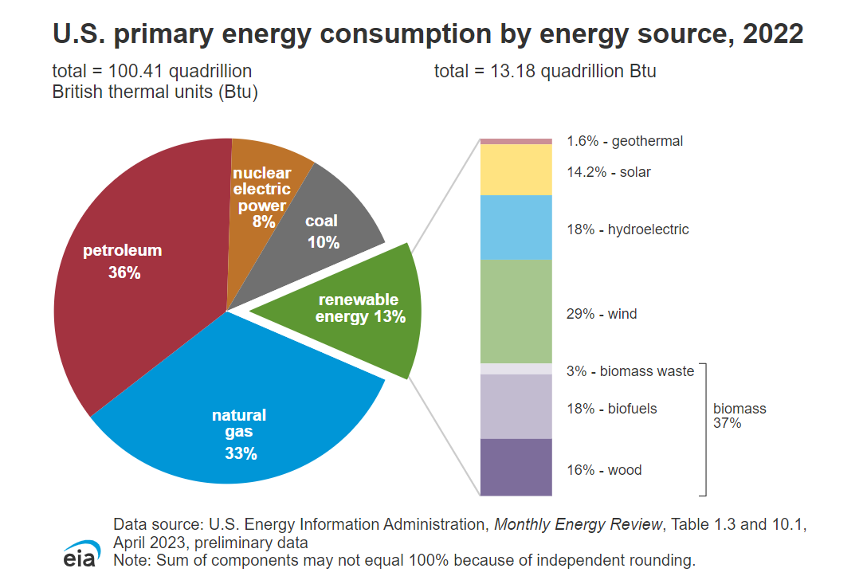
TABLE 3. (EIA) U.S. PRIMARY ENERGY CONSUMPTION BY ENERGY SOURCE

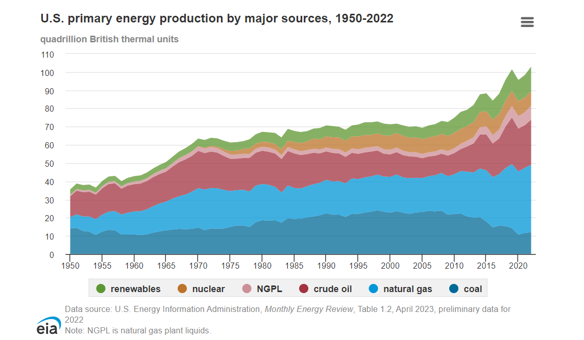
TABLE 4. (EIA) U.S. PRIMARY ENERGY PRODUCTION BY ENERGY SOURCE
Hydropower is one of the strongest sources of renewable energy to be used because according to The Wisconsin Valley Improvement Company, Hydropowered turbines can use 90% energy efficiency while fossil fuel plants can only produce 50% energy efficiency. Not only this but hydroelectricity is produced at a rate of $0.85 cents per kwh, which is 50% of the cost of nuclear energy, 40% of the cost of fossil fuels, and 25% of the cost of natural gas as shown in Table 5.

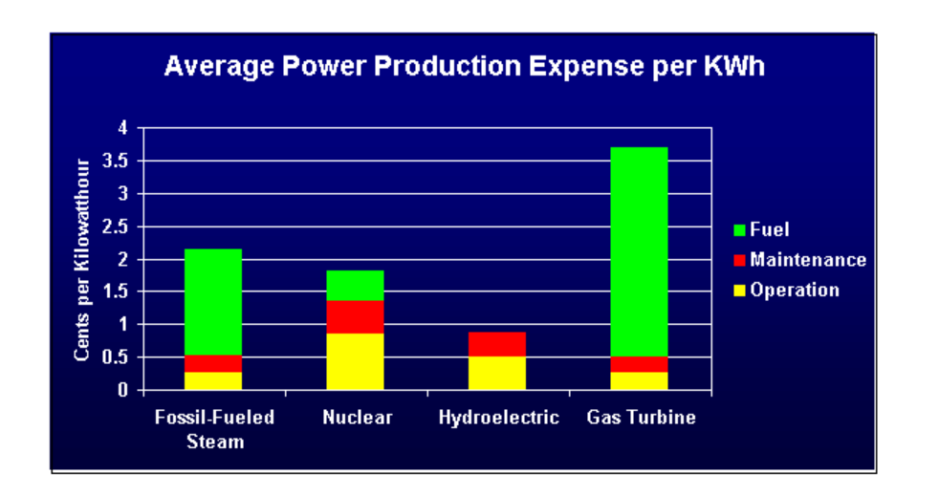
TABLE 5. AVERAGE POWER PRODUCTION EXPENSE PER KWH

We are planning to market our Helical Water Turbine to private and public entities like government organizations, government programs, and private corporations such as Con Edison, Bloom Energy, Power Secure, BoxPower, Schneider Electric, Eaton Corporation, Alpha Struxture, and other energy companies with an interest in centering our project on isolated power systems: community microgrids. We chose to center around this market because isolated communities like Alaska have potential to use hydroelectric energy to power their communities as opposed to other forms of renewable energy given that there is a constant water supply year round. Besides this the cost of producing and consuming hydroelectric power is far less than that of fossil fuels in these communities.

”https://www.wvic.com/Content/Facts_About_Hydropower.cfm#:~:text=In%20the%20U.S.%2C%20hydropower%20is,cost%20of%20using%20natural%20gas.”

2.3.1 Market Opportunity
The selected market opportunity within the “Powering the Blue Economy Report” centers on “Isolated Power Systems: Community Microgrids”. These microgrids serve communities that are not connected to major utility grids, such as those found in remote Alaska. The communities typically face challenges in accessing reliable and affordable energy. Many of these communities heavily rely on diesel generators for electricity generation. Also, some of these communities participate in the Power Cost Equalization (PCE) program. This program was implemented by Alaska to reduce energy costs and keep remote communities viable by receiving a baseline level of electricity subsidy.
However, diesel transportation to these remote locations is expensive, and government subsidies are often required to maintain affordable electricity prices for residents. By lessening dependence on diesel, remote communities can enhance their financial stability.
This market highly relates to our proposed concept and overall product as it offers a variety of positive outcomes that can be achieved. Our concept provides an in-depth explanation of technicality and design to provide the best results for our desired market choice. Additionally, it reduces energy consumption, allowing more money to circulate within the local economy.

2.3.2 Market Challenges / Market Gap
One of the main problems that needs to be addressed is that small, remote communities around the world, more specifically in Alaska, use fossil fuels to power their grids to produce electricity for the welfare of residents. These locations rely heavily on the usage of diesel fuel as their main source of energy to power their communities. In addition, these communities also depend heavily on bulk deliveries of diesel fuel to sustain energy consumption. There is a significant gap between the amount of fossil fuels being consumed and the demand for sustainable energy substitutions. The residents have relied heavily on fossil fuels and finding the specific towns in which this kind of device can work is a challenge.

2.3.3 Market Landscape
Given that device is designed with the intention of introducing it into remote or isolated communities such as Alaska, our team looked into the market landscape of this state. Renewable energy has been responsible for about one-fourth of Alaska’s total energy generation with hydropower talking nine-tenths of that percentage. The Alaskan rivers are grounds for some of
the highest hydroelectric power potential nationwide. This means that the device we are proposing has a market where it could be placed and used. Renewable marine energy is a growing market not only within the US but globally. In 2022, the United States holds the second highest market share within the marine energy sector as shown in the graph below.

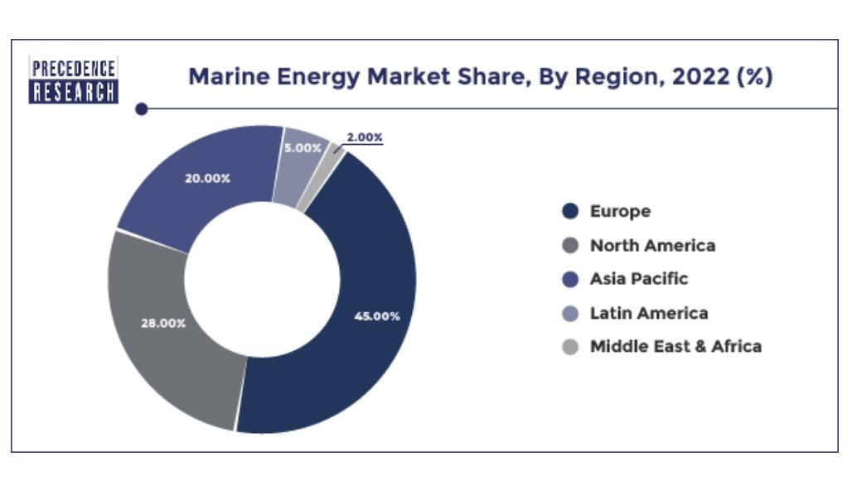
TABLE 3. (Precedence Research) MARINE ENERGY MARKET SHARE, BY REGION, 2022 (%)

The marine energy sector has an expected growth rate of about 21.20% between 2023 and 2032. There is opportunity for marine energy devices to be integrated into marine affiliated industries like fisheries and maritime transportation.

2.3.4 Competitive Analysis
This product has a less frequent need for maintenance which will in turn reduce the total cost of maintenance as there are less moving parts compared to traditional turbines. The adaptability allows for our product to be able to be installed in various aquatic environments such as rivers, tidal flows, coastal regions, making it adaptable to different geographical locations. There is little environmental impact and does not require large dams or disrupt natural water flow significantly.
One of the downsides is that there is a high initial investment when first purchasing the product and there is a chance that it could harm populations of fish and other aquatic species living in the water. However this product will be able to meet Renewable energy demand as well as allow for there to be technological advancements in turbine design. Materials technology may lead to improvements in the efficiency and cost-effectiveness of helical turbines, expanding their market potential.
There is still competition from other renewable energy sources such as solar power, wind power to take into consideration as well as companies and consumers that are too reliant on diesel fuel and other fossil fuels to generate power such as those in Alaska.

2.3.4 Product Market Fit
The product we are proposing fits the needs of many market segments but is of special interest to private and public entities that wish to operate in remote and/or isolated communities. The product is built so that there is minimal need for battery changes as well as calibrated to be able to output more electric energy. When placed in harsh environmental conditions such as in Alaska, the key features of the turbine provide a more secure and effective form of energy as opposed to diesel energy. The need for constant maintenance is reduced through our design and the energy output increases. The team’s particular concept is able to meet the needs and desires of the selected market by providing clean, renewable energy for these isolated communities to power their grids.
One of the biggest demands within this market is the need to reduce the usage of fossil fuels, in which these remote communities are using an abundant amount of diesel fuel to generate electricity to maintain daily activities. By generating energy without releasing any carbon emissions, we can potentially mitigate the reliance of diesel fuel, benefiting these communities in various ways. For instance, large, bulk deliveries of diesel fuel are transported to these communities constantly, requiring extensive storage capacity. This is a big issue to address because it is difficult to transport as well as highly expensive. By using hydropower turbines, we are able to reduce the cost of energy consumption because of the elimination of fuel transportation. In addition, with the reduction of fuel cost, a significant amount of money can be circulated throughout the local economy, potentially reducing the cost of living for local residents. Also, the risk of developing new business enterprises is reduced, which is very crucial in small communities.

2.3.4 Pricing Strategy
Given that our team was unable to materialize our Helical Water Turbine with the components that we wanted to produce our prototype with, we were unable to use the cost of goods formula to estimate the pricing related to our device. Therefore, we opted to use competitive pricing to figure out our pricing strategy for this project. Once we formalize and produce a Helical Water Turbine with the materials and up to date scaling we can formulate an optimal pricing strategy to sell into the market for private and public entities including isolated communities like Alaska. Based oSUNECO HYDRO TURBINES website, the estimations of cost to purchase a hydro powered turbine range between $15,000 dollars to $55,000 dollars. Therefore we are opting to currently price our devices to private and public entities at the same rate as SUNECO. If we were to expand to in home buyers we would have to modify the scaling thus by reducing the cost to in-home consumers significantly.

Product & Operations (development & operations)

3.1 Design Concept

The goal of our design was to improve a hydropower turbine to increase the torque generated to increase the overall efficiency. Since the technology is very new however, there are still a lot of improvements to be made to these designs before they are able to reach their full capabilities. Our project focused on the improvement of the blades of the turbine, with the hope of creating a rise in the torque, which would then lead to a larger power output for the device. We also kept environmental goals in mind while designing this project, which is why we decided to keep the rotational speed of the design relatively low. Keeping this speed low ensures that aquatic life will not be injured by the blades, and also minimizes the risk of increased turbidity in the water, which can make the surrounding area less habitable for the native species.

3.2 Design Description

The original design was made with the goal of creating a turbine with minimal vertical footprint and a low rotational speed, that can provide power to areas near a flowing source of water. Current turbines are one of the newest forms of hydropower energy on the market, and have the possibility to be a driving technology in the hydropower field. A horizontal hydropower turbine utilizes the natural flow of a river to rotate turbine blades, which spin a generator and produce electricity. This form of hydropower has more promise than wave energy converters since the capacity for power output is much higher. minimal vertical footprints, and rotate at a relatively low speed, they also are much more environmentally friendly than large hydropower facilities such as dams.

3.4 Product Challenges

If we were to implement this design into our desired market, the first obstacle we would face would be the high initial cost. This is a relatively large device, and would be made of a water resistant material, so it would be expensive to manufacture. Another issue would be the machining of the device, since the blades are made to have the profile of a specific hydrofoil, the shape would not be easy to manufacture on a large scale. One of the largest challenges of this design would be the maintenance of the turbine. Since this turbine will be placed deep underwater, any maintenance would require that the turbine is lifted above the water and held up as it is worked on. To overcome this challenge, we would make our device out of a water resistant material to minimize fouling. In addition to these issues, we have to ensure that the generator is protected from the water so that it is not damaged. This is done by sealing the generator within the bulb at the end of stage three of the design. Some social challenges include getting residents to invest in this new technology.
Given that this device would be used to substitute the use of diesel oil, there would need to be societal cooperation in order to integrate it into everyday use whether it is a petition or a state legislation to push people towards more sustainable ways of getting energy. There are also environmental aspects such as harsh weather that play a role in the function of the product. Since Alaska specifically has very harsh cold weathers, testing there would be vital to see the full function of the device as well as what would need to be altered.

Financials & Benefits Analysis

4.1 Financial Viability
The PikePower initiative, centered on the innovative Helical Water Turbine, presents a compelling financial opportunity within the burgeoning realm of urban marine energy generation. Similar to the success achieved by Verdant Power's RITE Project with tidal turbines, PikePower leverages the underutilized energy potential of urban waterways.
Optimizing the Helical turbine's blade design – encompassing factors like hydrofoil shape, length, chord length, and angle of attack – represents a strategic investment. While research and development, manufacturing, and deployment necessitate upfront costs, the projected benefits are significant.
Increased efficiency translates to enhanced power generation and revenue potential. Moreover, a meticulously designed turbine can minimize maintenance requirements, leading to long-term operational cost savings. This synergy fosters a financially robust project with far-reaching environmental and economic advantages.
The target market for PikePower is vast. Urban centers with robust currents represent a multitude of potential customers seeking efficient and low-impact electricity generation solutions. By drawing parallels with Verdant Power's RITE Project, we can quantify the projected financial gains associated with our optimized Helical turbine design. A thorough market analysis will elucidate the project's potential reach and market size within the urban landscape.
A compelling financial model will be instrumental in securing your approval. This model will meticulously detail the interplay between R&D costs, manufacturing investments, and the anticipated windfall from increased efficiency and reduced operational expenses. The inherently lower environmental footprint of Helical turbines presents a powerful narrative for attracting environmentally conscious investors.

4.2 Ancillary Financial Benefits

4.3 Operating Expenses
This section outlines the key categories to consider when estimating the O&M costs of a helical turbine. These costs can be broadly divided into operating expenses and maintenance expenses.
Operating Expenses encompass the routine costs associated with running the turbine. This includes:
- Lubrication oil and grease: Regular lubrication is essential for maintaining the smooth operation of the turbine's bearings and gears.
- Routine inspections with minor adjustments: Scheduled inspections allow for early detection of potential issues and enable minor adjustments to optimize performance.
- Monitoring system upkeep: Maintaining the health of the monitoring system ensures continuous data collection and facilitates informed decision-making regarding turbine operation.
- Power consumption for control systems (if applicable): In some helical turbine designs, control systems may require a minimal amount of power for operation.
Maintenance Expenses address repairs and overhauls required to ensure the long-term functionality of the turbine. These include:
- Periodic major inspections requiring disassembly and component replacement: Helical turbines may necessitate periodic disassembly for comprehensive inspections and potential component replacements to maintain optimal performance.
- Repair costs due to unexpected breakdowns or wear and tear: While less frequent than with traditional turbines due to the simpler design, unforeseen breakdowns or typical wear-and-tear issues may necessitate repairs.
- Gearbox maintenance (if applicable): Depending on the specific helical turbine design, gearbox maintenance may be required.
- Cleaning and biofouling mitigation (in marine environments): For marine-based helical turbines, regular cleaning is crucial to remove biofouling buildup that can impact performance.
It is important to acknowledge that the specific O&M costs will vary depending on factors such as the size of the turbine, its location, and the prevailing environmental conditions. However, a key advantage of helical turbines is their inherently simpler design with fewer moving parts. This generally translates to lower O&M costs compared to traditional wind turbines.

Design

5.1 Original Concept
Our design is based off of a concept created by Hatch Tank Co. for a hydro powered device that utilizes the natural current of a river to drive a turbine and generate electricity.
The concept proposed a turbine with helical blades and minimal vertical footprint.

Figure 1: Original Concept from Hatch Tank Co.
The design consisted of three main stages. The first stage was the inlet, this was the initial entryway for the water. The jet inlet employed the laws of conservation of mass to increase the velocity of the water while it neared the turbine blades. The second stage utilized the concept known as entrainment. Entrainment is the concept that, due to the pressure difference from an increase in velocity, more water would siphon into the turbine through the secondary inlets seen above. The third and final stage of this design included helical blades, which are rotated by the flow produced from stage one, and used to turn a generator to produce electricity.
Our task from Hatch Tank was to optimize the original concept for a flow velocity within the ranges of 2 to 3 m/s and with a minimal vertical footprint. The design was to have an expected lifespan between 30 to 50 years, operate with high torque but low rpm, and have a stage 3 inlet diameter of 3.4 m. The design was to be environmentally friendly. All , except, the stage 3 diameter requirement was adopted.
The original Hatch Tank concept had been presented to a design team at UTSA, Asterion, who did a phenomenal job integrating the original concept. Our team was most impressed by their integration of stages 1 and 2 into their build, as such our focus shifted to improving stage 3 of the design.

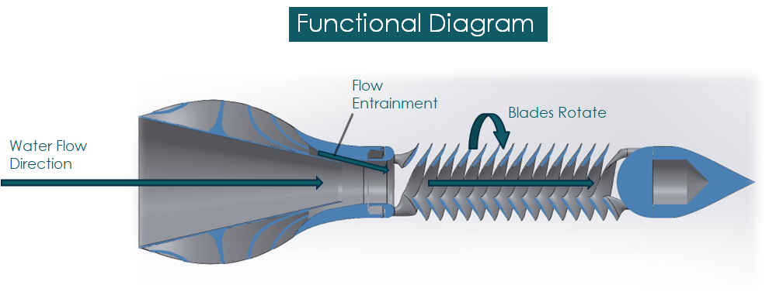
Figure 2: Asterion Team Redesign[8]

5.2 Our Design
Our design focused on the 3rd stage of the design concept by HatchTank, the helical blades. The goal was to find the ideal hydrofil shape, blade length, chord length, and angle of attack for the helical. The aforementioned parameters were adjusted such that the torque generated by helical blades was maximized while operating at a low RPM.
For our hydrofoil, after some initial research, 6 different hydrofoils were considered: NREL-S822, NREL-S825, NREL-S833, RISO-A-12,RISO-A-15, and RISO-A-18 [9]. The selected hydrofoils were to be analyzed for compatibility with our design. The analysis was performed via Blade Element and Momentum Element theory (BEM). The goal was to select the best 3 hydrofoils and perform CFD on them to make our final selection for prototyping.
The properties of these hydrofoils were analyzed via a matlab code based on BEM, taking into account profile drag, tip loss, wake rotation, and cavitation. The hydrofoils were ranked based on the potential torque obtained from the BEM analysis.
From our analysis, all researched hydrofoils depicted good performance at low angle of attack. To maximize the distances between the blades of our design, a high angle of attack was needed, hence, Eppler-e-817 was added to the selected hydrofoil list as it was the hydrofoil used by ASTERION. This was also to test the effect of a high angle of attack on our blades. NACA-63-218 was also, later, chosen as a replacement for the RISO hydrofoils due to the unavailable public information of the airfoil geometric coordinates.
Our design of the stage 3 was a tapered helical blade. The blades had three full revolutions and a total height of 24 meters in the horizontal direction. The major diameter of the blade was 6 meters with a minor diameter of 3.4 meters with a pitch length of 8 meters. The selected chord of the blade hydrofoil was 2.6 meters. The total number of blades in the full assembly was 3. The combination of parameters allowed the requirements from HatchTank to be met. Unlike Asterion, our blades remained tapered to maximize the velocity of fluid flow over each blade along its lengths.
Table 3: Helical Blade Dimensions
Major Diameter(m) | 6
Minor Diameter(m) | 3
Pitch Length(m) | 8
Height(m) | 24

5.2.1. Incorporation of Environmental and Sustainability Factors
At the initial stage of our design some environmental effects of our turbine in application were taken into consideration and designed against. From our first interview with Joseph Klein of Verdant Power, some factors to be considered in the design of hydro turbines were discussed. The major factors were turbidity, aquatic life, and on water activities.
There is the possibility that our design might stir its surroundings causing settled particles to rise and increase the turbidity of the water thus increasing its turbidity. This simple effect has the possibility of leading to a cascade of effects that would negate the environmentally safe requirement from our sponsor and our goal. A drastic increase in turbidity can make it harder for native aquatic plants to receive sunlight, which can lessen the food supply for fish and other marine animals. The blockage of sunlight caused by the increased turbidity also changes the temperature of the water near the bottom of the river, which can make it less habitable for aquatic life in that ecosystem.The dead animals and plant along with the increased turbidity of the water will make it unsanitary for domestic use as our design is targeting remote locations.
Furthermore, having a device near the surface of the water would disrupt water activities. Activities such as kayaking and boating would include the possibility of collision with the turbine which could damage the boat kayak endangering its residents. Similarly, fishing activities, a likely source of food for our target communities, would need to be halted as it includes the risk of entangling the fishing threads in the blades of turbine rendering both incapable of performing their services.
There is also the risk of collision of aquatic life with the turbine causing them to be killed and also damage the turbine in the process reducing its efficiency.
To combat the factors listed above some changes were made to our design. The 6 meter major diameter ensures that the turbine maintains a low RPM whilst the 24 meter height of the turbine in the horizontal allows for the generation of necessary torques. The low rpm guarantees that the device would not have the necessary motion or force to stir its surroundings to lead to increased turbidity and therefore negates the risk associated with turbidity.
By using a larger pitch of 8 meters, the design created bigger passageways for fish to swim through the blades. This design factor is coupled with the low RPM feature of our turbine in that fish can safely move between blades, as it has bigger gaps, with reduced rate of collision due to the lower speeds of rotation. Even if fish were to collide with the turbine, there would be no damage to both parties as the force of collision would be small allowing the fish to recover and swim away and our turbine undamaged. It saves both life and time since the turbine would not require disruption in its operation for maintenance.
To reduce the risk of encounters with people and their activities by the turbine on the water, the turbine is designed to be deployed at depths exceeding 10 meters. The turbine was analyzed and would not cavitate even past depths of 50. As such, the depth of the turbine can be easily adjusted in its environment. The change in fluid velocity to depth is not significant, hence, the turbine should still operate at maximum capability.

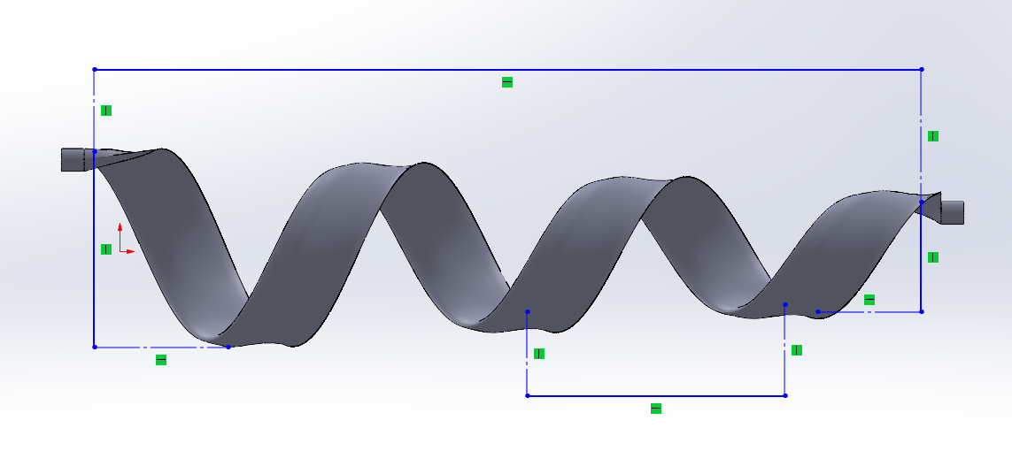
24m
3.4m
8m
6m
Figure 3: Helical Blade with NRELS825 Airfoil
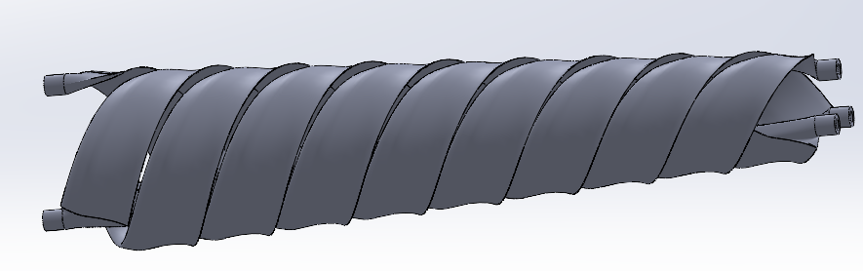

Figure 4: Helical Blades Assembly with NRELS825 Airfoil

Nomenclature
$a$ Axial Induction Factor  $a'$ Angular Induction Factor  $C_{d}$ Coefficient of Drag  $C_{l}$ Coefficient of Lift  $C_{p}$ Coefficient of Pressure  $C_{power}$ Coefficient of Power  $C_{t}$ Coefficient of Thrust  D Helix Diameter  $F$ Loss Factor  $F_{tip}$ Tip Loss Factor  $F_{hub}$ Glauert Correction  g Acceleration Due to Gravity  H Helix Height  $L$ Length of Helix  n Number of Helix Revolutions  P Helix Pitch Length  $P_{atm}$ Atmospheric Pressure  $P_{o}$ Local Pressure  $P_{s}$ Local Static Pressure  $P_{∞}$ Freestream Pressure  $R$ Radius of Rotor  $R_{hub}$ Hub Radius  $r$ Element Distance from Hub  $U$ Freestream velocity  $V_{i}$ Induced Velocity | $dT$ Element Thrust  $dQ$ Element Torque  $α$ Angle of Attack  $σ$ Solidity Ratio  $Ω$ Rate of Blade rotation  $ω$ Rate of Wake Rotation  $ϕ$ Relative Freestream angle  $λ$ Tip Speed Ratio  $λ_{r}$ Relative Tip Speed Ratio

Hydrofoil Profile Selection

6.1. NREL Hydrofoils
NREL hydrofoils have been specially developed to be used in horizontal axis wind turbines. The roughness effects of hydrofoils in NREL’s can be reduced by half relative to those developed for aircrafts. Three families of NREL hydrofoils were selected, namely S822, S825 and S833. S822 is a 16% thick foil developed for the tip regions of 3 to 10 meters diameter stall regulated turbines. S825 is designed for 20 to 40 meters horizontal axis turbine blades with variable speed and pitch, and has a thickness of 18 %. S833 is designed for turbine profiles of 1 to 3 meters with variable speed and variable pitch with a thickness of 18 %.
The S825 and S833 Hydrofoils have high lift coefficients and Lift-Drag ratios. The profile with the highest Lift-Drag ratio was the S833 which peaks at 150 at Reynold numbers in the turbulent range (1x10⁶).The pressure coefficient (C_{p}) for the S825 profile is the highest exceeding 12 at an angle of attack of 12 ($α=12ᵒ$). The cavitation number of S825 profile is likely to be more than the other two profiles especially when it is used at the tip regions of a blade. S822 and S833 hydrofoils have more or less similar pressure coefficients (approximates 10 at $α=12ᵒ$) which is lower than that of S825.

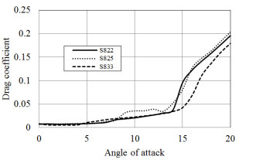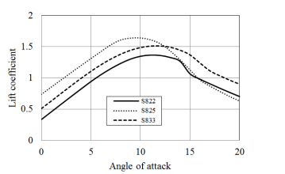

Figure 5:Lift and Drag Coefficients for NREL Blade Sections (1x10⁶)[9]

6.2. RISØ-A Hydrofoils
The RISØ-A foils were developed and optimized at RISØ National Laboratory in Denmark to be employed in wind turbines.This group of blade sections is characterized by their sharp nose. There are 4 blade profiles that were developed and tested (12,15,18, and 21) .They have quite low pressure coefficients providing high performance and low cavitation in hydrokinetic turbines. The design stall angle for these hydrofoils is 10ᵒ. The cluster has been developed to have seven foils between 30 to 12 % thickness. The 18 has a noticeably lower drag coefficient at the 10 degree stall angle while the lift data for all the blade sections is similar with the 12,15, and 21 having a higher lift coefficients at higher angles of attack (around 15ᵒ).
Because they are relatively new and there haven’t been many applications in marine energy, there haven’t isn’t much data on the geometry of the hydrofoil.
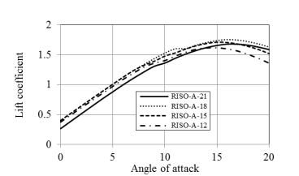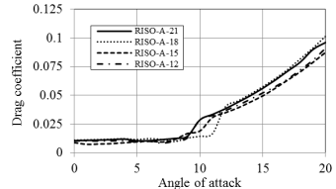
Figure 6:Lift and Drag Coefficients for RISO-A Blade Sections (1x10⁶)[9]

6.3. NACA
NASA is the most famously used hydrofoil for various applications such as aircraft wings, wind turbines and hydrokinetic turbines. They are widely known for their stall delay and less sensitivity to edge roughness [2].The most commonly used out of the NACA families are NACA 44 and NACA 63. Our NACA selections were NACA 4418, NACA63-818, and NACA 63-218. The NACA 4418 has a 18% thickness, and 4% camber at 40% of chord. The NACA 63 families all have a 18% thickness at 30% chord from the leading edge. NACA 63-818 has the greatest lift to drag ratio and coefficient of pressure making it more likely to cavitate. These are not good for stall regulated applications due to their high stall angles especially with NACA 4418 and NACA 63-218.
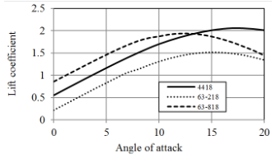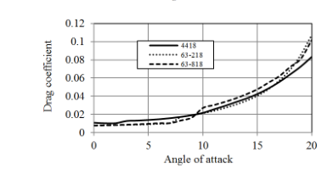
Figure 7: Lift and drag coefficients of NACA blade sections (Re=1x106).[9]

ANALYSIS

7.1. Hydrokinetic Analysis
The hydrokinetic analysis of the blades were performed via blade and momentum element method of blade analysis (BEM). The employed formulas took into account the wake rotation and state (turbulent/laminar), loss factor, and profile drag. Due to the helical nature and the lack of publicly available research on that, and also of resources provided by our sponsor HatchTank and researched, the blades were analyzed as straight blades in the vertical.The simplified blade allowed for the total length of each helical blade (L) to function as the blade radius ( R) in the blade analysis. For simplifications of calculations, the helical blade was assumed to not be tapered but rather have a uniform actual diameter (D) along its helical extrusion in the horizontal which also functioned as the hub diameter ($D_{hub }$) of the blade in the vertical geometric simplification of the helical blades. It was also assumed that the wake around the blades were laminar and that conditions on a single blade element was uniform to all elements of the blade.
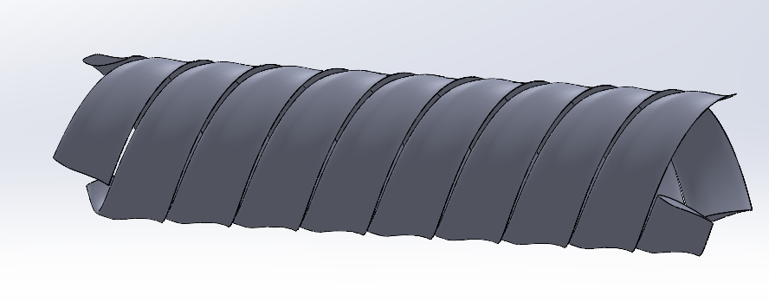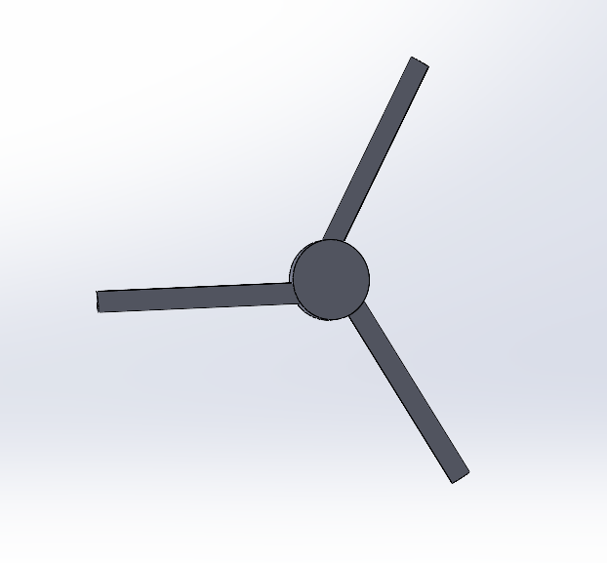
L
D
D
Figure 8: Design Simplifications for Analysis
The length of each blade L was calculated via integration on the characteristics of the blade.The changing parameter was the angle of revolution with n total revolutions obtained from the ratio of desired blade height (H) and pitch length (P). The revolutions were to $nθ$ , where $θ$ has a max value of 2π. The vector J designated the nature of the blade in the x ,y and z directions with respect to the angle of revolution 𝚹 and integrated over to obtain the total length L of each blade.
$J=<x,y,z>$ 1.1
$J=<\frac{D}{2}cosθ, \frac{D}{2}sinθ, Pθ>$ 1.2
$L=\int_{0}^{nθ}{}\sqrt{(\frac{dx}{dθ})^{2}+(\frac{dy}{dθ})^{2}+(\frac{dz}{dθ})^{2}}dθ$ 2.1
L=$2nπ\sqrt{{\left(\frac{D}{2}\right)}^{2}+P^{2}}$ 2.2
The process after the calculation of the blade radius R was an iterative process. The axial induction and angular induction factors of a single blade element, 3 m from the center of the hub, for our selected airfoils, were obtained at each angle of attack of each airfoil. The iteration process was considered unsuccessful, at an angle of attack, after a thousand induction iterations, or after generating imaginary or negative induction factors. The induction iteration was considered successful when a percent error of approximately 0 was obtained between previous and current iterations of induction factors, at an angle of attack, with a positive lift coefficient.
Axial and angular inductions factors are simply ratios of induced velocities to free-stream fluid velocities around rotors in the axial and angular directions, respectively. They represent the fraction of water velocities that are successfully used by the rotor and in our case blades. Hence, a high induction factor means higher successful conversion of water velocities to blade velocities. The induction factors also represent the disturbance of fluid downstream due to the extraction of velocities which reduces the efficiency of the overall turbine system. Therefore, a balanced axial and induction factors are sought. Equations 3.1 and 4.1 are definition induction equations[10]:
$a=\frac{V_{i}}{U}$ 3.1
$a'=\frac{ω}{2Ω}$ 4.1
where a is the axial induction factor, $V_{i}$ is the blade induced velocity, and U is the freestream velocity. Similarly, $a'$ is the angular induction factor, $ω$ is wake rotation, and $Ω$ is the blade rotation.
$Ω=\frac{U}{R}$ 5.1
where U is freestream velocity and R is radius of helix.
When taken into account BEM and loss factors, the induction factors can be further simplified. The wake around the blade can either be laminar or turbulent and is represented by the coefficient of thrust $C_{t}$. There are two derivations for the axial induction factor based on $C_{t}$ [11]:
$C_{t}=\frac{σ(1-a)^{2}(C_{l}cosϕ+C_{d}sinϕ)}{sin^{2}ϕ}$ 6.1
where a is the axial induction, $C_{d}$ and $C_{l}$are drag and lift coefficients, respectively, $σ$ is solidity ratio,and $ϕ$ is the relative freestream angle.
When $C_{t}≤ .96F$:
$a={\left[1+{\frac{4Fsin^{2}ϕ}{σ(C_{l}cosϕ+C_{d}sinϕ)}}^{}\right]}^{-1}$ 3.2
When $C_{t} > .96F$:
$a=\frac{18F-20-3\sqrt{C_{t}(50-36F)+12F(3F-4)}}{36F-50}$ 3.3
where F is a loss factor. When $C_{t}> .96F$, it implies a turbulent wake whilst laminar wake is observed when $C_{t}≤ .96F$. The axial induction, $a'$, does not change in both laminar and turbulent wake.
$a'={\left[{\frac{4Fsinϕcosϕ}{σ(C_{l}sinϕ-C_{d}cosϕ)}}^{}-1\right]}^{-1}$ 4.2

According to the lecture slides by Dr. James VanZwieten, it is “convenient” to ignore $C_{d}$ in $C_{t}$, $a$, and $a'$ without significant changes to the results of the analysis of the rotor system [10]. However, in our analysis, $C_{d}$ was considered and the wake around the blades was assumed to be laminar. The solidity ratio can be obtained from Equation 7.1 [10]:
$σ=\frac{Bc}{2πr}$ 7.1
where c is chord length, B is the number of blades, and r is the element distance from the center of the hub.
The loss factor is a combination of Prandtl tip loss and Glauert correction (hub loss):
$F_{tip}=\frac{2}{π}cos^{-1}[e^{\left(\frac{-B(L-r)}{2rSinϕ}\right)}]$ 8.1
$F_{hub}=\frac{2}{π}cos^{-1}[e^{\left(\frac{-B(r-R_{hub})}{2R_{hub}Sinϕ}\right)}]$ 9.1
$F=F_{tip}F_{hub}$ 10.1
where $F_{tip}$ is the Prandtl tip loss, $F_{hub}$ is Glauert correction, $R_{hub}$ is the radius of the hub. The Prandtl tip loss accounts for the assumptions of infinite blades by the BEM and Glauert correction accounts for wake formation at greater speeds. However, Glauert is invalid in hydrofoil analysis due to the incompressible nature of water.
The last parameter needed for iteration was $ϕ$, the relative freestream angle[10]:
$ϕ=tan^{-1}\left(\frac{(1-a)}{(1-a^{'})λ_{r}}\right)$ 11.1
$λ=Ω\frac{R}{U}$ 12.1
$λ_{r}=λ\frac{r}{R}$ 13.1
where $λ_{}$ and $λ_{r}$ are tip speed ratio and relative tip speed ratio, respectively.
After each successful iteration convergence, the torque and thrust of the Momentum and Blade element were calculated along the coefficient of power using the obtained axial and angular induction factors[10]:
For momentum element theory:
$dT_{M}=4a'(1+a')\frac{1}{2}ρΩ^{2}r^{2}2πrdr$ 14.1
$dQ_{M}=4a'(1-a)\frac{1}{2}ρUΩr^{2}2πrdr$ 15.1
For blade element theory:
$dT_{BE}=(C_{l}cosϕ+C_{d}sinϕ)\frac{1}{2}ρ{U_{r}}^{2}Bcdr$ 16.1
$dQ_{BE}=(C_{l}sinϕ-C_{d}cosϕ)\frac{1}{2}ρ{U_{r}}^{2}Bcrdr$ 17.1
where $dT$ notation represents element thrust and $dQ$ element torque, $ρ$ is water density, and $U_{r }$ is fluid relative velocity.
$U_{r}=Ωr\frac{(1+a')}{cos(ϕ)}$ 18.1
The coefficient of power $C_{p}$ is represented by
$C_{p}=\frac{8}{λ}\int_{λ_{h}}^{λ}{}F{λ_{r}}^{3}a'(1-a)\left[1-\frac{C_{d}}{C_{l}}cotϕ\right]dλ_{r}$ 19.1
where $λ_{h}$ is the tip speed ratio (Equation 12.1) with $r$ equal to $R_{hub}$.
The iteration procedure is summarized in flowchart below:
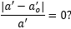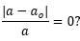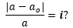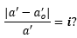
Start

a=0
a’=0

a=0
a’=0

End
YES
YES
YES
NO
NO
NO
Calculate
I = 0
Read at A
Calculate
Calculate
a , a’
I >1E3
OR
OR
AND
AND
Calculate
Store
Save Storage
Figure 9: Flow Chart of Iteration Process

7.2. Cavitation Analysis
Cavitation in turbines is the formation of water vapor around blades due to the reduced pressure. Cavitation occurs when the pressure around the blade falls below that of the vapor pressure of water causing vaporization of the water and bubble formation in blades. This phenomenon could lead to damages to blades of turbines from the shock waves of the popping blades which would reduce the life and efficiency of the blades and needed to be designed against[8]. Cavitation is governed by Equations 20.1 and 21.1:
$σ_{cav}=\frac{P_{o}-P_{v}}{q}$ 20.1
$C_{pressure}=\frac{P-P_{∞}}{.5ρU^{2}}$ 21.1
where $σ_{cav}$ is cavitation number, $P_{o}$ is the total local pressure around blade, $q$ is the dynamic pressure, P is local static pressure, and $P_{∞}$ is the freestream pressure. Cavitation occurs when $\left|C_{pressure}\right|>σ_{cav}$.
The pressures can be obtained from Equations 22 to 26:
$P_{o}=P_{atm}+ρgh+\frac{1}{2}ρU^{2}a(2-a)-\frac{1}{2}ρ(ΩrR)^{2}$ 22.1
$q=\frac{1}{2}ρ{U_{r}}^{2}$ 23.1
$P_{S}=P_{o}-q$ 24.1
$P_{∞}=P_{s}+\frac{1}{2}ρU^{2}$ 25.1
$P_{v}=6.211e^{\left(\left(18.678-\frac{T}{234.5}\right)\left(\frac{T}{T+257.14+T}\right)\right)}$ 26.1
where $P_{atm}$ is atmospheric pressure, h is depth of turbine, and g is the acceleration due to gravity. $P_{v}$ was obtained using the Arden Buck equation where T is temperature, at the deployed depth of the turbine, in celsius[12].

Results And Discussion
The observed performance parameters from the analyses result followed a trend; $C_{l}/C_{d}$, Torque, Power. From all the tested hydrofoil the greater the lift to drag ratio ($C_{l}/C_{d}$), the higher the torque generated, and the greater the power generated except for NACA 4418. This trend confirmed the accuracy of our analysis as the greater $C_{l}/C_{d}$ the higher the lift being generated by the hydrofoil, hence, higher performance.
However, to measure the actual accuracy of the analysis, the values obtained from the Blade Element theory (BET) and Momentum Element theory (MET) needed to be compared. From our results, the percent error in both Lift and Torque from the BET and MET were low, especially for the torque. The percent error between BET and MET for torque was relatively 0 . For the lift, excluding NACA 4418, the highest percent error was 6.1% for NREL S822 which is still low and acceptable.
NACA 4418 had a unique result in comparison to the other airfoils. It had a negative coefficient of lift to drag ratio of 2.91. The analysis did not allow for the convergence of negative lift coefficients,hence, the negative was from the drag coefficient. This implied the lift was being increased by the drag. From the analysis, ANCA 4418 had the best performance out of hydrofoil tested but also had the greatest percent error of 49.2% for the BEM percent lift although had about 0 percent torque error. Due to the high lift percent error, it was not considered as good data and disregarded.
The induction factors from all the analyses were in the ranges of .28 to .31 for the axial induction and .16 to .25 for the angular induction factor. This result is good as it shows although some velocities are being extracted from the water flow, it is not necessarily slowing it down and therefore would not impact the water environment activities on the water negatively. Furthermore, the efficiency of our device is less likely to be impacted and reduced by the water downstream in application.
There were multiple angles of attack convergence for each hydrofoil, however, the angle with the best performance was selected and recorded from the analysis.
From the analysis the best hydrofil was NREL S825. NREL S825 had the greatest performance, excluding NACA 4418, in all performance observed parameters; Power, Torque, $C_{l}/C_{d}$. NREL S825 was projected to generate a power of 2.1 MW with a torque of 140 MNm. Its coefficient of lift to drag ratio was 144.77, the greatest out of the tested parameters with the lowest percent lift error of 1.6%.
From the analysis the three selected hydrofoils for further analysis of performance were NRELS s825, NACA-63-218. Note that although the Eppler-e817 was analyzed and an angle of attack of $5^{ο}$ as the best angle of attack for the hydrofoil for our design, the assigned angle of attack for further testing was $30^{ο}$. This decision was made due to the average low angle of attack of convergence of BEM to test the effect of high angles of attack on our design.

Table 4: Best Performing Angle of Attack for Tested Hydrofoils.
Hydrofoil | α | Power(W) | Torque(Nm) | Torque %Error | Lift %Error | a | a’ | $C_{l}/C_{d}$
NREL S822 | 14 | 1956688.69 | 134568394.5 | 0 | 6.10 | 0.292 | 0.167 | 38.58
NREL S825 | 5 | 2105429.61 | 140258320.5 | 2.075e-14 | 1.599 | 0.307 | 0.178 | 144.77
NREL S833 | 12 | 2010474.47 | 136759866.0 | 2.129e-14 | 4.501 | 0.302 | 0.172 | 52.23
Eppler-e817 | 9 | 2008129.42 | 136309387.6 | 4.340e-14 | 4.265 | 0.286 | 0.168 | 54.31
NACA-63-218 | 12 | 1989072.10 | 135631557.7 | 2.146e-14 | 4.909 | 0.287 | 0.167 | 47.41
NACA 4418 | 5 | 5234237.10 | 225348441.65 | 3.875e-14 | 49.205 | 0.191 | 0.244 | -2.91

Computational Fluid Dynamics
During the beginning stages of our project, the main focus was research. We researched hydrofoils for the turbine blades. The goal was to create a turbine model for selected hydrofoil, post analysis, and run a CFD simulation to determine the hydrofoil with the best performance and finalize the hydrofoil selection.Three different classes of our best performing hydrofoils were to be selected for this stage. With our current analysis result, the selected hydrofoils would have been NREL S825, NACA 63-218, and Eppler-e817. Our institution does not provide access to CFD softwares or offer CFD courses. As such, FreeCad was used. This open-source 3D modeling software utilizes OPENFOAM as an engine for its CFD module. FreeCAD, however, proved to be much more challenging to learn than expected. The first few months of the fall semester were spent educating and familiarizing ourselves with CFD and freeCAD.
FreeCAD when performing CFD analysis required a lot of power. While running a few tutorial simulations in an attempt to get a better understanding of the software, our personal computers continuously crashed. The team was forced to perform the simulation via our advisor’s computer, which had ten available CPUs. To successfully run a simulation, we had to employ 9 of the 10 available CPUs. This project is being performed for CAPSTONE, hence, a professor was our lead advisor, Dr. Masoud Masoumi. Unfortunately, Dr. Masoumi left the following semester depriving us access to his advice that was used for the CFD. As such no CFD were performed and the method of prototyping became our sole means of finalizing our hydrofoil selection post analysis.

Challenges of the Design Process
Throughout this project, we have learned a significant amount about the design process and the challenges that come along with it. One of the challenges we faced was coordination and integration with multiple disciplines. Since we have team members both from the engineering and business side, it was at first difficult to get on the same page and coordinate our schedules and efforts. From this obstacle however, we learned how to work with other fields. This is one of the most important qualities that we can take into the workforce as any project in the field will require some level of interdisciplinary communication to work with people from different areas of expertise.
Another challenge we faced was the scheduling and planning of the project. In a project there are always unforeseen issues, for example, the amount of time that it took for us to 3d print our prototype. When we initially created a schedule for the semester, we did not properly account for these obstacles, and were optimistic in our time estimations. This taught us to always allow for a proper cushion when scheduling, so that if things go wrong, you do not fall behind schedule. During the course of this project, we also learned how to work under a budget. Economics is a very important aspect of engineering that is not as heavily focused on during education as it should be. When working in the field, every project has a budget, and it is a goal of engineers to design and complete the project while staying under the budget. Ultimately, this project has helped to hone the non-technical skills that will be valuable to us in our careers, and given us an insight into working on a project in the professional world.

Build and Test

11.1 Concept Development
The original design from Hatch Tank, as seen in Fig.1, was designed under the conditions of minimizing the vertical footprint, maximizing the blade surface area, and maximizing the torque at a low rpm. This design however had room to be improved. It was found by the Asterion team that the performance could be enhanced by remodeling the three main stages of the project. The inlet in the first stage was changed to a basic converging nozzle, with paths for entrainment integrated into both the inlet and second stage of the project. Switching to a converging nozzle and removing the bulb present in stage one of the original concept allows for an increased volume of water to pass through the turbine. The added entrainment paths integrated throughout stages 1 and 2 also aim to increase the water flow through the turbine. For stage three the asterion team switched to a straight blade orientation, and significantly increased the angle of attack, they also decided to use the Eppler 817 hydrofoil as the profile for their blades. Their redesign yielded positive results, and was an improvement from the original design, our goal however was to develop the design even further.

Since the Asterion team did a lot of work to improve stages 1 and 2, most of our focus was on the improvement of stage 3. The first change we made was switching from straight blades to tapered blades. The reason for this decision was that the tapered blades would allow for more water flow to interact with blades closer to the generator, and would minimize the wake effect caused by the blades. This would hopefully increase the torque put onto the blades, and thereby increase our power output. Another major focus of our project was finding a more effective hydrofoil, and changing the angle of attack, chord length, and pitch length.

11.2 Design Process
During the beginning stages of our project, the main focus was research. We began by researching hydrofoils to find a hydrofoil we could use as a profile for the turbine blades. Based on our research, we found a list of hydrofoils that could be utilized for our concept. We aimed to create a turbine model for each hydrofoil and run a simulation to determine the hydrofoil with the best performance. Our first method for determining this was using computational fluid dynamics (CFD) analysis software. Since our institution cannot access premium CFD software, we decided to use FreeCad. This open-source 3D modeling software utilizes OPENFOAM as an engine for its CFD module. FreeCAD, however, proved to be much more challenging to learn than we expected. We spent the first few months of the fall semester educating ourselves on how to work in freeCAD so that we would be able to model the turbine properly. Another issue with the software was that the CFD analysis was computationally expensive. While running a few tutorial simulations in an attempt to get a better understanding of the software, our personal computers continuously crashed. This forced us to simulate it on our advisor’s computer, which had ten available CPUs. To successfully run a simulation, we had to employ 9 of the 10 available CPUs. Based on the complexity of the software and the required computational power, we decided that using this software would not be an efficient way to model our turbine.
After deciding to forgo a CFD analysis on our design, we decided to create a MATLAB code. This code would take the hydrofoil shapes as an input and calculate the torque, lift, and power for each hydrofoil at specific angles of attack. The code also had the capability to predict cavitation based on the blade profile. These output values were then tabulated into an Excel sheet, as shown in Table 4 above.
The goal of using this Matlab code was to narrow down our possible options for hydrofoils so that we would save our resources on physical testing of all possible hydrofoil shapes. Based on table 4 above, we can see that the best-performing hydrofoils are the Eppler-e-817, NREL S825, and the NACA-63-218. During testing, we also found a RISO hydrofoil that performed very well, but the RISO hydrofoil was eliminated from contention since the coordinates were not available online, so we would not be able to model the blades using the RISO profile. Besides this, we were able to successfully create three separate 3D models that we would be able to test physically.
During our attempt to physically test our product, we faced several challenges. The first challenge we faced was finding a place where we would be able to test our device. Our school has a small flume of 0.3 meters by 0.5 meters, with a maximum flow rate of 0.014 cubic meters per second. These conditions are not ideal since the actual dimensions of our turbine are approximately 8 meters in diameter with a 40-meter length. The turbine was designed for a flow of approximately 2.5 meters per second. Hence, the turbine operates at a high Reynolds value (in the millions) and would require higher velocity, as it is scaled down, to properly simulate the actual environment of the turbine.
An attempt was made to find alternate locations with the desired flow speed. The attempts were unsuccessful. No location could meet our size and flow speed requirements. The focus once again shifted to the school flume with an interest in devices that could potentially accelerate the flume fluid flow for our purpose. This proved challenging as well. The team would need a device that could bring the flow speed up to nearly 180 meters per second. Devices such as water jets were researched, but after looking into all possible options, it was decided that no device would meet our required flow speed. It was decided then to prototype our model and under the assumption of adequate environment simulation by the school’s Flume, would use the flume for our test and finalize our hydrofoil selection. However, the next obstacle hindering our progress was the prototyping itself.
To at least increase the efficiency of our build for testing, a higher model was sought. The mode of prototyping was to be 3D printing and as such needed bigger printing space. The 3D printers at our school had a small space of 256 mm by 256 mm by 256 mm. Hence, the team attempted to outsource our 3D printing for a bigger prototype. We reached out to different companies in an attempt to outsource our 3D printing job, but the quotes received were high and extremely expensive and would put us over budget. The team was able to obtain a printer dimension that would print bigger parts through Aaron Andrade but later realized the dimensions provided were for the printer and not the printing space. That printer had the same printing space as our school 3D printer. The team still decided to split our parts between the two printers to reduce the time spent on printing.
With our current 3D printing space, our model was to be scaled by a factor of .89%. The necessary materials were obtained. A fiber-glass material was selected for printing the helical blades and forwarded to Aaron. The other parts, included a makeshift inlet and bulb, were sent to our school to be printed with ABS. Components for assembly were also purchased including two ball bearings of sizes 35 mm and 25mm for the inlet and outlet, respectively, 15 packs of M2 by .4 mm of 4.1 mm length heat inserts, 10 packs of M2 by .4 mm of 8 mm length , and a 3.175mm shaft waterproof brushless motor.
There were some other complications with 3D printing. The first was the limited availability of the school's 3D printing due to other projects at the school and miss dimension in model due to an error that was spotted in our analysis and resolved. The angle of attack of our model changed based on the result prompting a recall of parts to be printed and a redesign of models. Furthermore, there was some faulty printing with Aaron’s printer that required starting the process of 3D printing from scratch. There were also faulty print jobs, where the supports would be too heavy due to the shape of our turbine blades. We also had difficulty finding a proper bearing. At first, we attempted to print the bearing, but since the diameter was so small, the printed bearing would not rotate properly, and all iterations of the bearings were unsuitable for testing. We then decided to buy a bearing online, but this came with its challenges, as now we had to ensure that the bearing would adequately fit into the prototype. Luckily, we could find a proper bearing that would cooperate with our design. We were eventually able to finish printing and assembling our turbine, which can be seen below in fig.10.
While the printing of the turbine had been completed, we also had issues with the testing of our turbine since we had to schedule a time where the necessary faculty could be present in the lab with us. Since we had already fallen behind schedule, we were unfortunately not able to test our turbine in the flume, and were not able to get physical results for our prototype.
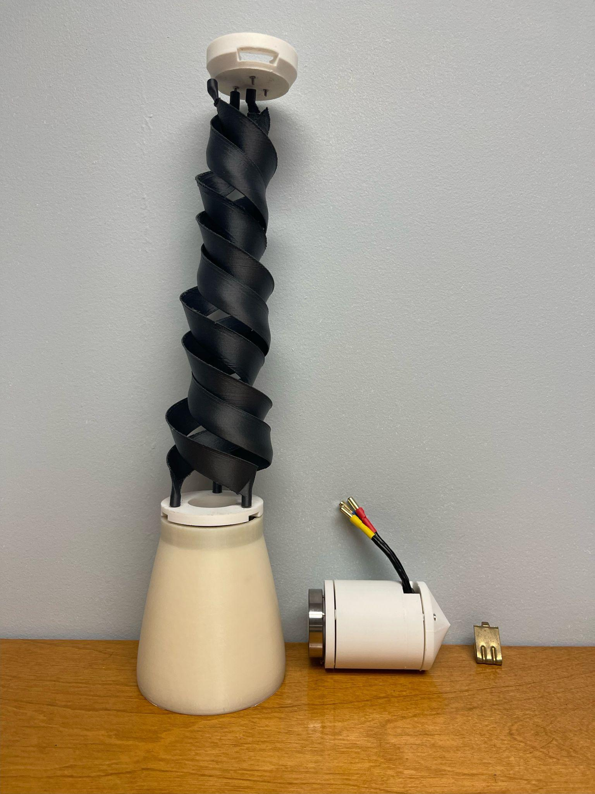
Figure 10: Assembled Prototype

Conclusion and Future Work
Our design is one that will be significant to the advancement of the hydropower industry. Our turbine is able to generate a large amount of power, while being environmentally safe due to the tapered blades, minimal vertical footprint, and low rotational speed. This design is especially important for remote communities, where energy is not easily accessible. Many of these communities rely on diesel fuel for electricity, which emits a very large amount of carbon dioxide, and also presents risks during storage and transportation. Our turbine is also a better alternative than solar or wind power, since hydropower is more reliable, and less weather dependent.
Throughout the design process of our prototype, we were able to learn many valuable lessons, despite not being able to physically test our turbine. First, we learned to always prepare for unforeseen obstacles, and incorporate ample time for that within your schedule. We also learned how to design under the constraint of a budget, and to take economic reasons into account for every design decision. This is a skill that we will be able to take into our lives, and will better prepare us for our work in the field. Another very important skill that we gained during this project was the ability to coordinate with colleagues from different areas of expertise, this is another quality that is very important in the field, and will be very beneficial to all of us during our professional careers.
For future teams, the first goal should be to run physical tests on our design to create baseline values. Once the tests have been run, the future team should experiment with other hydrofoils with the goal of increasing the torque and power output. Another objective should be to find a testing site that will allow the turbine to be scaled down by a larger factor, so that the required velocity conditions will be easier to create. Lastly, any future teams working on this project should try to further optimize the inlet, as most of our research was focused on the blades of the turbine.

References:

- LiVecchi, A., A. Copping, D. Jenne, A. Gorton, R. Preus, G. Gill, R. Robichaud, R. Green, S. Geerlofs, S. Gore, D. Hume, W. McShane, C. Schmaus, H. Spence. 2019. Powering the Blue Economy; Exploring Opportunities for Marine Renewable Energy in Maritime Markets. U.S. Department of Energy, Office of Energy Efficiency and Renewable Energy. Washington, D.C.
- “Hydropower & Dams.” Hatch, https://www.hatch.com/Expertise/Energy/Hydropower-and-Dams.
- Asmus, Peter. “How Alaska Fits into the Global Microgrid Movement.” University of Alaska Fairbanks, 29 July 2022, https://www.uaf.edu/acep-blog/how-alaska-fits-into-the-global-microgrid-movement%20.php.
- “Report to Congress - Remote Areas of Alaska: Affordable and Reliable Options for Meeting Energy Needs and Reducing Emissions.” Department of Energy, https://www.energy.gov/node/4592765.
- “Ocean and River Hydrokinetic : REAP.” Renewable Energy Alaska Project, https://alaskarenewableenergy.org/technologies/ocean-and-river-hydrokinetic/.
- “Critical Pathways to Renewable Energy in Remote Communities: A Comparative Analysis of Renewable Energy Transitions in Alaska.” Renewable Energy, https://renewableenergy.usask.ca/cases-resources/walket-et-al-2022.pdf.
- “Free-Flowing River Revs Up Resilience of Alaska Native Village.” Department of Energy, 10 December 2020, https://www.energy.gov/indianenergy/articles/free-flowing-river-revs-resilience-alaska-native-village.
- Mauricio Bailey, Colin Coker, Mikaela Gonzalez, Fabian Loperz, “Final Report for Team Asterion’s ‘Helical Water Turbine’ Spring 2023”, UTSA.
- Muratoglu, Abdullah & Yuce, Mehmet. (2015). Performance Analysis of Hydrokinetic Turbine Blade Sections. Advances in Renewable Energy. 2. 1-10.
- James VanZwieten, Carey M. Oster, Alana E.S. Duerr (2011) “Design and analysis of a rotor blade optimized for extracting energy from the Florida Current” in Proceedings of the ASME 2011 International Conference on Ocean, Offshore, and Arctic Engineering, Rotterdam, Netherlands, June 19-24, no. OMAE2011-49140
- Li, Haifeng, "Modeling and simulation of hydrokinetic composite turbine system" (2014). Doctoral Dissertations. 2502.
- Wikimedia Foundation. (2024, February 25). Arden Buck equation. Wikipedia. https://en.wikipedia.org/wiki/Arden_Buck_equation
- “DOE Partners With 9 Island and Remote Communities to Boost Resilience and Plan for Low-Cost Renewable Energy Systems.” Department of Energy, 25 July 2023, https://www.energy.gov/eere/articles/doe-partners-9-island-and-remote-communities-boost-resilience-and-plan-low-cost.
- “Rural Energy For America Program (REAP) | Rural Development.” USDA Rural Development, https://www.rd.usda.gov/inflation-reduction-act/rural-energy-america-program-reap.
- “What We Do > Renewable Energy and Energy Efficiency Programs > Energy Efficiency & Conservation > Renewable Energy-Village Energy Efficiency Program.” Alaska Energy Authority, https://www.akenergyauthority.org/What-We-Do/Renewable-Energy-and-Energy-Efficiency-Programs/Energy-Efficiency-Conservation/Renewable-Energy-Village-Energy-Efficiency-Program.
- “Alaska Profile.” U.S. Energy Information Administration (EIA), https://www.eia.gov/state/print.php?sid=AK.
- IRENA – International Renewable Energy Agency, https://www.irena.org/.
- “U.S. energy facts explained - consumption and production.” U.S. Energy Information Administration (EIA), https://www.eia.gov/energyexplained/us-energy-facts/.

https://www.eia.gov/state/analysis.php?sid=AK

