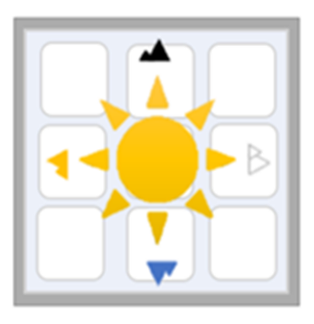

NAVAJO NATION SOLAR INITIATIVE
  - DURANGO, COLORADO

To empower individuals and families on the Navajo
Nation by facilitating access to renewable energy,
specifically solar power

Laurie Williams

Camille Keith

Jessica Rupe
Martine Tsosie
Marc Stevens

Durango/CO/81301, williams_l@fortlewis.edu, 970-682-8415
Durango/CO/81301, crkeith@fortlewis.edu, 406-212-3764
Durango/CO/81301, j.mariepierce@gmail.com, 970-388-5416
Durango/CO/81301, mrtsosie@fortlewis.edu, 505-360-3063
Dawes County/NE/69367, marc@offgridsolutions.us, 308-430-3765

