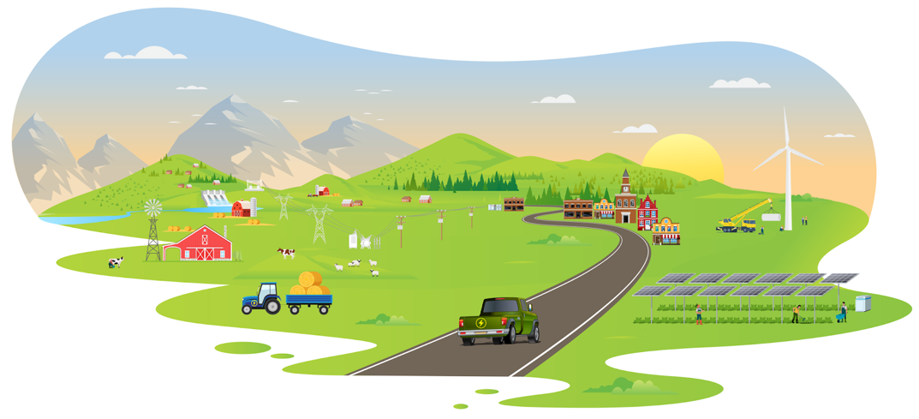

Energizing Rural Communities Prize

Title: Is this heaven? No, it’s Iowa (solar powered)
Team Name: QstN
Team location: Des Moines, Iowa
Project Location: Grinnell, Iowa

We are building resilience into rural grocery stores through energy efficiency and renewable energy projects by engaging ESG investors

Video Link:
https://youtu.be/5BEJSHZdSuo

Our Partners:
Fareway www.fareway.com
Joel Fortney www.linkedin.com/in/joelfortneycfa/
Solar Design Studio www.solardesignstudio.com/

