

Wallowa County Microgrid Resiliency Corridor
Wallowa County, Oregon
(County Population: 7700)

Interconnected Microgrids for the Cities of Wallowa, Enterprise & Joseph
Powered by Locally Available Renewable Energy Feeding Local Critical Infrastructure
Fish Compatible Hydropower, Solar, Forest Residuals Biogas

Wallowa Resources Project Team

JOSEPH BASILE GAVIN COLLIER

Community Energy Program Manager Community Energy Project Coordinator

joe@wallowaresources.org gcollier@wallowaresources.org
541-426-8053 ex. #52 541-426-8053 ex. #68
Nils Christoffersen
Wallowa Resources, Executive Director
nils@wallowaresources.org
541-426-8053 ex.# 25

Project Partner Organizations
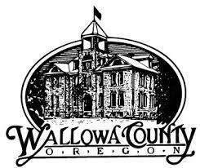


Wallowa Resources Microgrid 3 Minute Video Link

