SUN Rural Solar Projects & Workforce Development, Barnwell County

Competitor Name
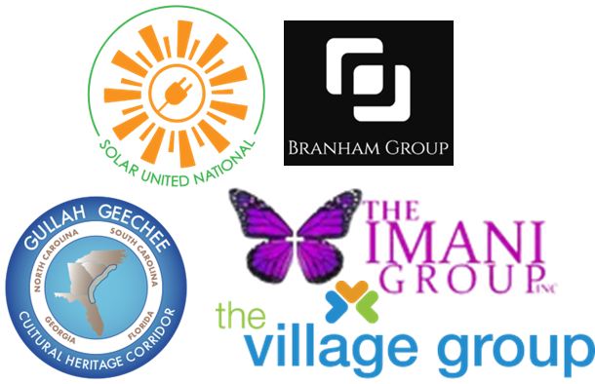
SUN Rural Solar Projects & Workforce Development

Organization
Solar United National, LLC.
Brad Leon
Brad@solarunitednational.com
843.345.9025
https://solarunitednational.com/
Zip: 29464-9502

Location of Primary Benefits
WILLISTON, SC 29853-5024

Short Descriptions of Proposed Plan, Activities, and Use of Prize Funds
Projects have two components, a community solar farm, and a community-owned training building where paid trainees learn hands-on by building solar farms. Solarized training buildings are anchors of a microgrid providing grid resilience and disaster recovery with energy storage and electric vehicle chargers. Our workforce development program is a 5-week, paid, hands-on introduction to clean energy opportunities in the communities we serve. To realize these projects, we will need to make required grid upgrades.

Activities and Use of Prize Funds
There are three categories of activities, Community Development, Workforce Development, and Project Development. All activities are planned to achieve the prize goals.

Link to 3-minute video
https://vimeo.com/829208920

Project Members
Team Lead Name: Brad Leon – Solar United National – Solar Developer
Team Member 2: Grant Scheffer – Solar United National – Solar Developer
Team Member 3: Drew Harris – Solar United National – Solar Developer
Team Member 4: Jarrett Branham – The Branham Group - EPC
Team Member 5: Rev. Brendolyn Boseman – The Imani Group – Barnwell Community Partner
Team Member 6: Marilyn Hemmingway – The Gullah Geechee Chamber of Commerce – Georgetown Community Partner
Team Member 7: Ray Funnye – The Village Group – Georgetown Community Partner

We are submitting two entries as a single team. This entry focuses on three rural solar projects in Barnwell County, SC. The other entry represents two communities over 170 miles away near Georgetown, SC.

