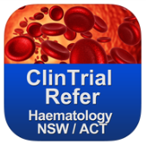
ClinTrial Refer A tool to use to cross-refer patients
Improving recruitment to clinical trials- A template for cancer networks to collaborate.
The Haematology Clinical Research Network (HCRN) is a network of clinical trial unit managers and coordinators throughout Australia. One core objective was to develop strategies to break down cross-referral barriers between hospitals. We developed an App, ClinTrial Refer, with key search filters of Disease, Location & Sponsor.
Real-time data entry is from the trial unit managers at each site. The streamlined database ensures currency of trial information at the fingertips of the user. Used as a template, we have been replicating this recruitment tool to other disciplines and areas. Each new derivative app provides a platform for a new collaboration between like-minded clinicians to cross-refer participants. Each new app is tailored to specific use. The trial unit managers from participating trial sites deliver updated data on their recruiting trials to the app manager (usually one of the trial unit managers, or a collaborative group administrative officer). This data is entered into a user-friendly password-protected web-based database.
This means that trial data in the App is current and comprehensive- but is also targeted to the audience. There is a contact email, where doctors can email from their smartphones for information immediately. Not all trial data- targeted trial knowledge.
Free to download, doctors, trials staff & patients can access this data anywhere, all the time. The App is a tool which enhances knowledge management, and facilitates communication and co-operation. Doctors can find trials across their local area, and contact the site immediately.
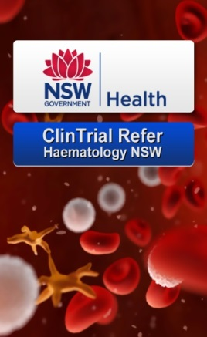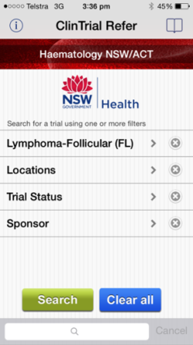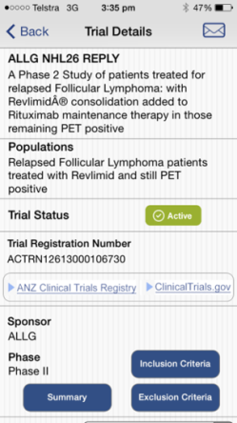 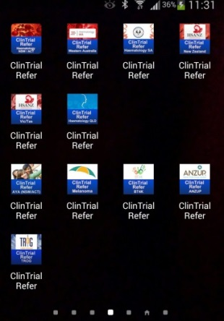
We would like to implement this template across as many disciplines and geographic areas as possible. It has already been adapted for other haematology and oncology (Melanoma, AYA, Children’s hospitals NSW, Urogenital, Radiation Oncology) collaboratives throughout Australia, and overseas in France (LYSA, The Lymphoma Study Association), and New Zealand. We would like to spread this successful initiative across the world.
The single physician/hospital model of care for clinical trials is being challenged in a new era of collaboration.
Trial Knowledge, current and targeted allows clinicians to easily refer patients across hospitals.

