
U.S DOE Inclusive Energy Innovation Prize: Phase One
MKE Energy Partners
Flip the Switch! Innovative Energy Solutions
from Communities, for Communities
Milwaukee, WI
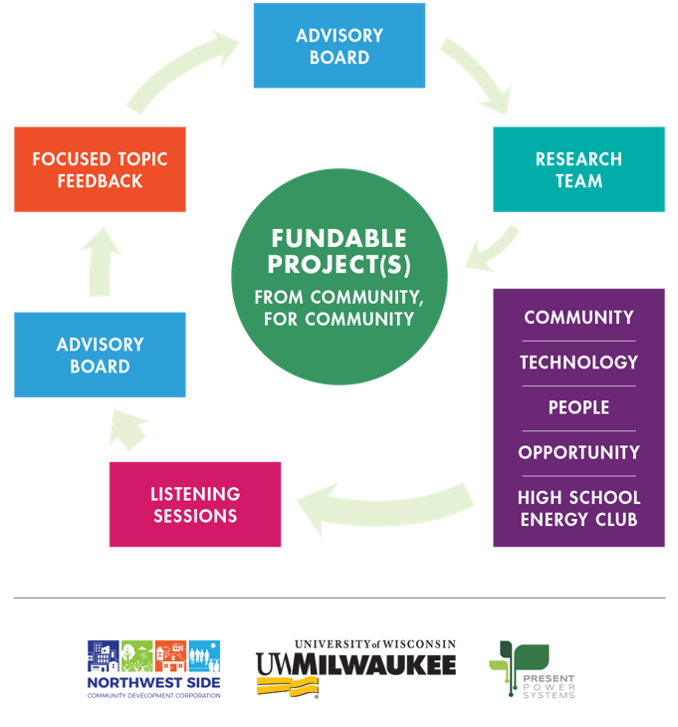
Working together towards a clean and prosperous future by collaborating with disadvantaged communities to enact positive, sustainable economic and lifestyle advantages through community and business partnerships, using clean energy technologies as the catalyst.

https://www.youtube.com/watch?v=PNC2WcQ0310
Partners and Team Members:
Northwest Side Community Development Corporation:
Willie Smith, Executive Director, wsmith@nwscdc.org, 414-447-8230, https://www.linkedin.com/in/willie-smith-899185b/
Andrew Haug, Senior Development Manager, ahaug@nwscdc.org, 651-399-4554, https://www.linkedin.com/in/andrewhaug/
University of Wisconsin-Milwaukee:
Robert Cuzner, Director, Center for Sustainable Electrical Energy Systems; Site Director, NSF Grid-Connected Advanced Power Electronic Systems; Associate Professor, Electrical Engineering & Computer Science, cuzner@uwm.edu, 262-923-0701, https://www.linkedin.com/in/rob-cuzner-5608812/
Antoinette Spector, Assistant Professor, Department of Rehabilitation Sciences & Technology, aspector@uwm.edu, 414-251-7029, https://www.linkedin.com/in/antoinette-spector-pt-dpt-phd-6b984636/
Present Power Systems:
Jason Katcha, CEO and Co-Founder, jason@presentpowersystems.com, 414-704-0274, https://www.linkedin.com/in/jason-katcha-0553754/

