SEEEDing Knoxville’s Just Energy Ecosystem

Knoxville, Tennessee, in urban Appalachia

Team SEEED Knox’s video https://youtu.be/uzc22fhSV_k
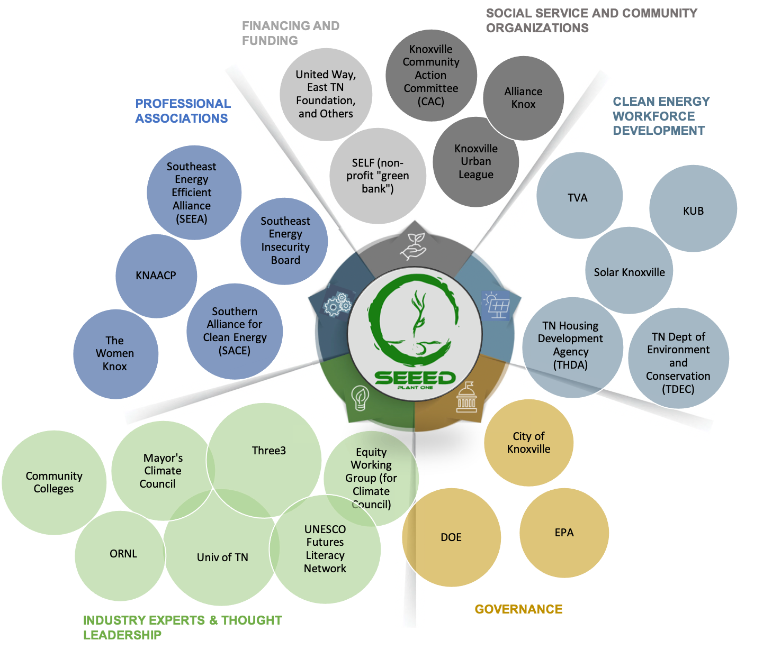
SEEED’s energy Innovation project has two aims that focus on procedural and distributive justice in the development of a just energy ecosystem. The first objective is to inspire and increase participation in clean energy jobs training and economic advancement for the disadvantaged young people in the under-resourced neighborhoods served by SEEED. The second aim is to enable the development of replicable clean energy transitions that deliver equitable benefits across disadvantaged communities in support of Justice40 goals and as restoration for historical inequities. Embedded in the struggle are barriers stemming from racial wealth disparities as well as a lack of futures literacy necessary for decision-making at the community level. Low income residents just don't understand how they will bear the brunt of climate change or how they can benefit from the green economy. Through this challenge, partners would connect with local and global institutions to bridge knowledge and build capacity to advance economic opportunity and plan for a more inclusive and clean energy future.

TEAM
SEEED Inc. http://seeedknox.org
Stan Johnson, Executive Director, Knoxville TN 37915, stan@seeedknox.org, 865-936-2623
Laurel Bowen, Knoxville TN 37915, laurel@seeedknox.org, 865-257-1364
Three³ http://threecubed.org
Beth Hawkins, Knoxville, TN 37902, bhawkins@threecubed.org, 865-963-3255
Erin Rose, Knoxville, TN 37902, erose@threecubed.org, 865-963-3256
Dr. Bruce Tonn, Knoxville, TN 37902, btonn@threecubed.org, 865-963-3254
City of Knoxville, TN
Brian Blackmon, Knoxville City Office of Sustainability, 30902, bblackmon@knoxvilletn.gov, 865-215-4430

