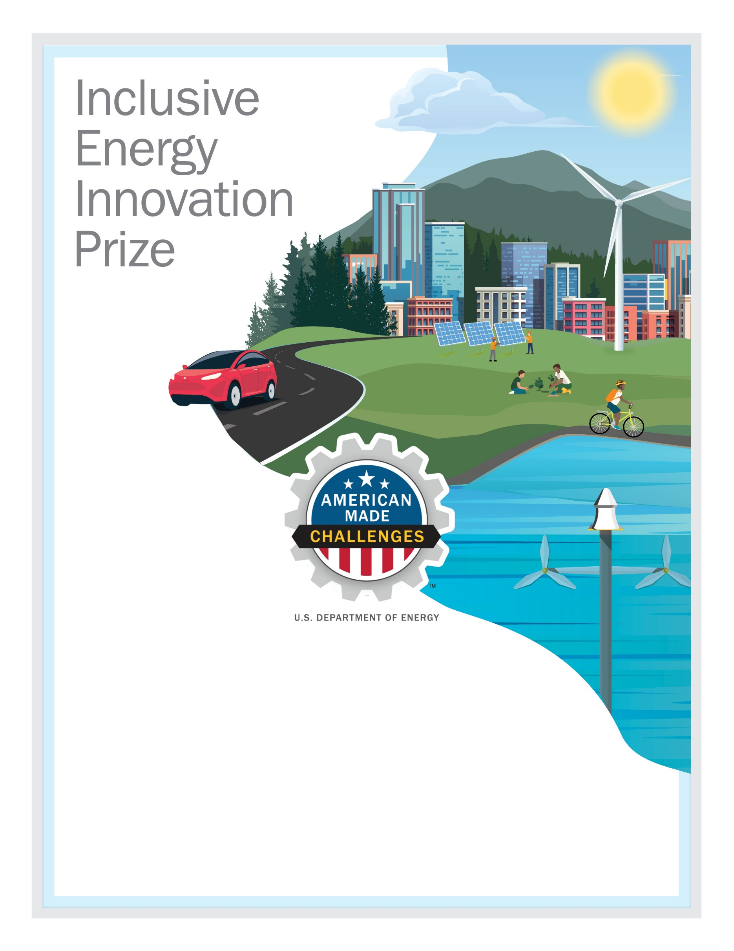
CarbonBank
Conventional Vehicle Tailpipe Carbon Capture
To provide technology, installation, infrastructure, and processes so people can transition from fossil-fueled vehicles
https://youtu.be/KDVkdX4nn7A
Team Lead: Meredith, Jaxon, merigjaxon.apps@gmail.com, 469-816-4665, https://www.linkedin.com/in/merigjaxon/
Your city and state: Phoenix, Arizona

