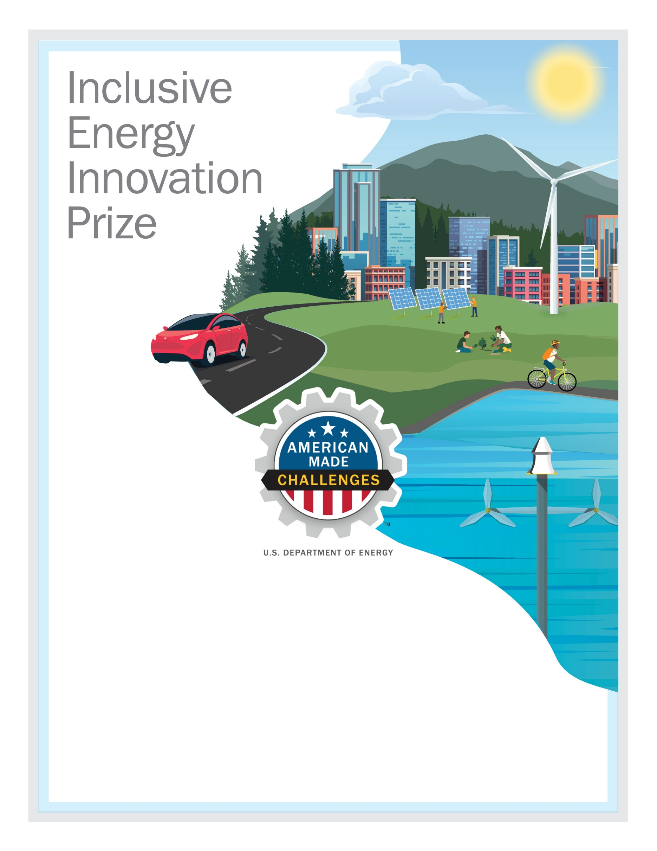
TEAM OASIS
Electric Power at Black Wall Street
Oasis Fresh Market, a grocery store in the historic Black Wall Street community, will use electric vehicles (EVs) to develop a rideshare and delivery program, with the goal of increasing access to resources in North Tulsa, OK. Link to video

Team Lead Name: Aaron (AJ) Johnson, aj@oasisfreshmarkets.net, linkedin.com/in/aaron-aj-johnson/
Team Member 2: Charlie Love, charlie@theoasisprojects.org, linkedin.com/in/charlotte-charlie-love/
Team Member 3: Hollie Wall Dalenberg, hollie@theoasisprojects.org, linkedin.com/in/holliewalldalenberg/
Team Member 4: Edith Newton Wilson, edith@rockwhispererllc.com, linkedin.com/in/edithnewtonwilson/

Other partners: Modus, Radical Solar Energy, Tulsa Area Clean Cities, Tulsa Renewable Business Alliance

City, State: Tulsa, OK

