The Solar Commons Initiative

A Solar Commons is a community economy tool. A Solar Commons Agreement will allow a neighbor with a solar pv array (host) to capture the sun’s common wealth and pass a portion of it on to a community trust. The trust is peer governed by the solar host & community partners (trustees) and the community beneficiary. Public facing art and a digital peer-governance Solar Commons dashboard allow all parties to work transparently together with the trust funds for the twenty-year life of the solar panels. Solar Commons trusts support reparative justice and other community empowerment projects in low-wealth communities following Solar Commons guiding principles and standards.

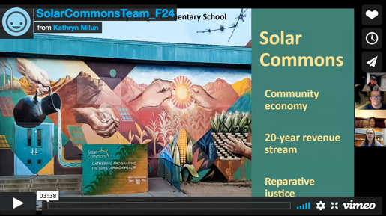
3 minute Video: https://vimeo.com/681716975

Solar Commons Team
(Governing Board of the Solar Commons Nonprofit
501(c)3 national organization headquartered in Duluth, MN)
Community Partners

Dunbar Pavillion, Tucson, AZ
Tucson Urban League
School of Art, University of Arizona
Center for the Future of Arizona

Heliene, Inc. Mt. Iron, MN
Bois Forte Food Sovereignty Group
Indigenous Food Sovereignty Anchor Institutions in Minnesota
MN Design Center, University of Minnesota
Kathryn Milun kmilun@d.umn.edu
https://cahss.d.umn.edu/faculty-staff/dr-kathryn-milun

Cole Carlson colecarlson17@gmail.com
https://www.linkedin.com/in/cole-a-carlson-pe-cem-a381b233/

Kathy Crowson, kcrowson@sehinc.com
https://www.linkedin.com/in/kathy-crowson-12aaa01a6/
Rumbidzai Masawi, faith.sawi@gmail.com
https://www.linkedin.com/in/rumbidzai-faith-masawi-27089227/

