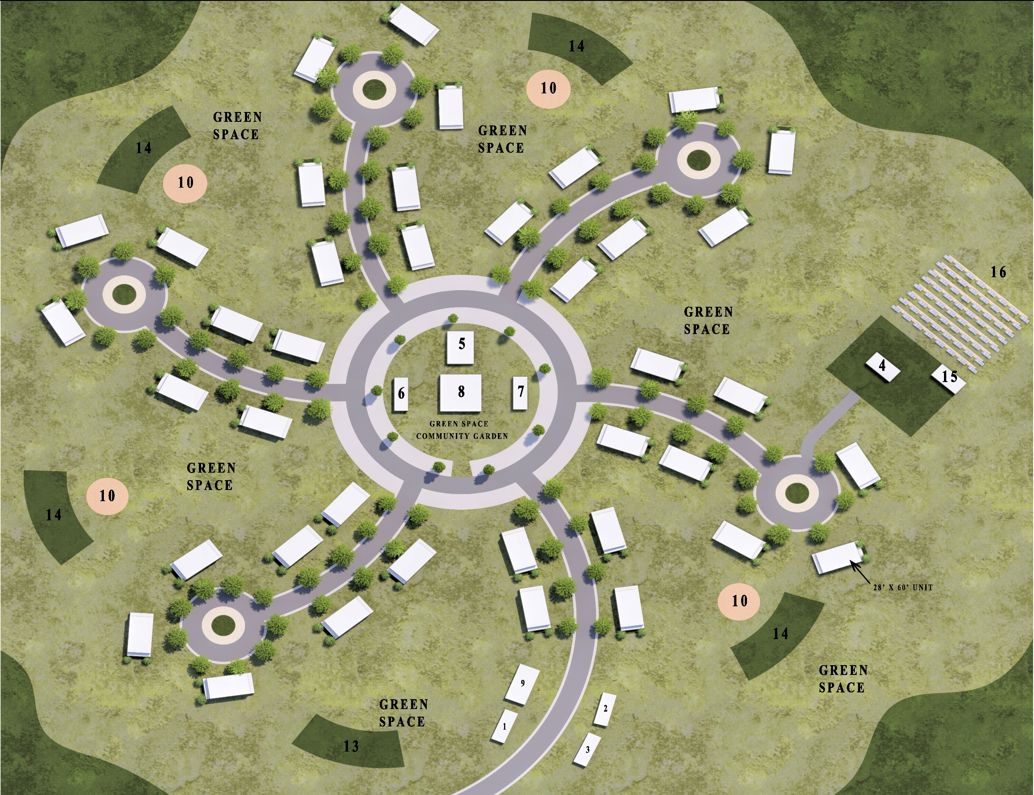
White Earth Net-Zero Sustainable Communities
Develop the framework to build a sustainable community in each of the five villages on the White Earth Indian Reservation. Each will consist of 39 net-zero ready homes, 8 community buildings (derived from ten “grassroots engagement workshops”) powered by a 1MW community solar array with a microgrid and smart battery to zero out all energy costs for the sustainable community.
Our Video: https://youtu.be/6hIkqJTiX74
Nathan Greenlaw, ngreenlaw@greenlawrealty.com, 612-396-2665, https://www.linkedin.com/in/nate-greenlaw-8371024/
Natalie McArthur, nmcarthur@greenlawrealty.com, 218-849-2702, https://www.linkedin.com/in/natalie-mcarthur-5b39aa5b/
Eugene McArthur, buggermcarthur@gmail.com, 218-204-0049, https://www.linkedin.com/in/eugene-mcarthur-05114a5b/
Ogema, MN

