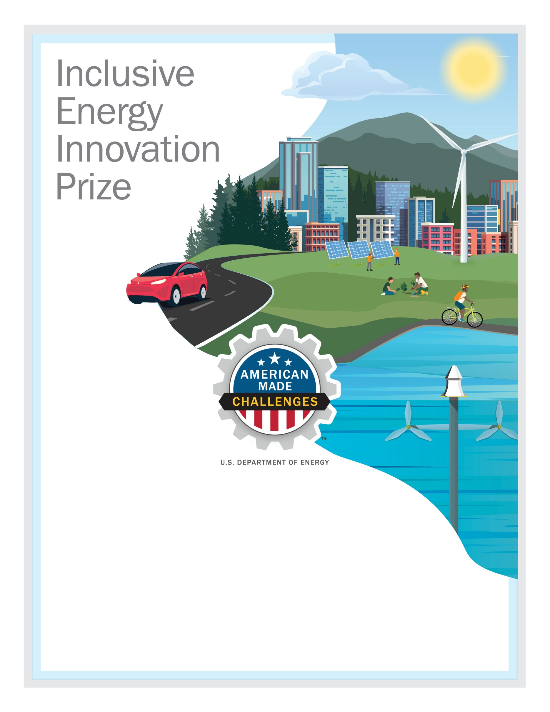
Ko’asek Band of the Abenaki Nation
Ko’asek Community Center - Solar Combined Heat & Power
Solar Combined Heat and Power for the Community Center for the Ko’asek Tribe using Parabolic Solar Concentrators and Stirling Engines.
Link to your three-minute, online video pitch
Team Lead Name: Chief & Elder Paul (Gwilawato) Bunnell. bunnellloyalist@aol.com
Team Member 2: War Chief David Nepveu. davidnepveu9@gmail.com
Team Member 3: Mark W. Schauer Ph.D. markwschauer3@gmail.com
Other partner: SunSpirit Enterprises, LLC.
Your city and state: Alstead, NH

